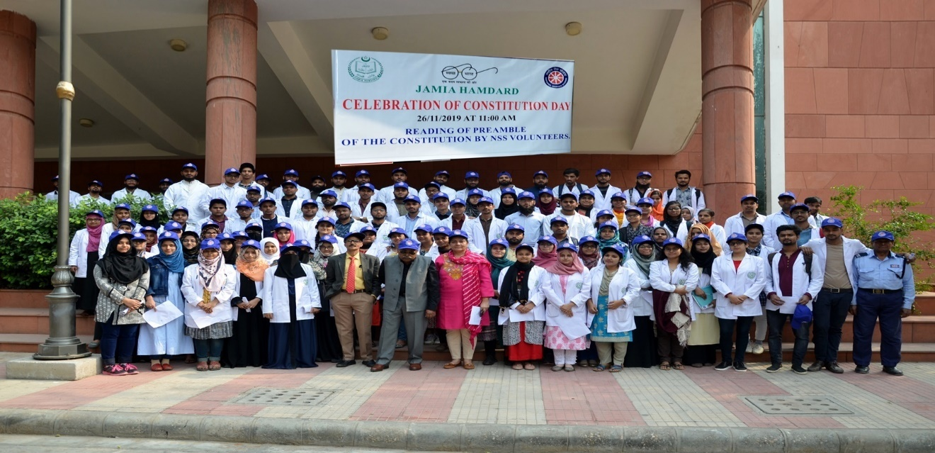

**Celebration of Constitution Day**

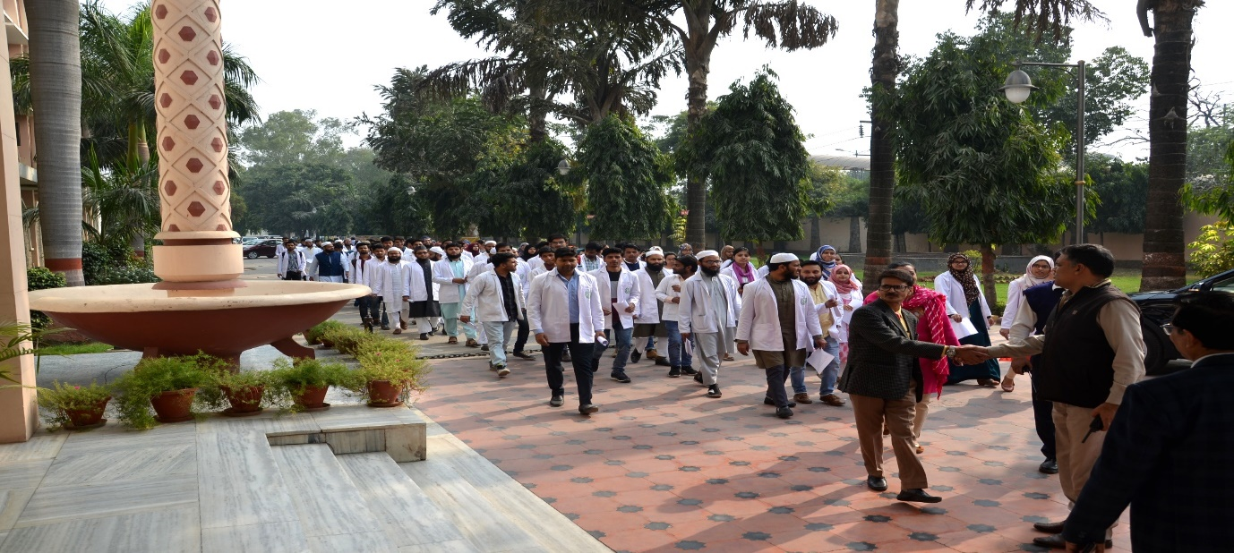

**Celebration of Constitution Day**

NSS Jamia Hamdard organised a programme on 26.11. 2019 to celebrate Constitution day. The preamble was read out and Prof Syed Mahtab Ali, NSS Program Coordinator and Convenor of this Programme addressed the NSS volunteers highlighting the importance of Fundamental Rights guaranteed by the Constitution of India. Thereafter, NSS Volunteers organized a march From School of Unani Medicine to the office of the Hon’ble Vice Chancellor.

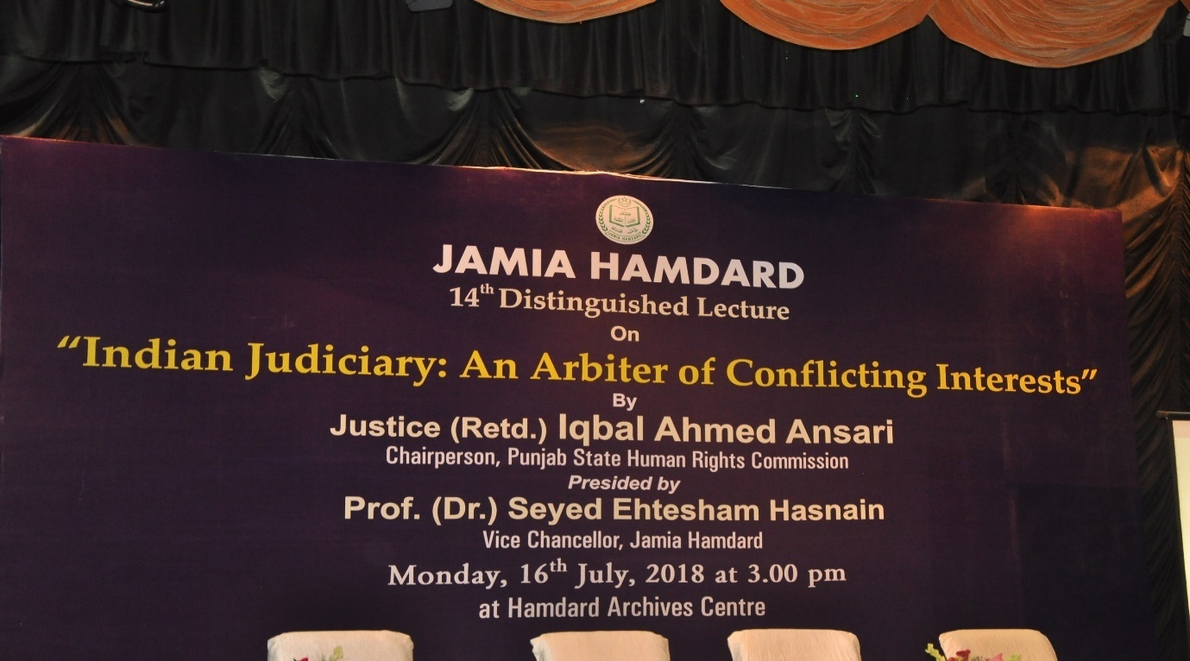

**Distinguished Lecture on ‘Indian Judiciary: An Arbiter of Conflicting Interests’**

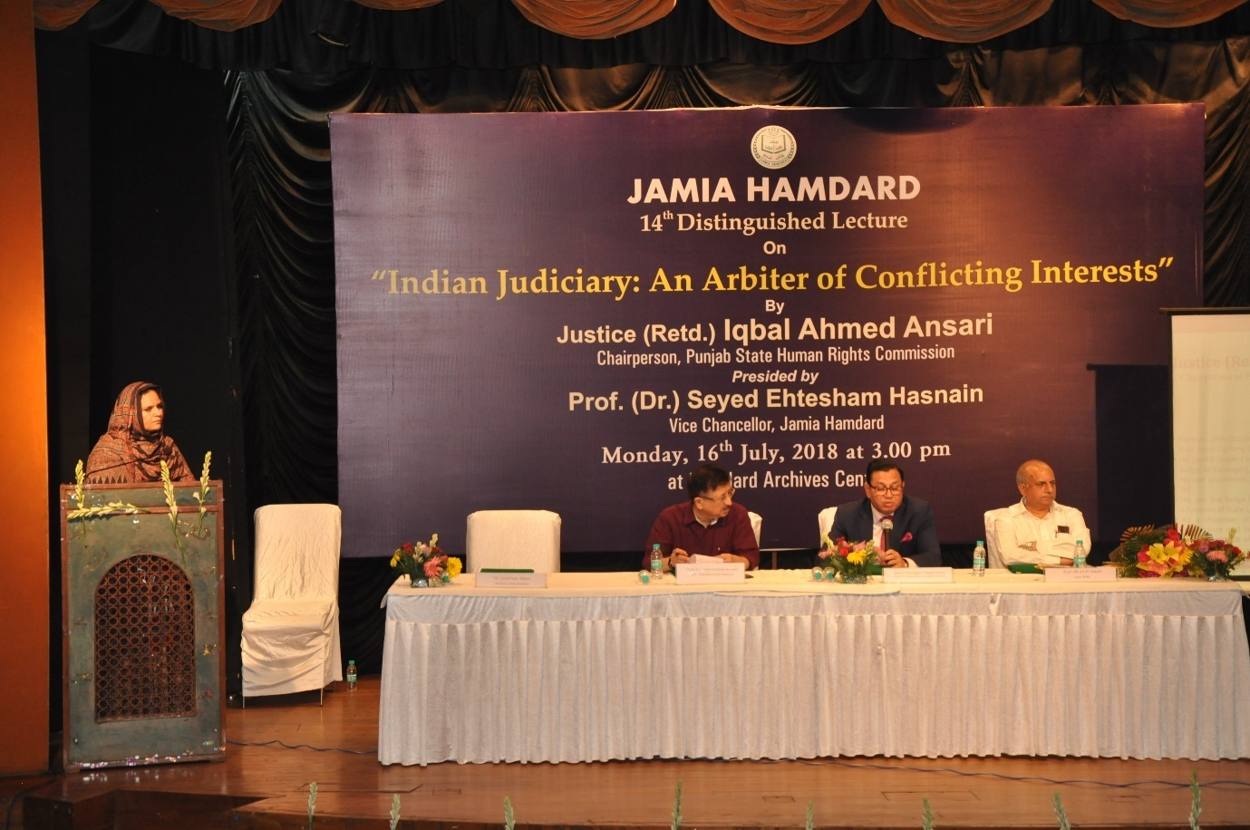

**Distinguished Lecture on ‘Indian Judiciary: An Arbiter of Conflicting Interests’**

On July 16, 2018 Justice (Retd.) Iqbal Ahmed Ansari, Chairperson, Punjab State Human Rights Commission delivered a distinguished lecture on the topic ‘Indian Judiciary: An Arbiter of Conflicting Interests’ at the Convention Centre and emphatically talked about the role of judiciary in the promotion and protection of the ideals of the Constitution.

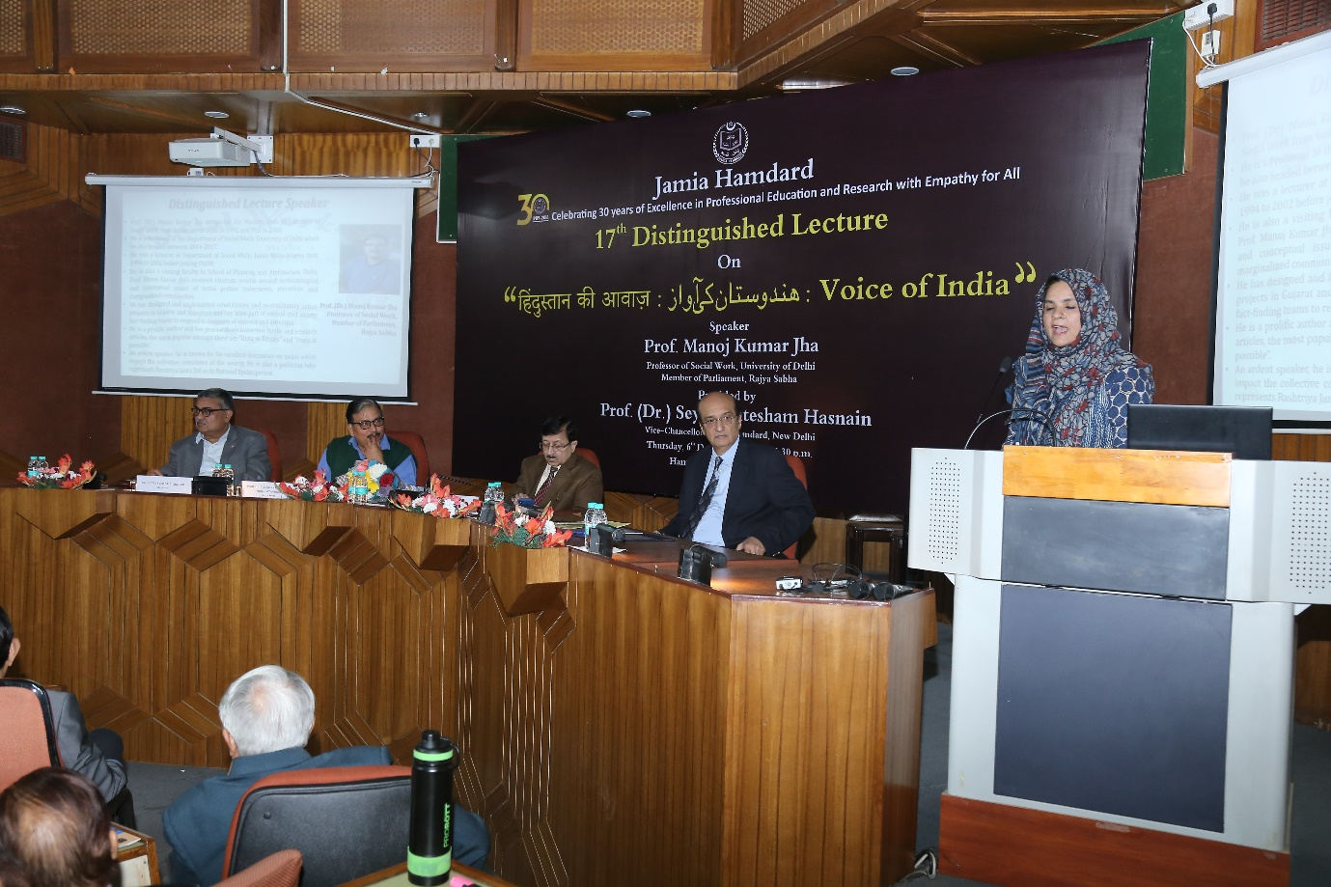

**Distinguished Lecture on ‘Hindustan Ki Awaaz: Voice of India’**

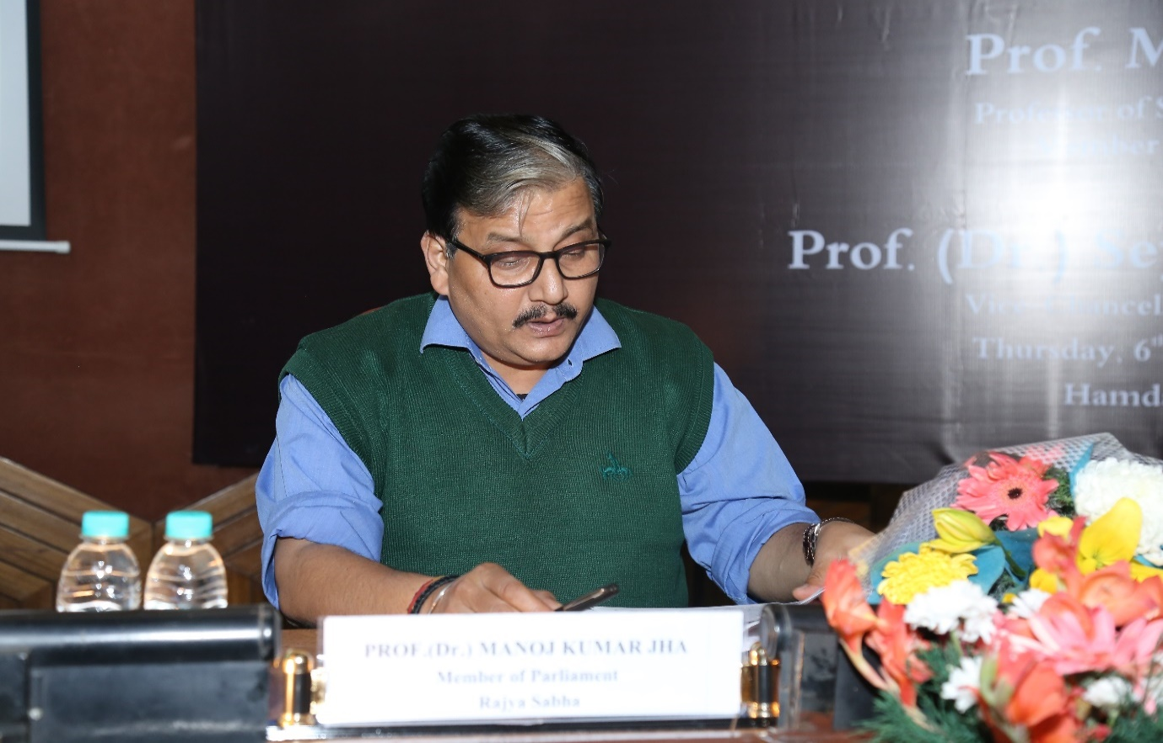

**Distinguished Lecture on ‘Hindustan Ki Awaaz: Voice of India’**

On December 6, 2018 Prof (Dr.) Manoj Kumar Jha, Professor of Social Work and Member of Parliament, Rajya Sabha delivered a distinguished Lecture on the topic ‘Hindustan Ki Awaaz:  Voice of India’ at the Convention Centre. Touching upon various aspects of the Constitution he forcefully highlighted how the survival democracy is intertwined with the preservation and protection of the Constitution.

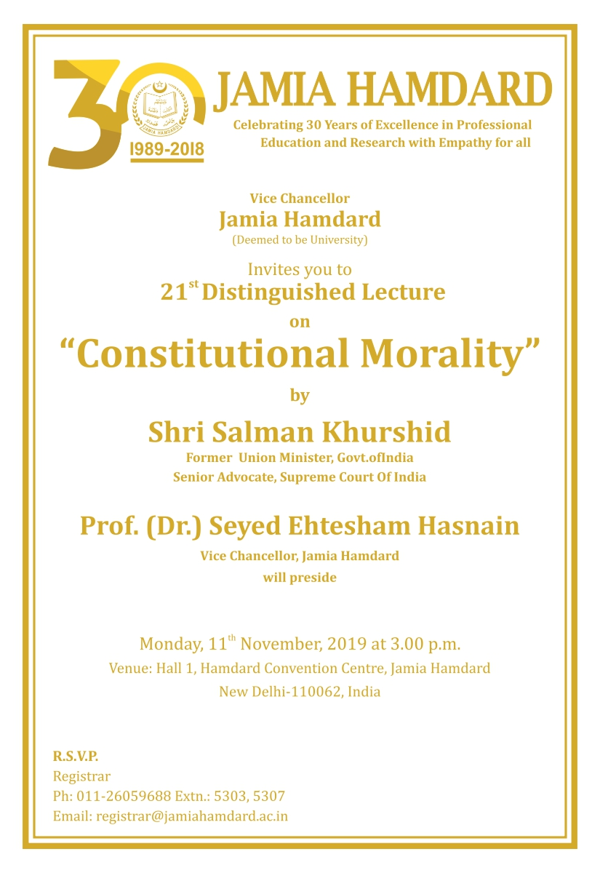

**Distinguished Lecture on ‘Constitutional Morality’**

Mr. Salman Khurshid, former Cabinet Minister and a prominent and veteran politician delivered another distinguished Lecture on the topic ‘Constitutional Morality’ at the Convention Centre on November 11, 2019. He eloquently spoke about moral and political philosophy embodied in the Constitution.

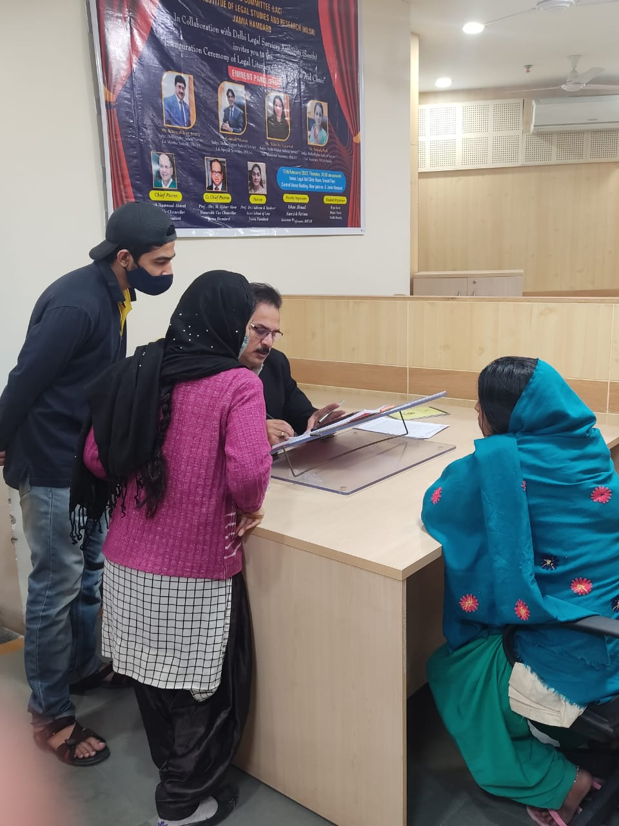

**Free Legal Assistance at Legal Services Clinic**

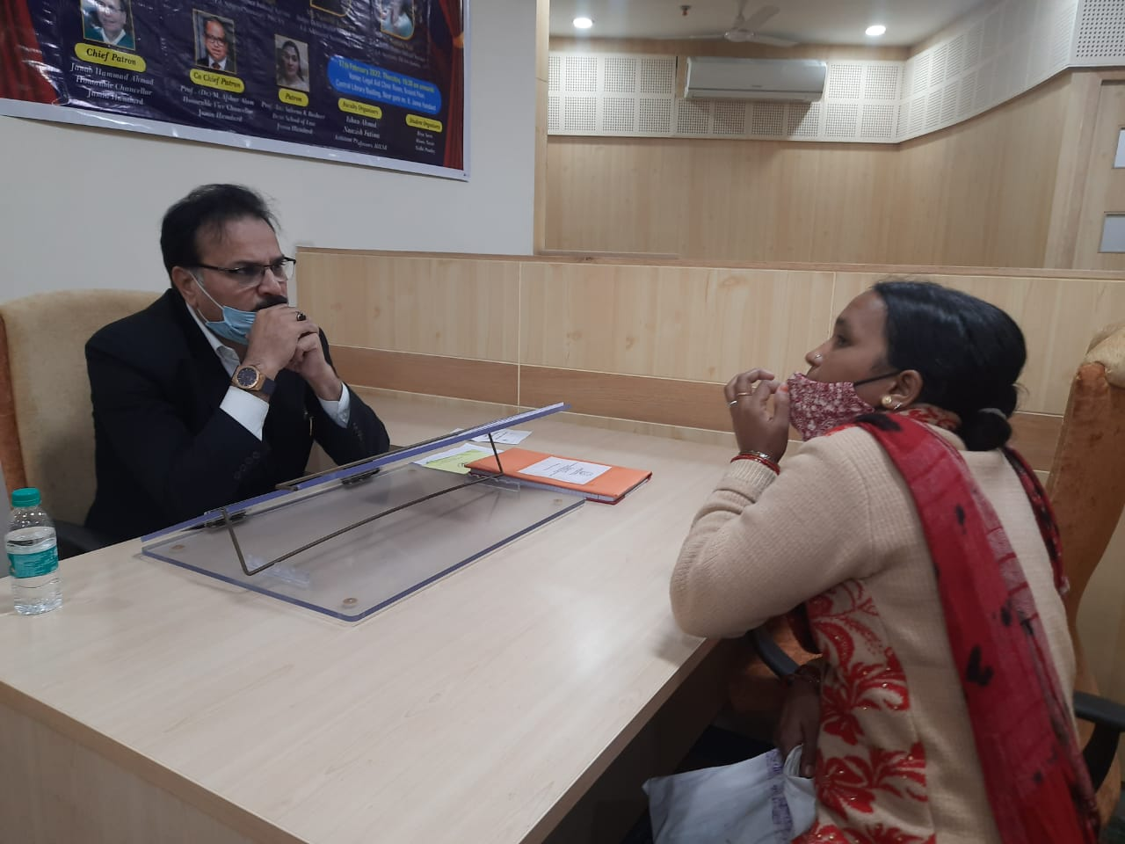

**Free Legal Assistance at Legal Services Clinic**

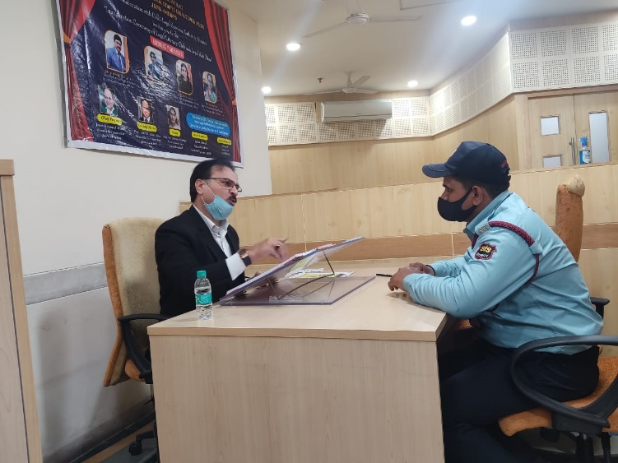

**Free Legal Assistance at Legal Services Clinic**

School of Law, Jamia Hamdard in collaboration with Delhi Legal Aid Services Authority (South) has established a Legal Services Clinic at Ground Floor, Central Library Building, Jamia Hamdard where practising lawyers visit to provide free legal assistance to the poor and underprivileged.

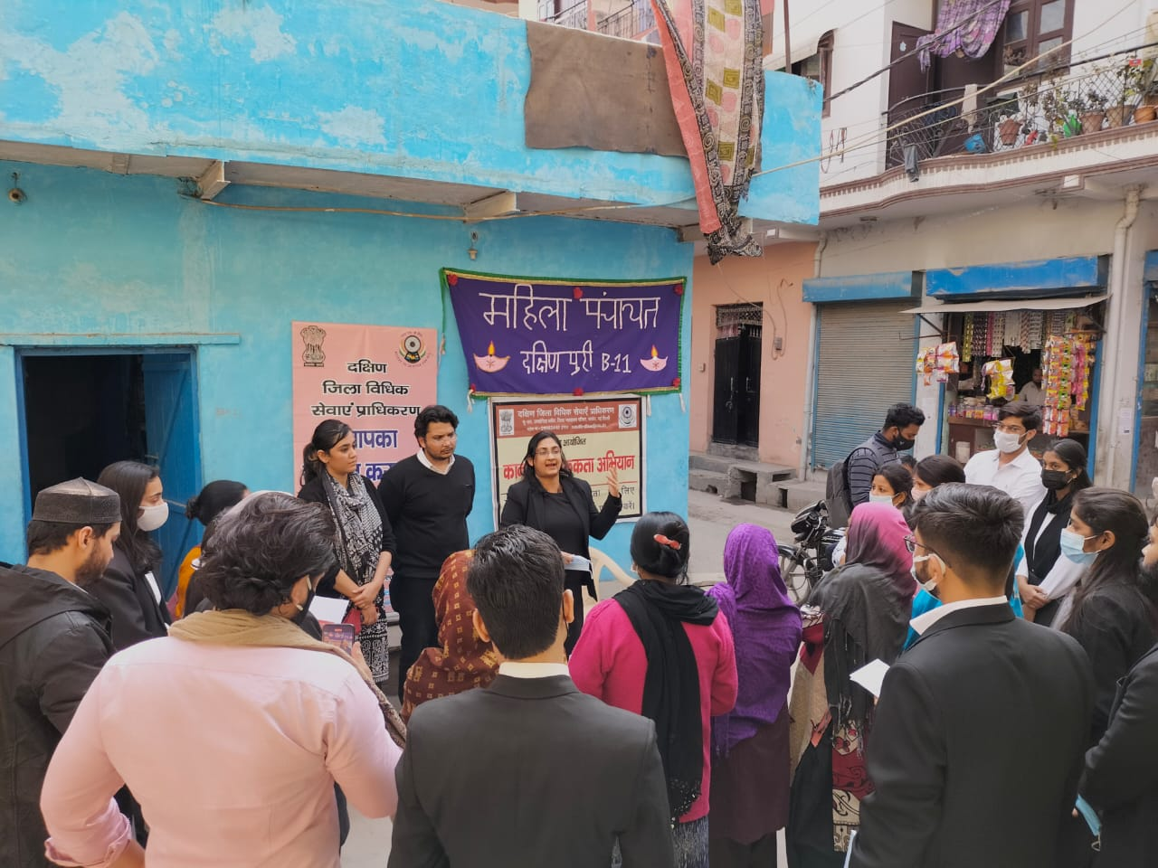

**Legal Awareness Drive on Domestic Violence**

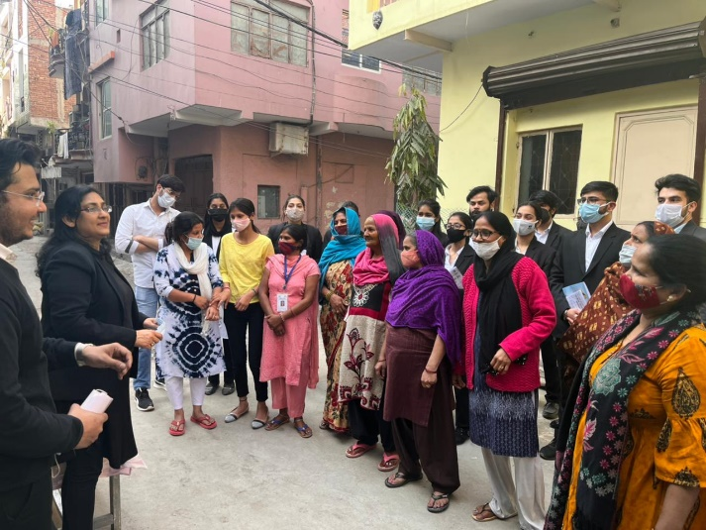

**Legal Awareness Drive on Domestic Violence**

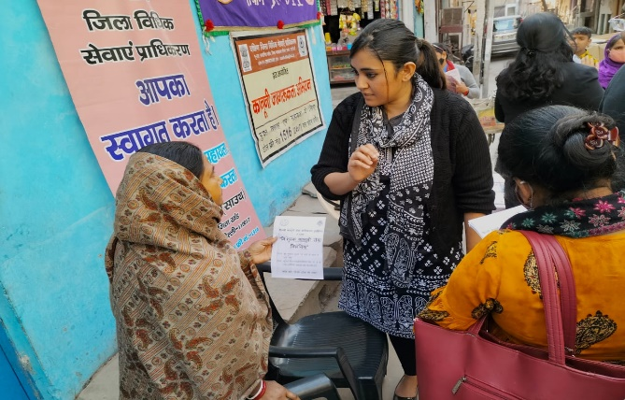

**Legal Awareness Drive on Domestic Violence**

A Legal Awareness Drive on Protection of Women from Domestic Violence in collaboration with Mahila Panchayat (Dakshinpuri) was organised by School of Law on 18th February 2022 in Dakshin Puri, Near Batra Hospital, New Delhi

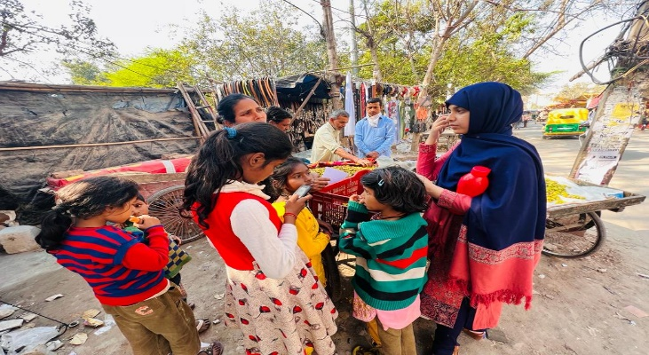

**Social Outreach Programme on protection of children from sexual violence**

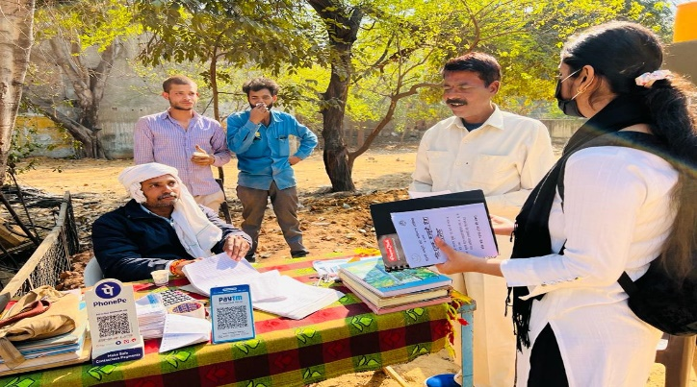

**Social Outreach Programme on protection of children from sexual violence**

A Social Outreach Programme was organised by School of Law on protection of children from sexual violence 9th March, 2022 near Tughluqabad Fort, Old Tughluqabad, New Delhi.

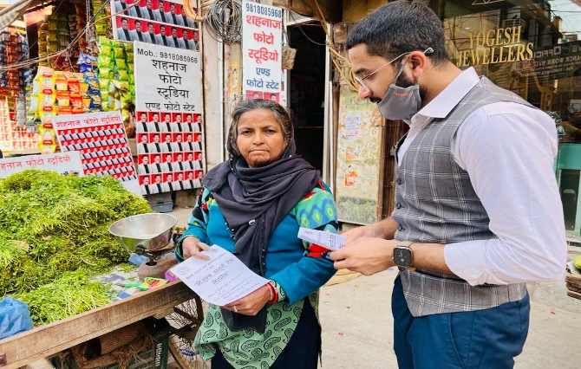

**Social Outreach Programme on Domestic Violence**

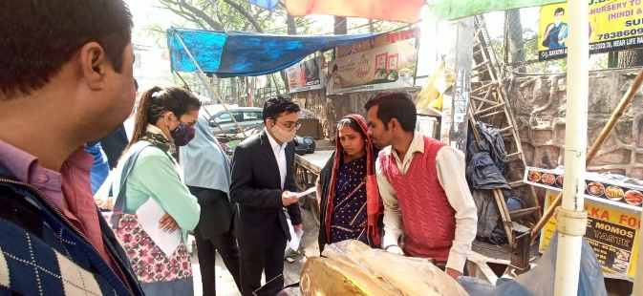

**Social Outreach Programme on Domestic Violence**

A social outreach Programme was organised by School of Law on domestic violence on 16th March, 2022 near Gali no. 35 and 36, Tughluqabad, New Delhi

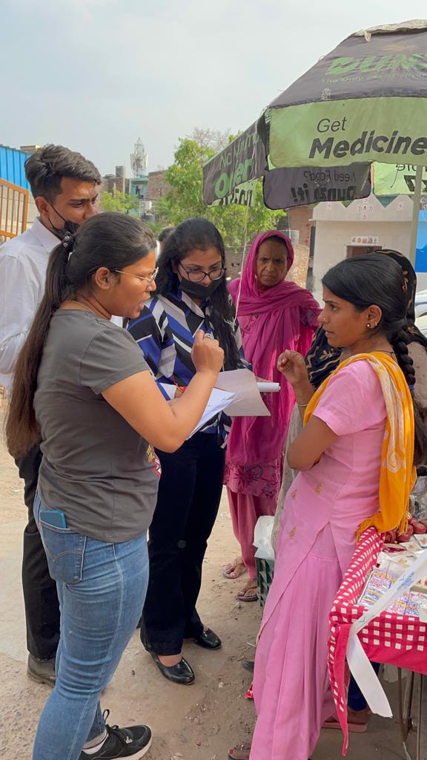

**Social Outreach Programme on outraging the modesty of women**

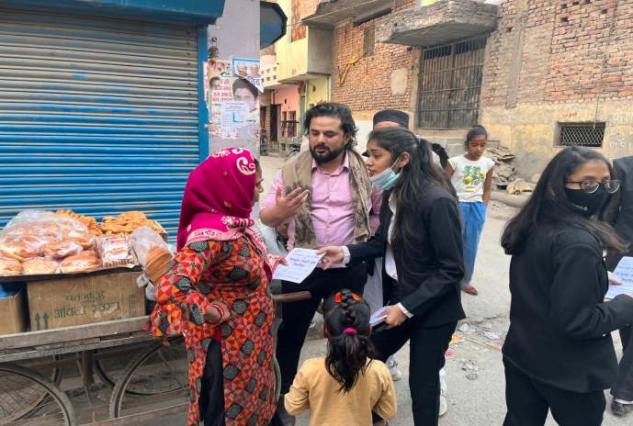

**Social Outreach Programme on outraging the modesty of women**

A Social Outreach Programme was organised by School of Law on outraging the modesty of women organised on 23rd March, 2022 near Hamdard.Public School, Sangham Bihar, New Delhi.

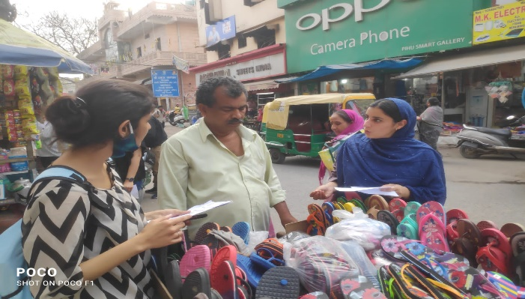

**Social Outreach Programme on Motor Vehicles Act**

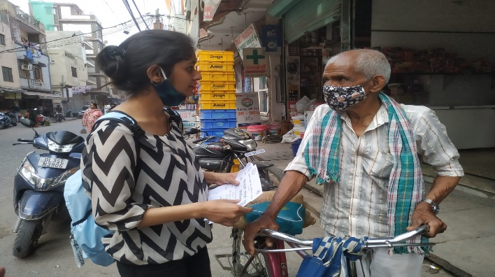

**Social Outreach Programme on Motor Vehicles Act**

A Social Outreach Programme on Motor Vehicle Act was organised by School of Law on 8th April, 2022 near Sangam Vihar Police Station, opposite Batra Hospital, New Delhi.

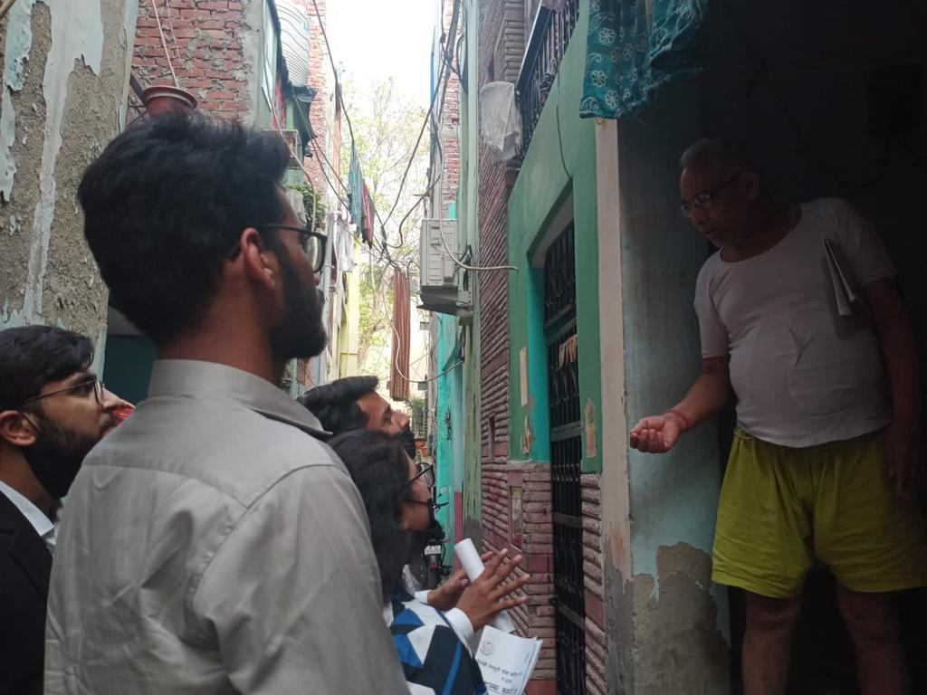

**Social Outreach Programme on Consumer Protection Act**

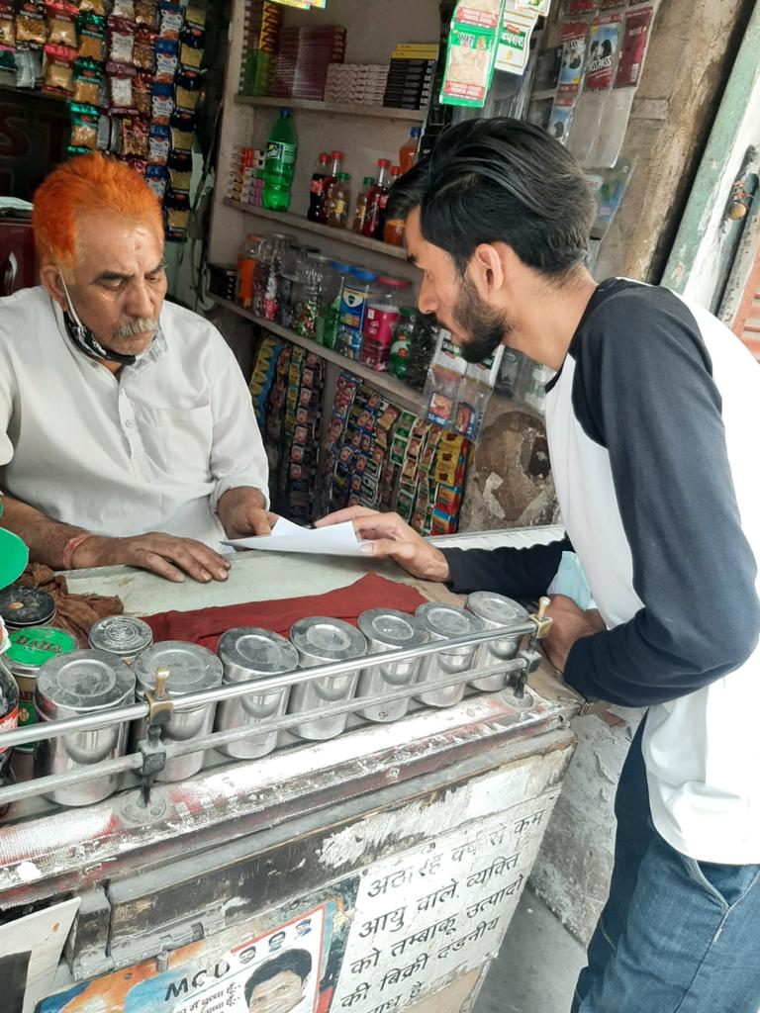

**Social Outreach Programme on Consumer Protection Act**

A Social Outreach Programme was organised by School of Law on Consumer Protection Act on 16th May, 2022 near street no. 36, Tughluqabad, opposite gate no. 6, Jamia Hamdard

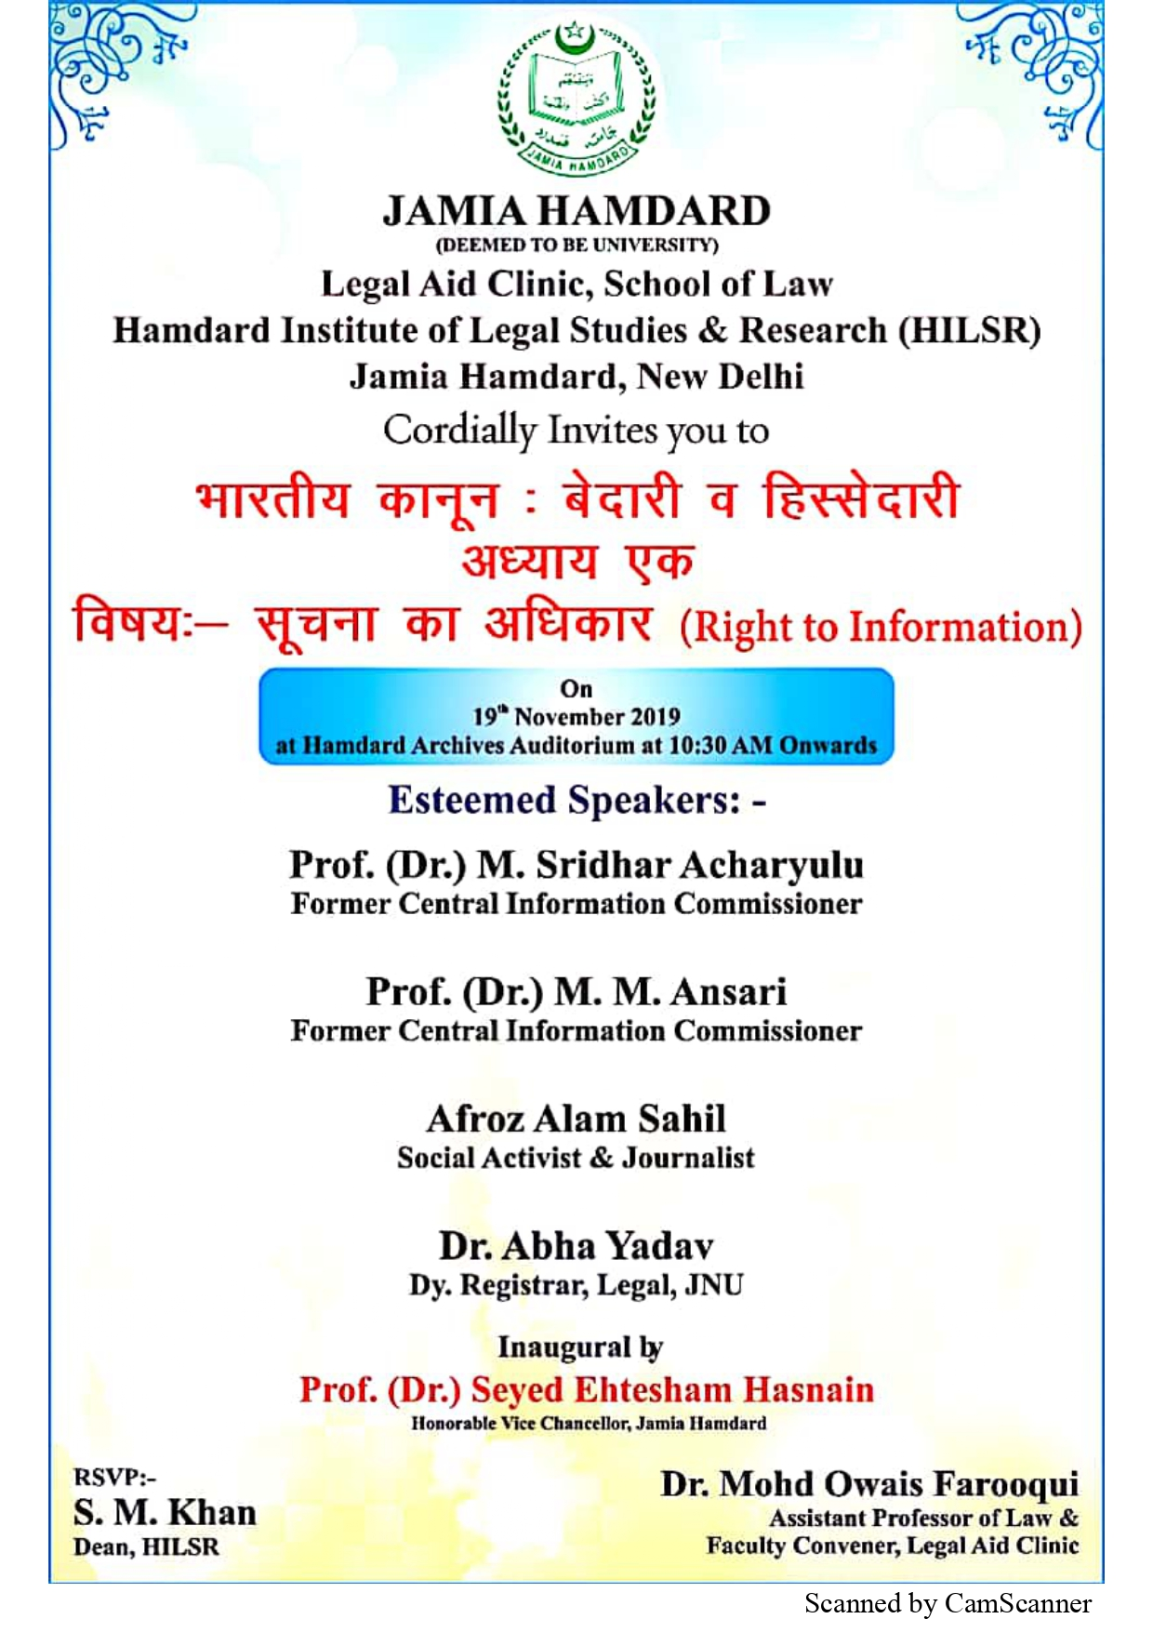

**Workshop on the Right to Information Act**

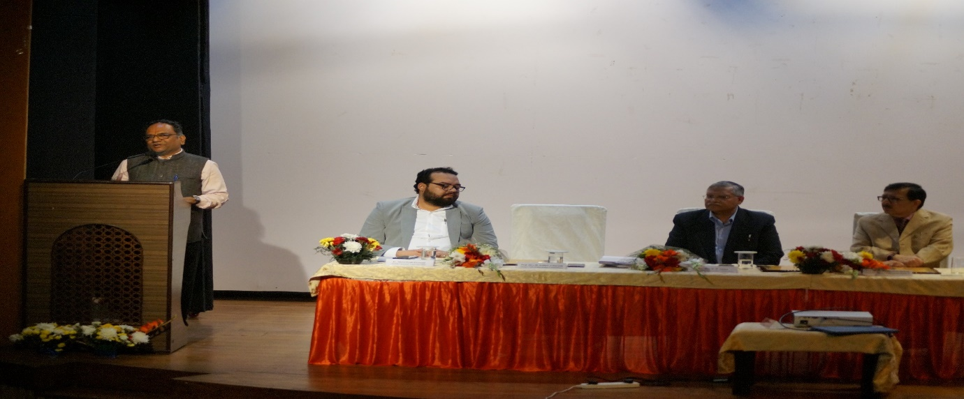

**Workshop on the Right to Information Act**

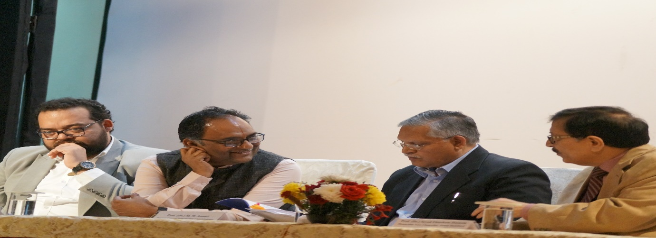

**Workshop on the Right to Information Act**

School of Law organised a workshop on right to information act on 19th November, 2019 to create awareness about right to information. A large number of participants attended the workshop. Two former Central Information Commissioners, Prof. Sridhar Acharya and Prof. M. M Ansari graced the occasion and spoke about how to meaningfully exercise right to information outlining the link between the right to information and rights guaranteed under the Constitution.

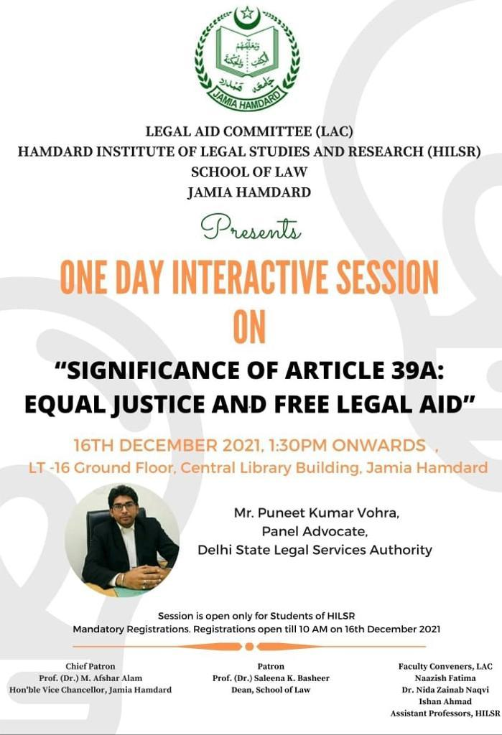

**Interactive Session on Significance of Article 39A**

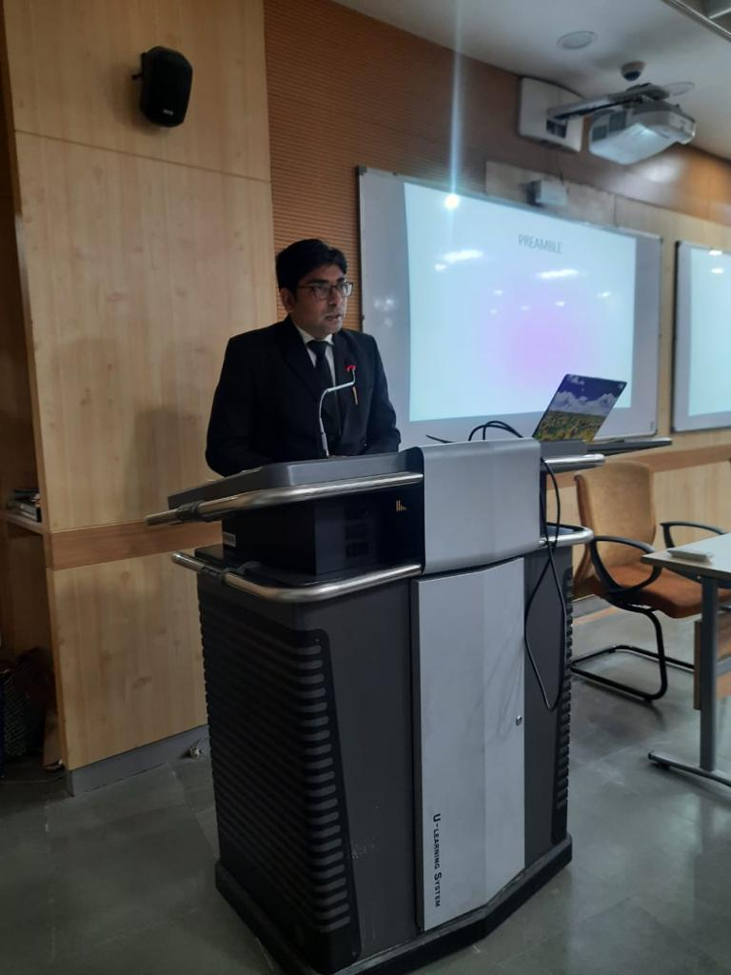

**Interactive Session on Significance of Article 39A**

An interactive session was held on the significance of Article 39A of the Constitution at the School of Law on 16th December, 2021. Mr. **Puneet Kumar Vohra** who is an empanelled Advocate at Delhi State Legal Services Authority spoke about the responsibility of lawyers to provide legal aid to the poor and the needy.

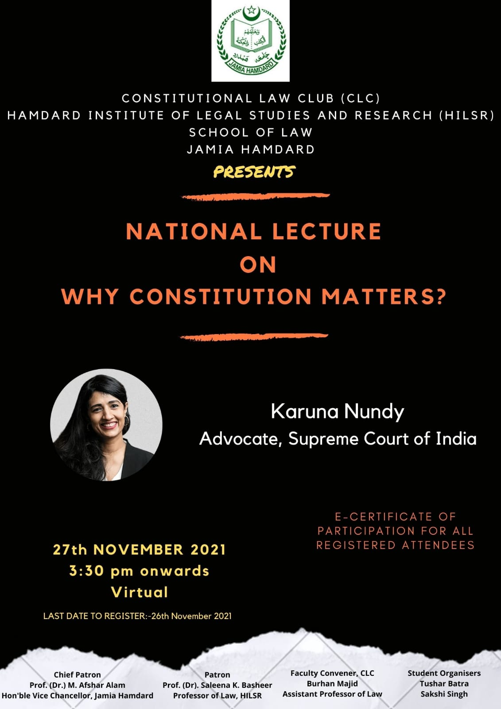

**Lecture on ‘Why Constitution Matters’**

School of Law organised an online lecture by Karuna Nundy, a distinguished advocate of the Supreme Court of India on ‘Why Constitution Matters’. Ms. Nundy eloquently spoke about the importance of the Constitution in safeguarding guaranteeing the basic civil and political rights to the citizens of India.

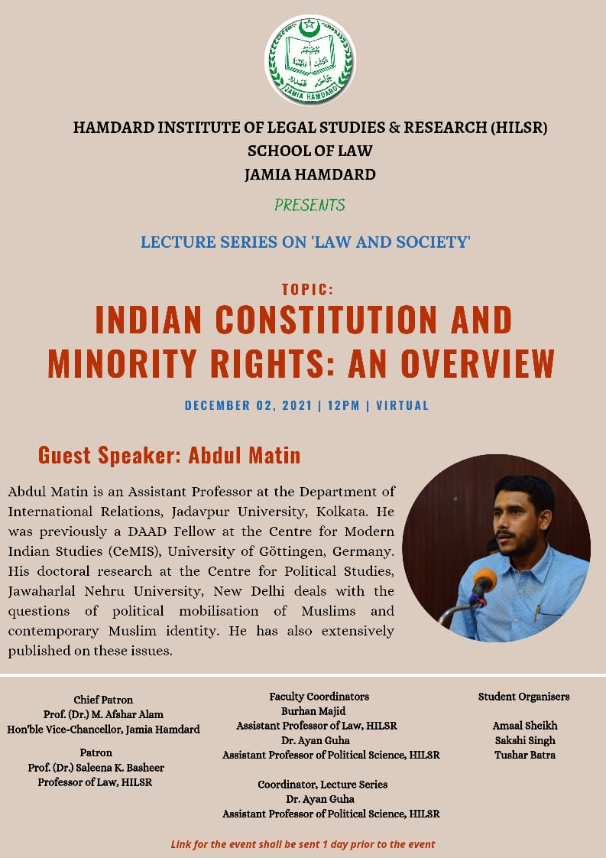

**Lecture on ‘Indian Constitution and Minority Rights’**

School of Law organised an online lecture by Abdul Matin, Assistant Professor, Department of International Relations, Jadavpur University, Kolkata on ‘Indian Constitution and Minority Rights’ on 2nd December, 2021. The speaker eloquently spoke about the theoretical and practical implications of the relevant provisions of the Indian Constitution with regard to the rights of the minorities.

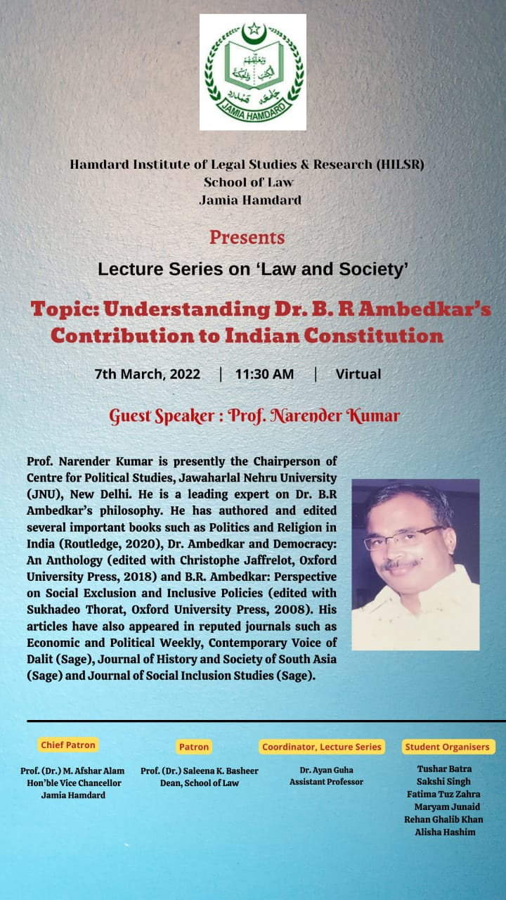

**Lecture on ‘Understanding Dr. B.R Ambedkar’s Contribution to Indian Constitution’**

School of Law organised an online lecture on ‘Understanding Dr. B.R Ambedkar’s Contribution to Indian Constitution’ by Prof. Narender Kumar, Chairperson of Centre for Political Studies, Jawaharlal Nehru University (JNU), New Delhi on 7th March, 2022. The speaker emphatically highlighted how the Indian Constitution was shaped by the political and ideological convictions of Dr. Br. Ambedkar.

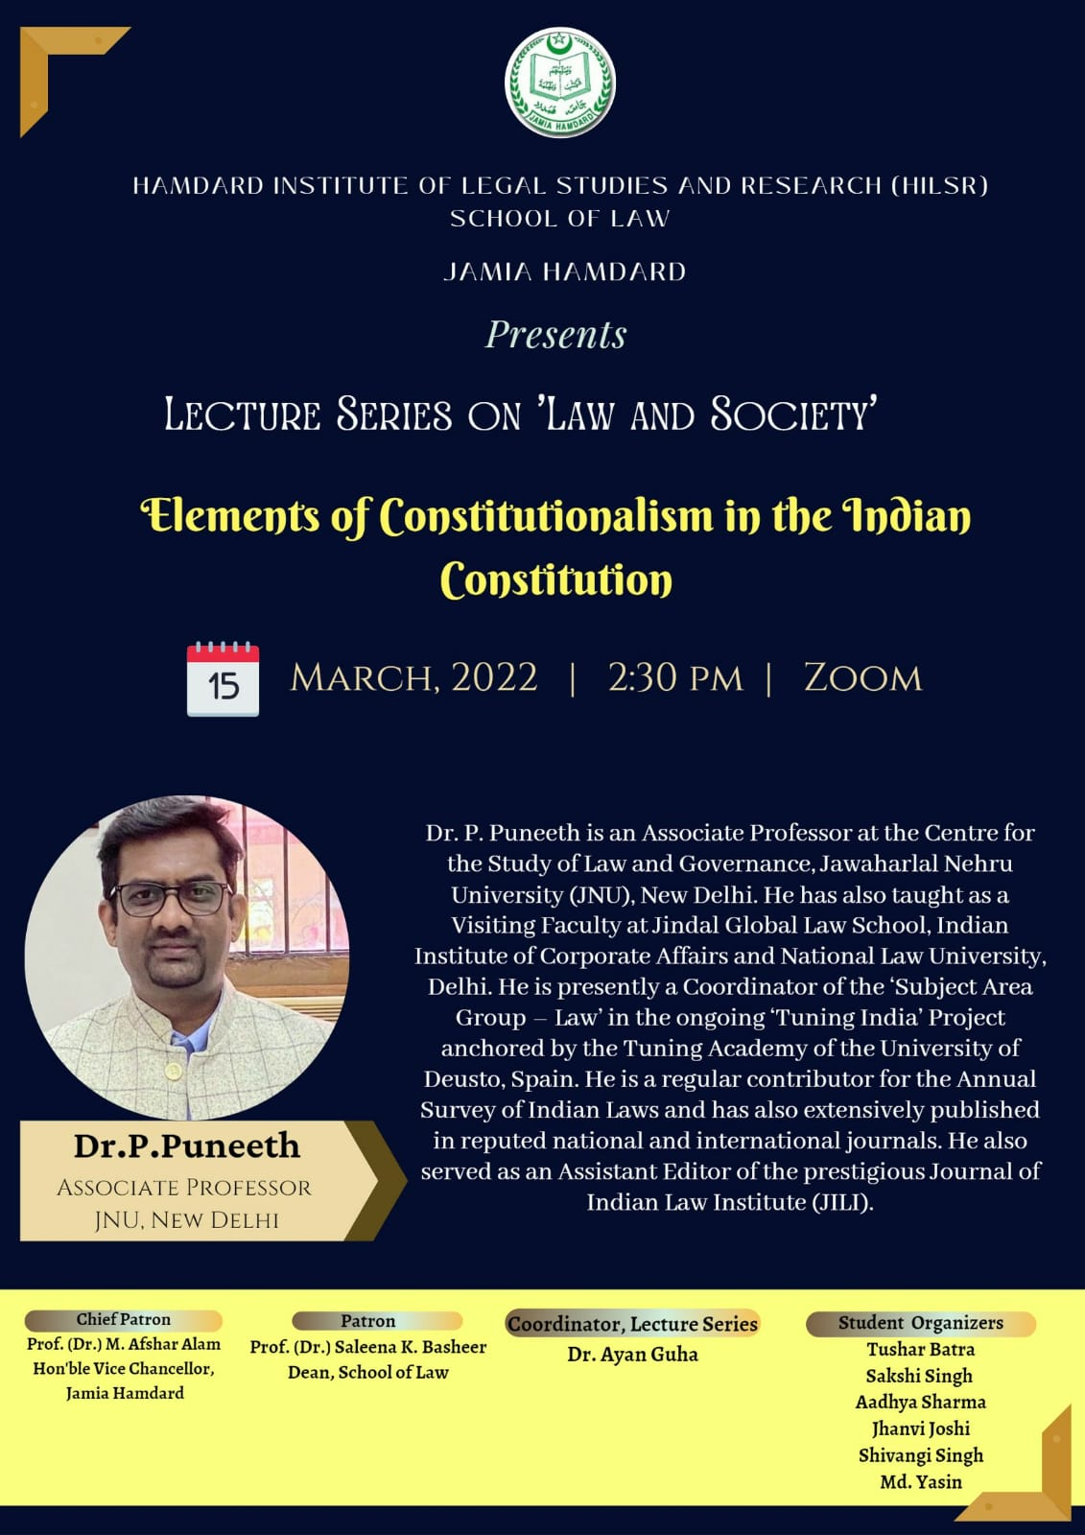

**Lecture on ‘Elements of Constitutionalism in the Indian Constitution’**

School of Law organised an online lecture on ‘Elements of Constitutionalism in the Indian Constitution’ by Dr. P. Puneeth, Associate Professor, Centre for the Study of Law and Governance, Jawaharlal Nehru University, New Delhi. Dr. Puneeth insightfully explained how the Indian Constitution is an embodiment of the true spirit of Constitutionalism.