DEAN STUDENT’S WELFARE, DSW
SHAMROCKS, ECO CULB ACTIVITIES
JANUARY-JUNE 2022
- INTERNATIONAL DAY OF FORESTS WITH WORLD POETRY DAY, 20th March ,2022.

On the occasion of World Forest Day and World Poetry Day, the office of DSW, Shamrocks (ECO club) organised an awareness session “KEEP IT GREEN” on 20th March,2022 “Imparting knowledge on the importance of trees “for the slum’s students in collaboration with Feed the needy, NGO. The slum scholars from classes 1 to 5 were educated on current environmental issues and importance of trees in a way they could best understand through plantation of saplings, painting leaf design, stand-up comedy, pledge, lecture, poems and slogans. The words of welcome were delivered by Shreshth- the host of the event and all the speakers were modestly invited to carry the event forward and impart knowledge to the children of slums. Dr Sapna Jain who herself is an environmentalist spoke eloquently about the environmental issues and importance of trees in simple language so the children could easily absorb her words. Further Dr Abroo Aman Andrabi suggested eco-friendly ways through which one can make the world a better place to live in. Komal who is one of the members of the NGO taught the children some rhymes on trees which the children enjoyed repeating loudly. The children were well acquainted with Mr Asif who is the founder of the NGO. He then greatly embellished the main aspects of the importance of planting trees and how without trees our lives will be affected. To make his points clear, he along with the members of his NGO taught leaf-impression painting which the children excitedly learned. Taking this excitement forward a versatile mimicry act was enacted by Farhan, student member, Eco Club which not only entertained the children but also highlighted the importance of trees in providing oxygen. A pledge was taken by all children to protect their plant and to look after it as carefully as they can. With the innocent faces asking -" When can be the next time we will see you? “The event “Keep It Green” was a true success in spreading Environmental awareness, Smiles and Togetherness.

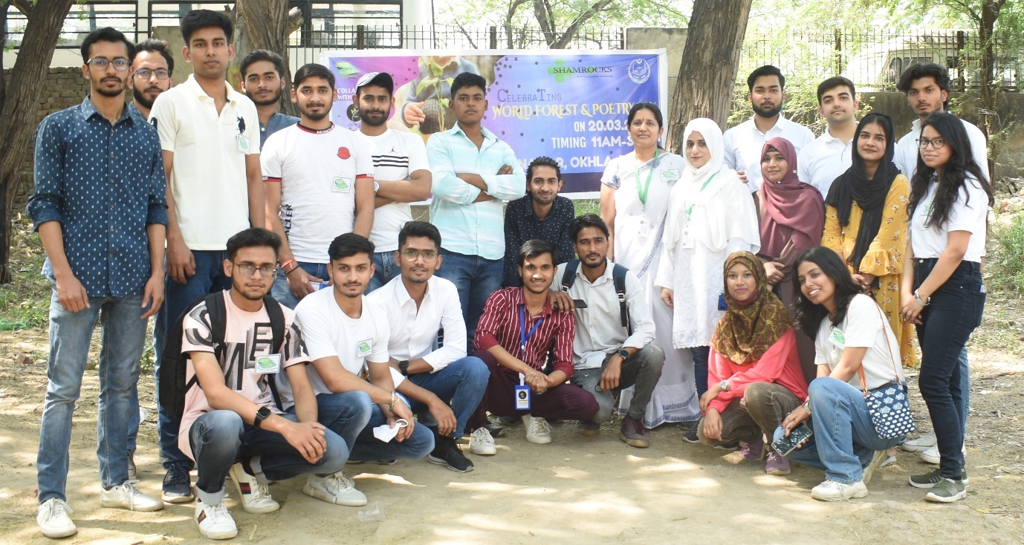
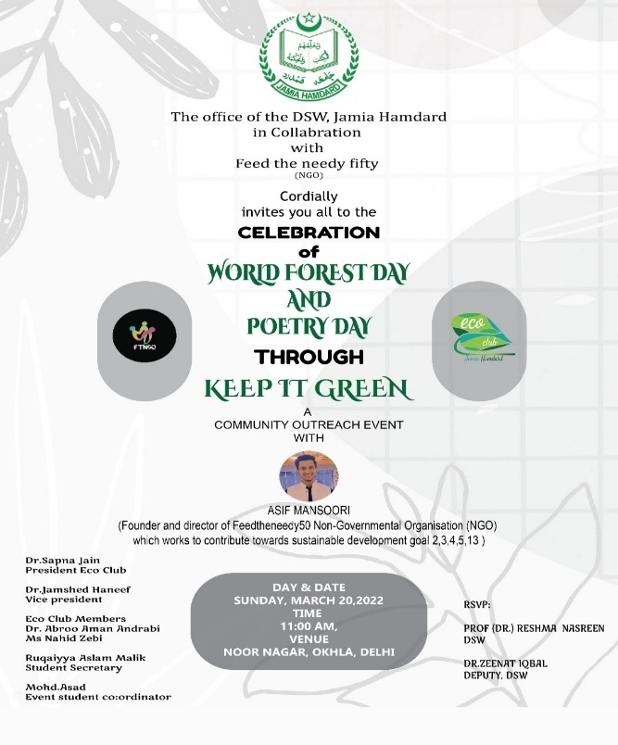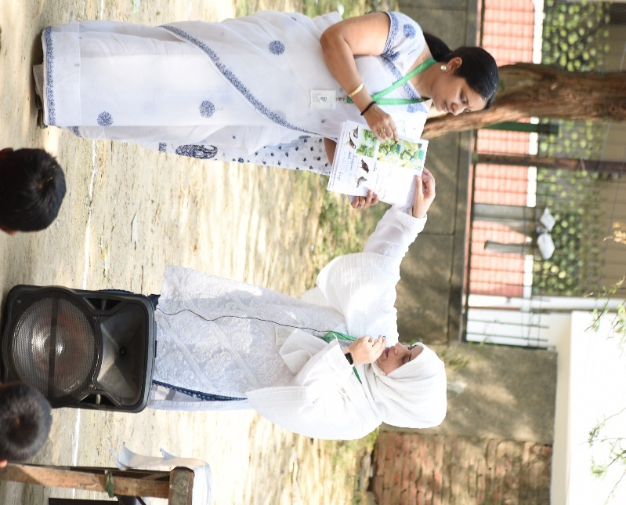

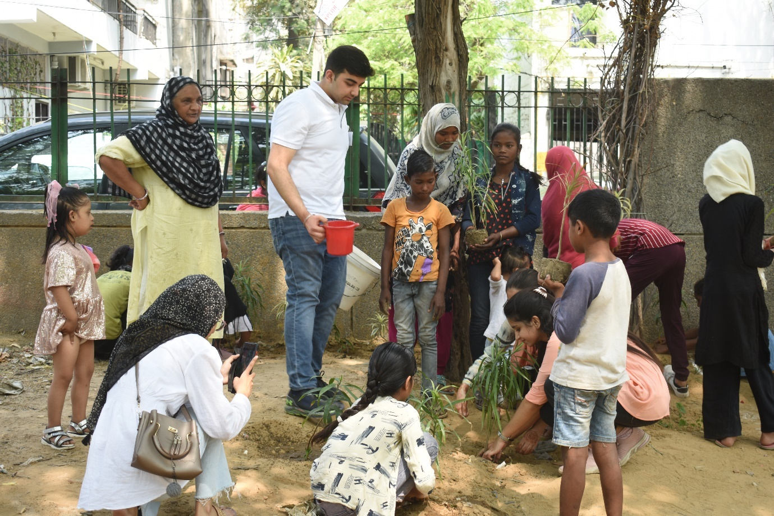
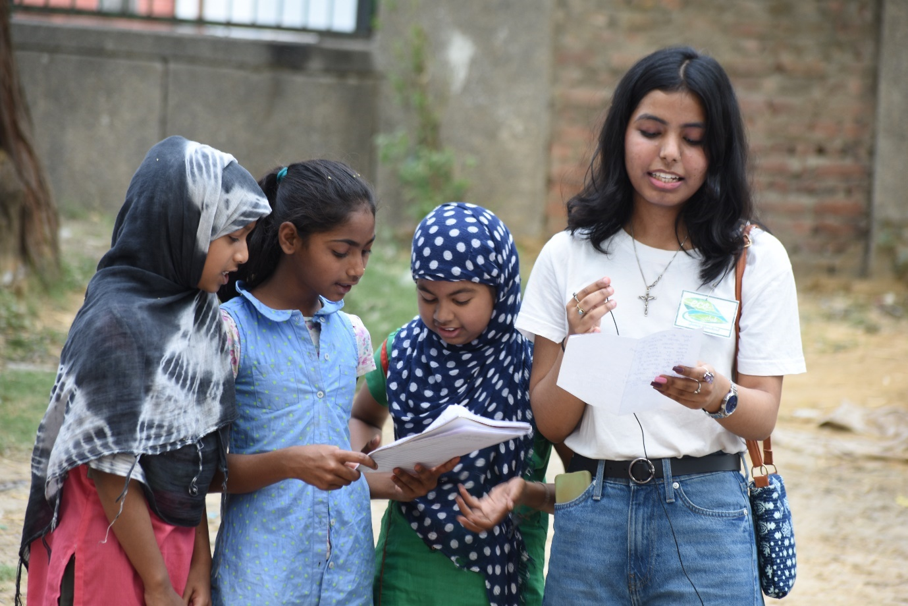
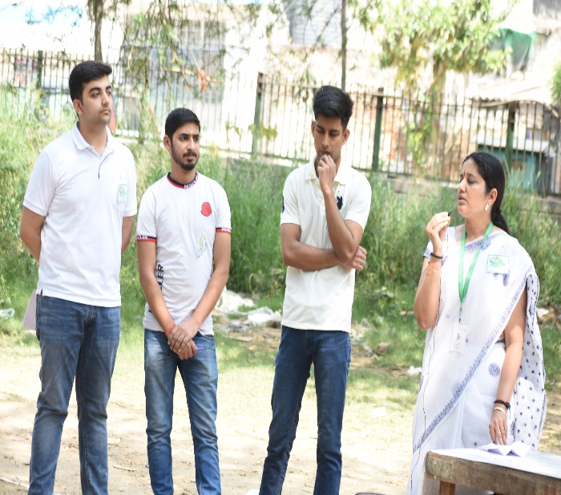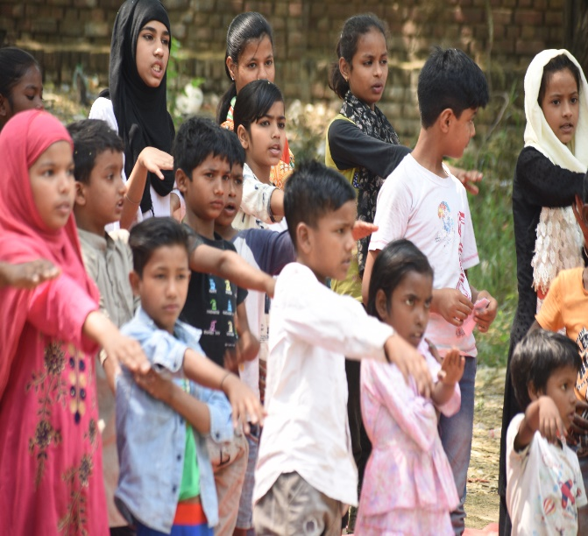
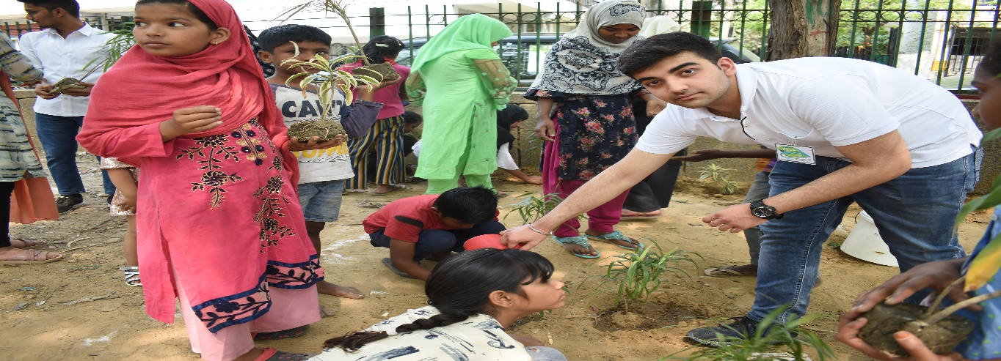
- INTER-COLLEGE SYMPOSIUM COMPETITION, 2nd April,2022
The Shamrock, ECO-Club team, Dean Student Welfare won FIRST prize in Inter-college “NIRANTRATA”, Sustainability Symposium organized by NatureKnocks, Eco club of Maharaja Surajmal Institute, Janakpuri on the topic – “Integrating SDG's in reducing water pollution in cities”. The Shamrocks Team, Eco-club members Farhan Tyagi, Saurabh, Adiba Bari, Sana, Ruksana Mir mentored by Dr Sapna Jain, President Eco Club represented Jamia Hamdard in the event. The event was divided into two rounds: round 1 and round 2. The Jamia Hamdard Shamrock, Eco club team cleared round 1 which was held on 29th March 2022, in an online mode that was comprising MCQ-based questions out of 15 teams. Round-2 was held on 2nd April 2022 in offline mode in which the Shamrock team gave a presentation on a working Sewage Water Management model and was declared the Winner out of the five selected teams from round 1.
Farhan Tyagi, Saurabh, Adiba Bari, Sana, Ruksana Mir from Department of Computer Science and Technology innovative concept and their wonderful presentation got them 1st Position.

EVENT HIGHLIGHTS

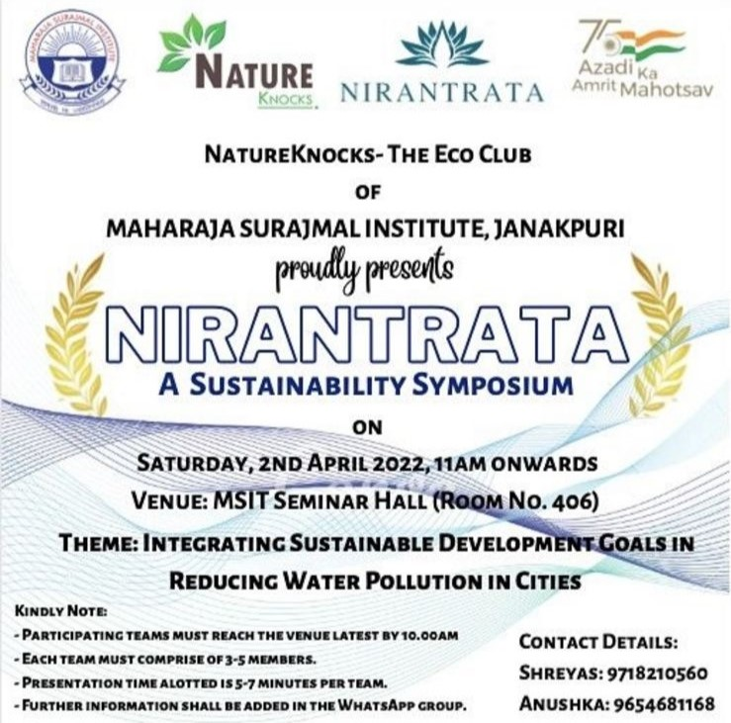

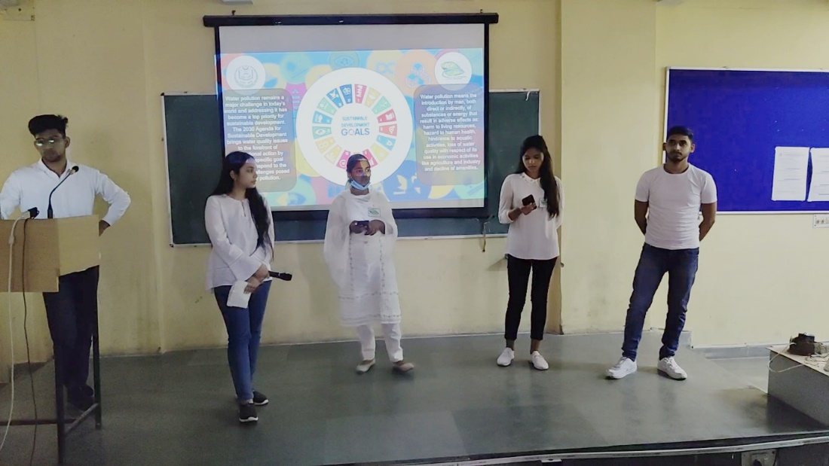

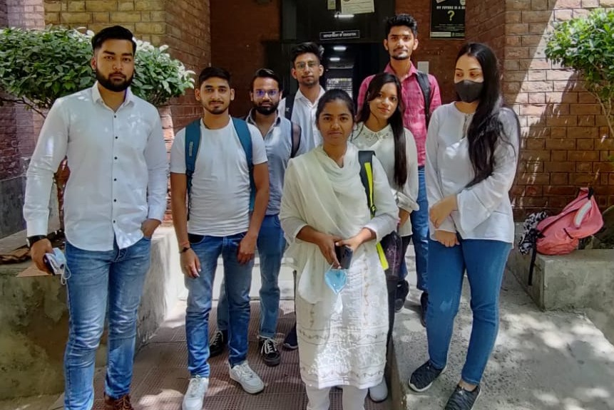

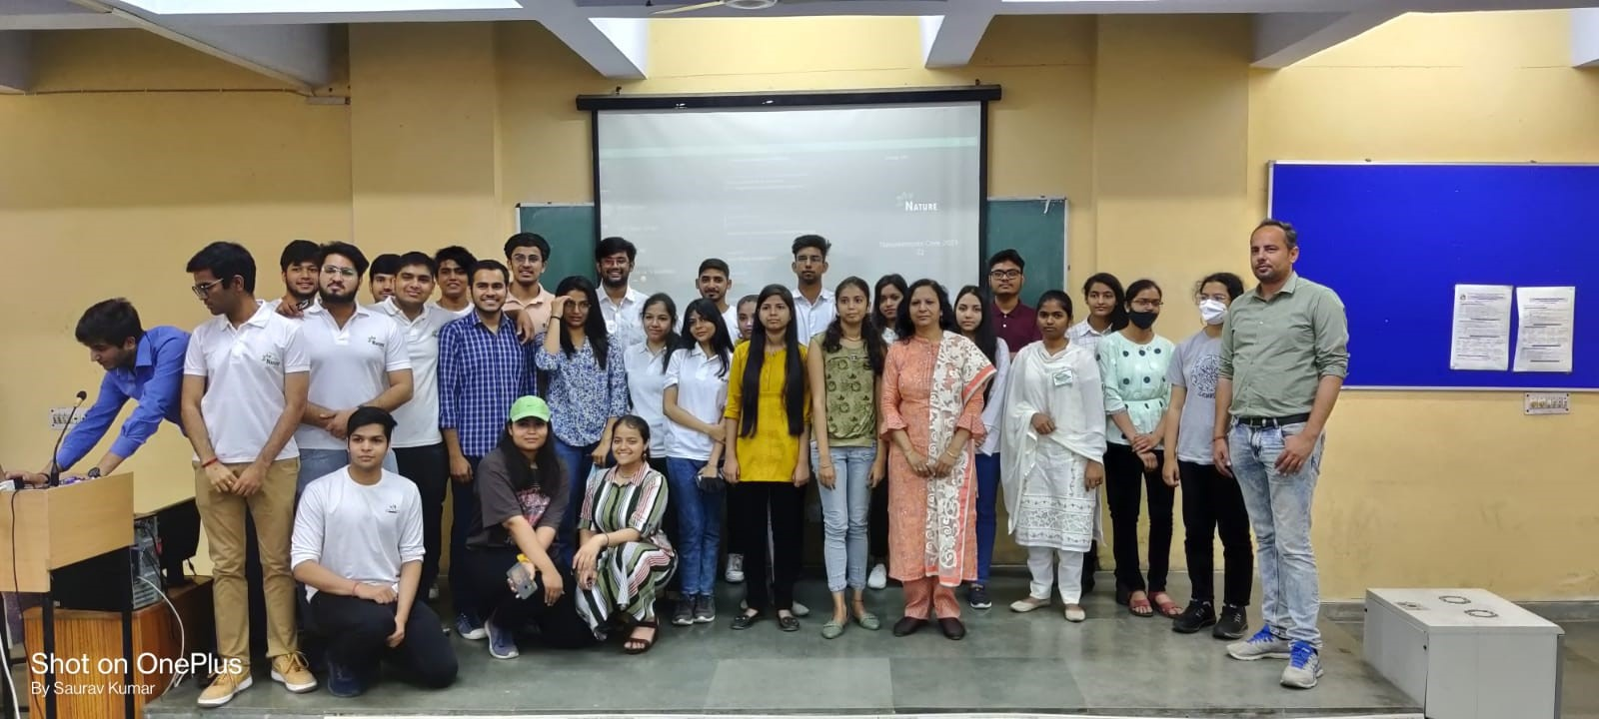

- CAREER DEVELOPMENT WORKSHOP ON AQUATIC TECHNOSCIENCE,20th April,2022
Shamrocks, Eco-Club, under the aegis of Dean student’s Welfare, acknowledged the importance of aquatic creatures by observing World Aquatic Animal month through organising a career development workshop on “Aquatic Technoscience” in collaboration with Nagodas fish farming and consultancy Pvt ltd which works towards sustainable development goal 14(life below water) on 20th April,2022.

The programme began with the Holy Quran recitation by Saleh Umar. Dr Reshma Nasreen, Dean Students Welfare in her welcome address gave insight about the environment friendly initiatives implemented in Jamia Hamdard and encouraged students for active participation students in DSW club activities. Dr Zeenat Iqbal, Deputy DSW also graced the event. Dr Sapna Jain, President, Eco Club in her opening remarks discussed about United Nations General Assembly declaration of year 2022 as the International Year of Artisanal Fisheries and Aquaculture dedicated to conservation and use the oceans, seas and marine resources in a sustainable manner. Dr Abroo Aman Andrabi, Member, Eco club introduced the speaker to the audience. The room jampacked with students was awestruck by Keynote speaker Mr Sajan's M Gupta lecture as he explained the concept of Biofloc technology with the its entrepreneurship opportunities. He explained the mechanism with the videos of onsite projects which his team is working in India and abroad.

The students showed inquisitiveness and enthusiastically participated throughout the session. Ms Nahid Zebi, Member, Eco Club delivered the vote of thanks and the event was wrapped up by the national anthem. With over 200 students taking benefit from this career workshop and the keynote speaker Mr Sajan M Gupta- Director of Nagodas Group, promising them internships and future entrepreneurship avenues, the workshop succeeded in achieving its objective.

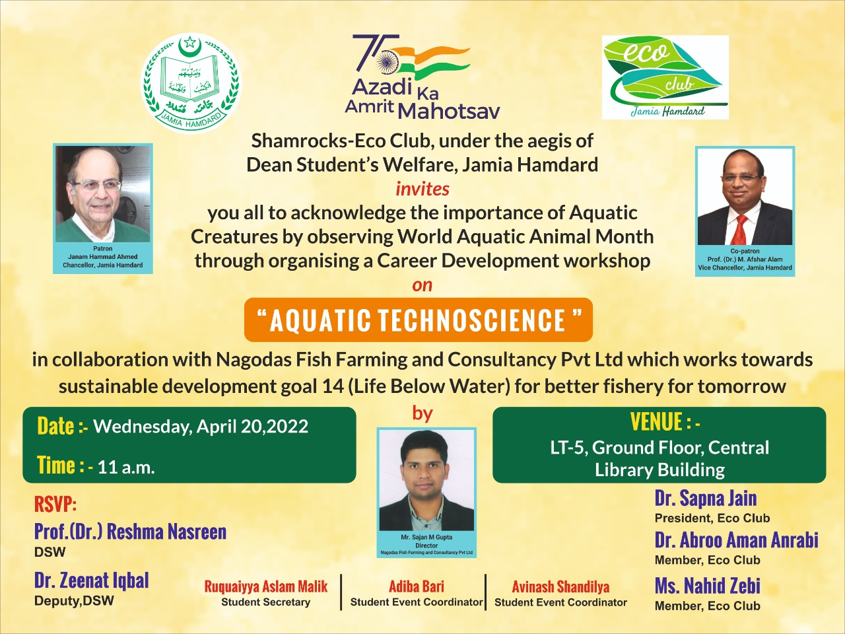

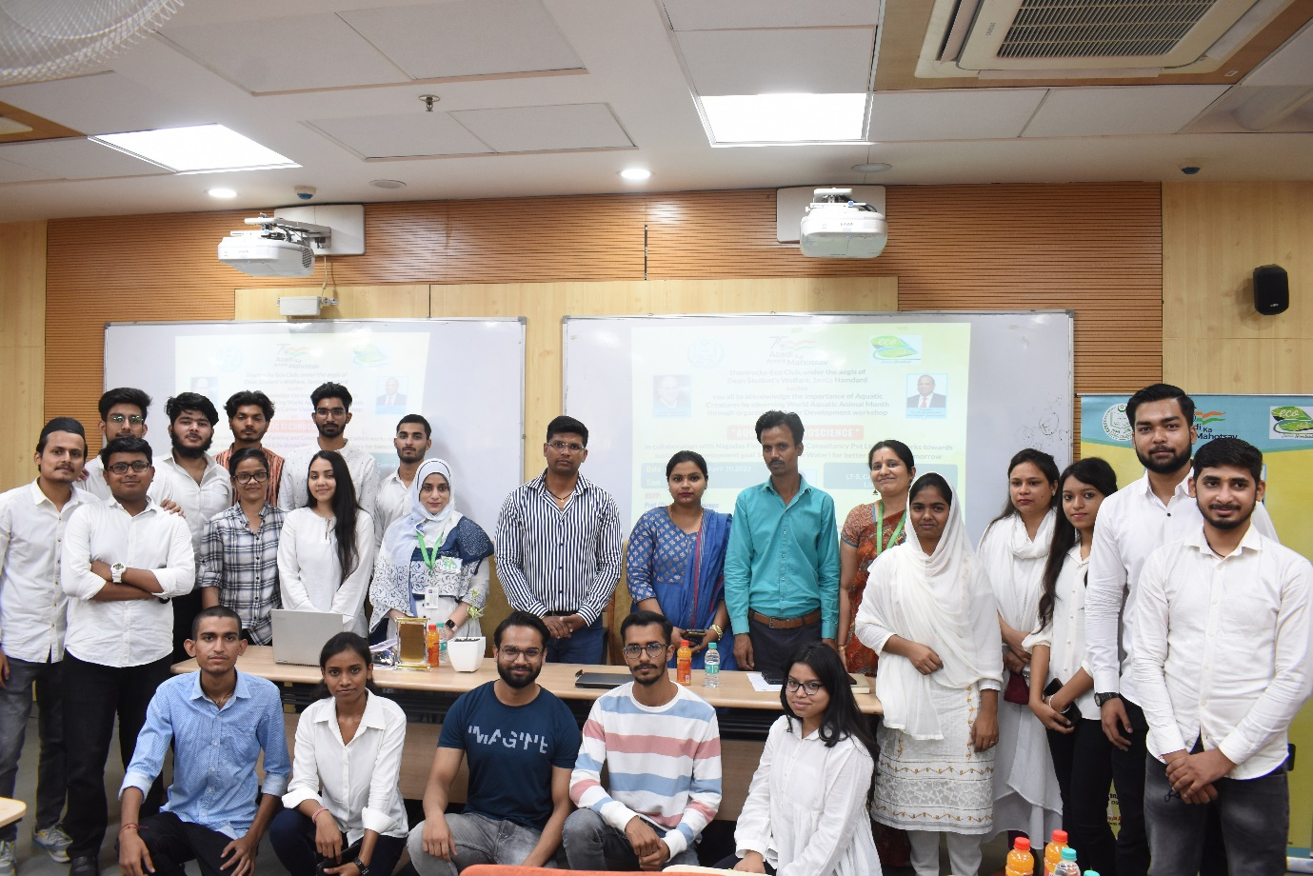
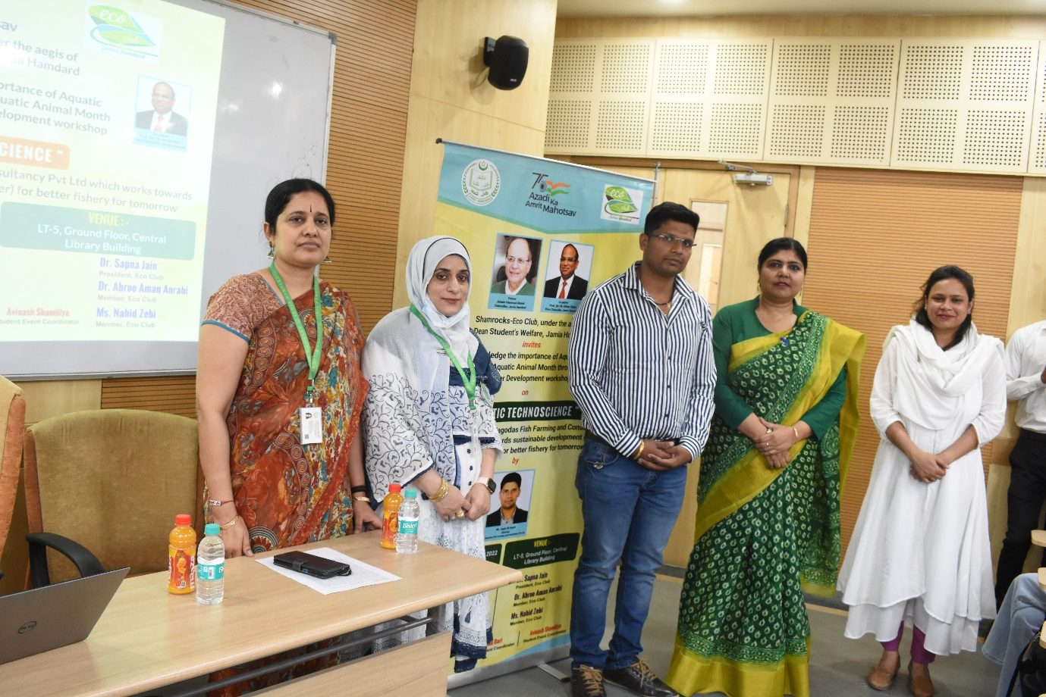
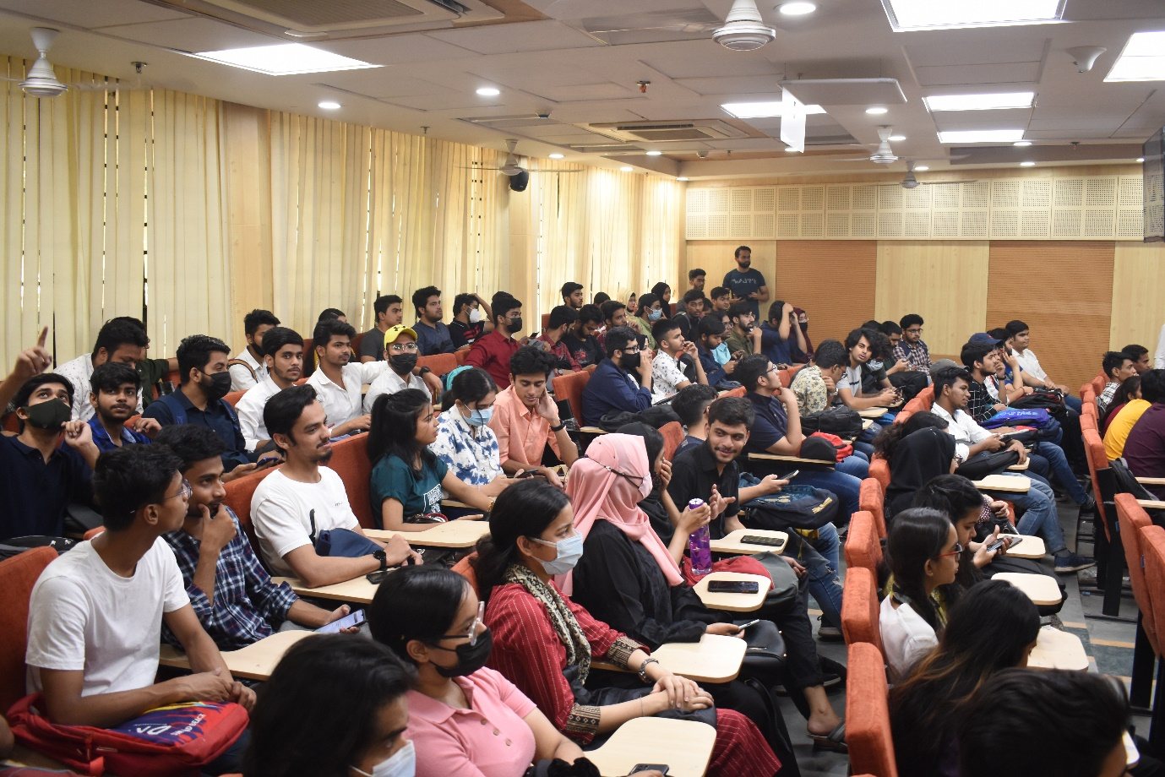
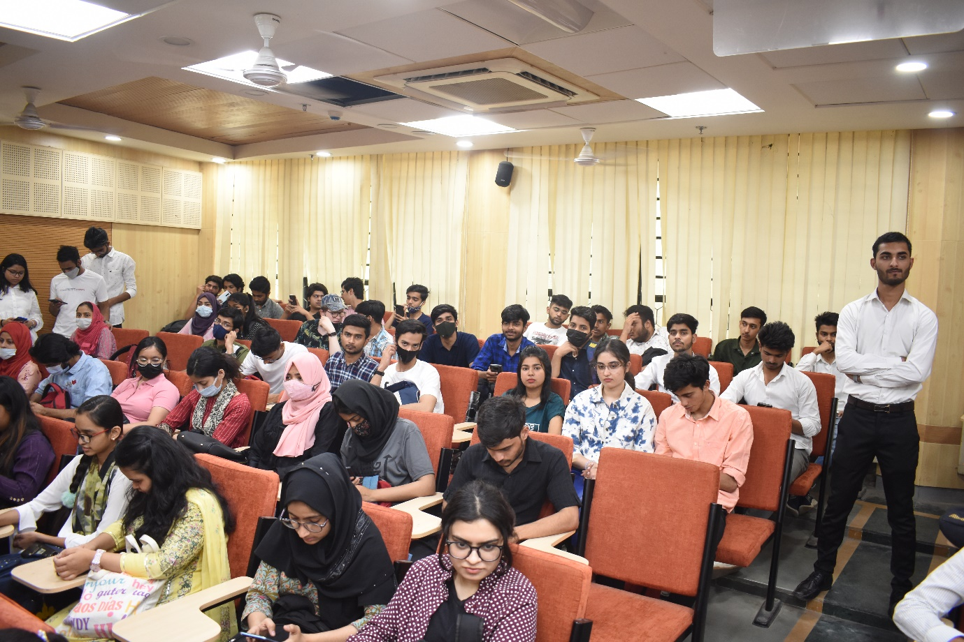
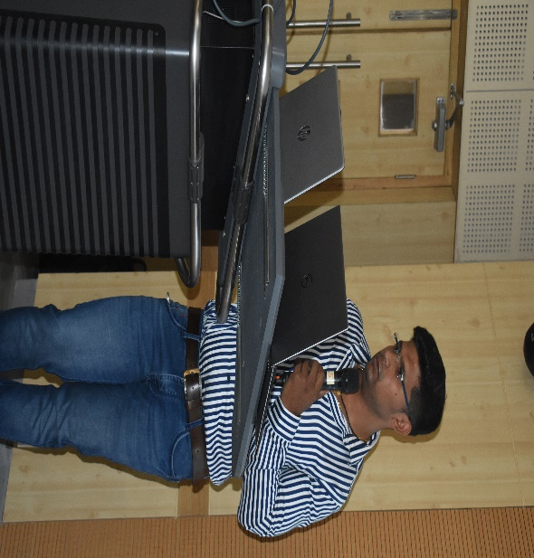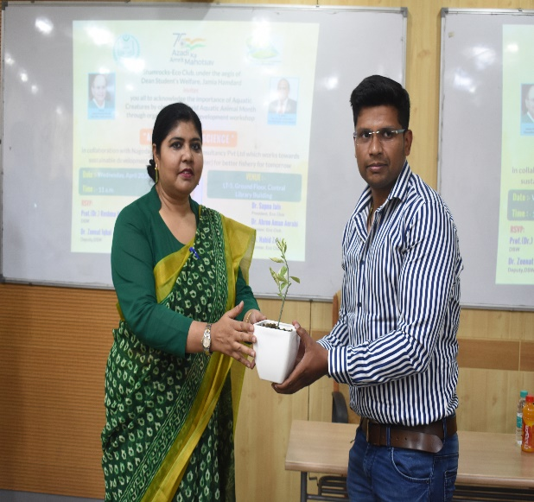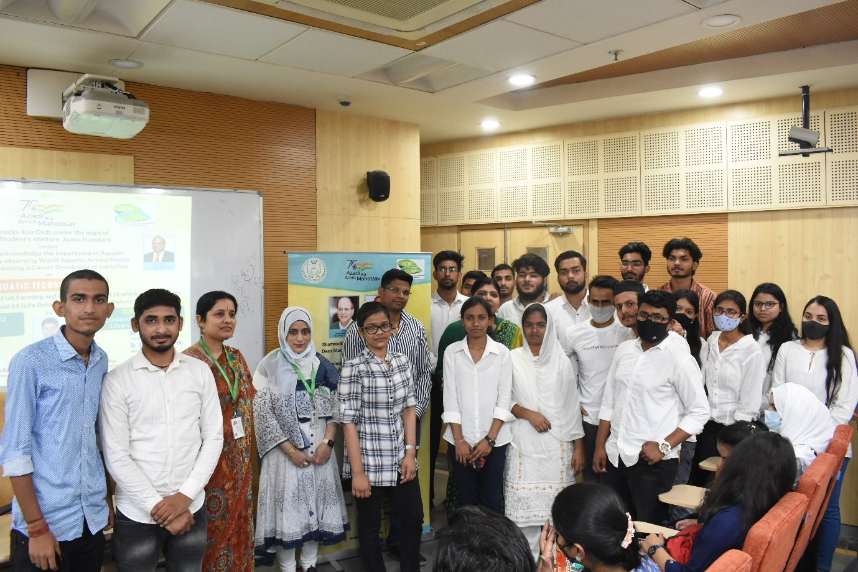

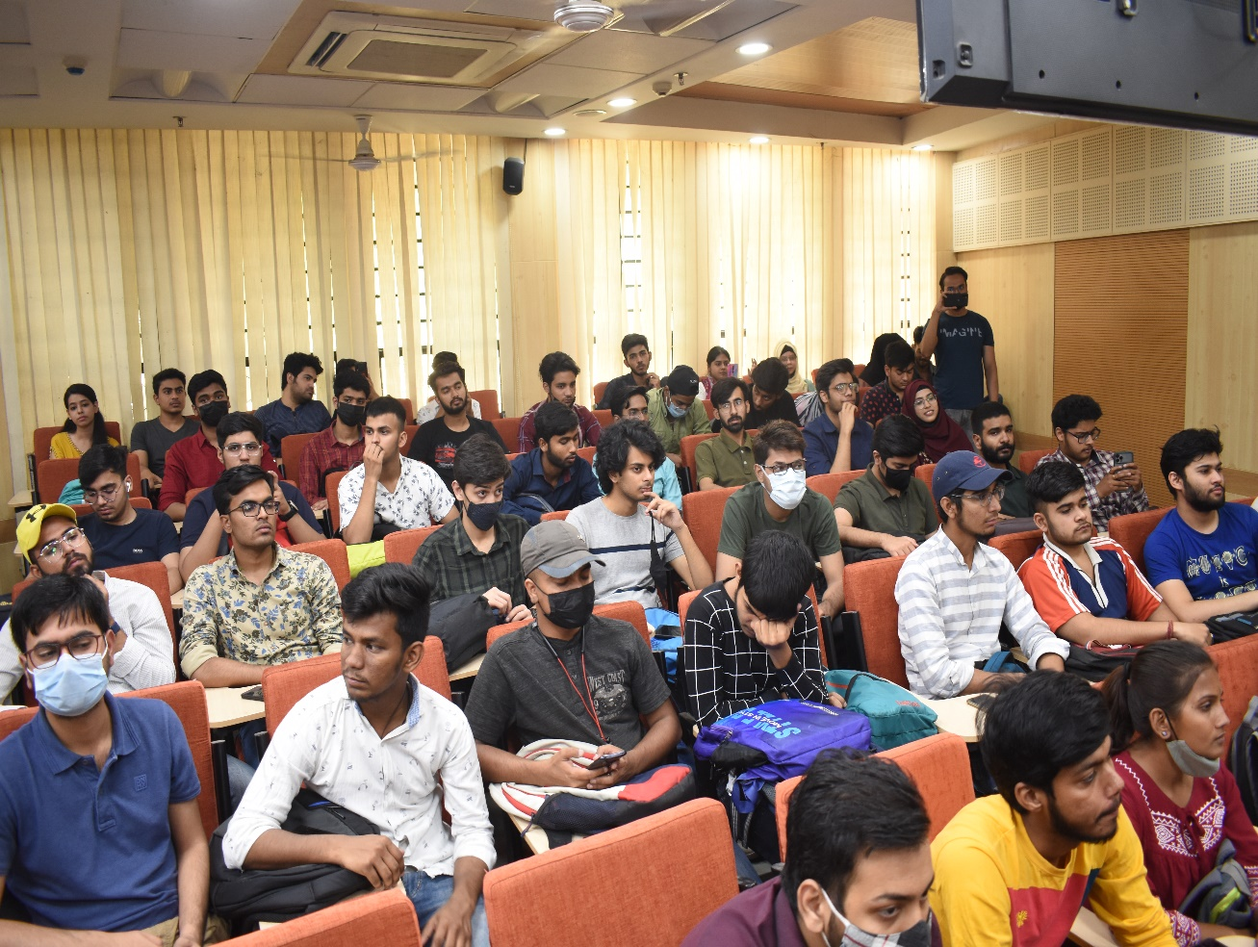
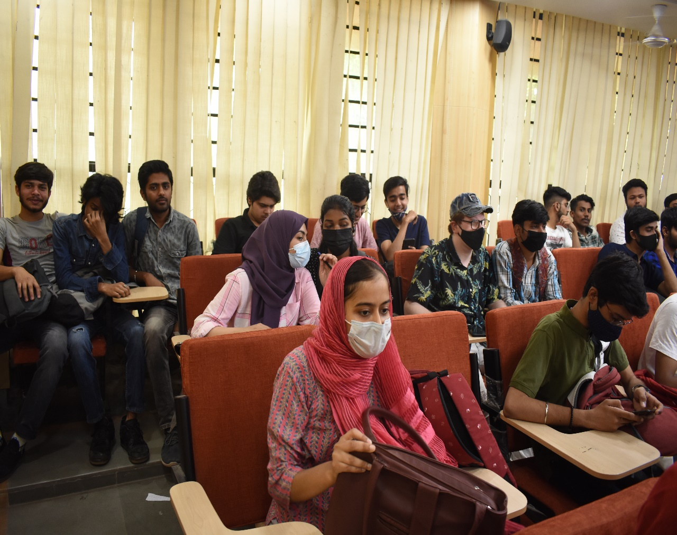

- ORIENTATION SESSION ON SOLID WASTE MANAGEMENT, 10th May,2022
Shamrocks, Eco-Club, under the aegis of Dean Student’s Welfare organised an Orientation session on Solid Waste Management in association with the Indian Pollution Control Association (IPCA) on May10,2022. Hon’ble Prof. (Dr.) M Afshar Alam, Vice Chancellor, Jamia Hamdard presided the session. Hon’ble Prof. (Dr.) M Afshar Alam, Vice Chancellor Jamia Hamdard in his presidential address discussed the issue of solid waste management in our midst to ensure that our environment and health are preserved. He motivated students to understand the importance of adopting eco-friendly practices for in their life for contributing towards sustainable development of the society. Prof. (Dr.) Reshma Nasreen, Dean Student’s Welfare in her welcome address highlighted the impact of applying 3R’s, Reduce, Recycle, Reuse in improving our economic and environmental growth of society. Dr. Zeenat Iqbal, Deputy, Dean Students Welfare in her ever-golden words very beautifully described that Islam also emphasized the importance of preserving the environment. This is indicated in the Quranic verses which urge humans to take good care of the environment. This is particularly so when humans themselves are created from one of the elements of the nature, which is soil. Dr Abroo Aman Andrabi, Member, Eco club introduced the speaker to the audience.

Mr Ashish Jain, Founder Director, IPCA took an interactive session with students to explain the importance of segregation of waste, its types and sources of solid waste. He presented a framework for understanding the linkages between poor solid waste management, exposure and associated adverse outcomes He sensitized the students about waste workers living and health conditions and adverse effect of the dumped waste landfills in the cities. Ms. Garima Kaushik, Expert Program and Partnership discussed the IPCA initiatives which will implemented in Jamia Hamdard for solid waste management and with the Eco Club students. Mr Ajay Garg, Secretory, IPCA in his motivational talk inspired students to be self-responsible to contribute to bring behavioural change among students, faculty, staff and society for segregation of waste and littering in Jamia Hamdard campus.

Dr. Sapna Jain, President, Eco Club in her concluding remarks explained how solid waste management is an integral component of actions for achieving at least 13 Sustainable Development Goals and their pertinent targets out of the 17 United Nations Sustainable Development Gaols and its impact on three sustainability domains: ecology, economy, and society. Ms. Nahid Zebi, Member, Eco Club delivered the vote of thanks and the event was wrapped up by the national anthem. With over 115 participants, the session was a successful in arousing curiosity, knowledge and new visions into their lives. With the aim to take one step closer to reduce the solid waste and to motivate the students to keep the surroundings green and clean this session is s starting point is to adapt good waste managing practices in the best way they can.

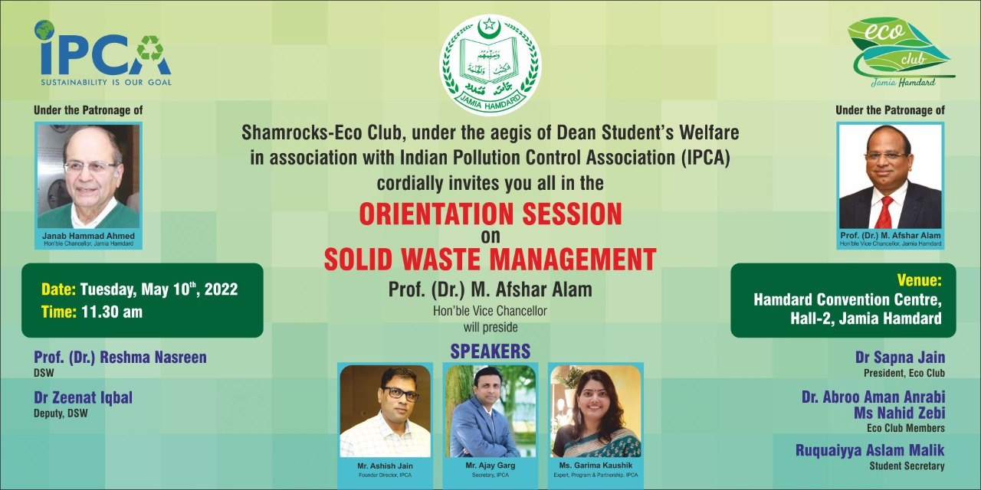

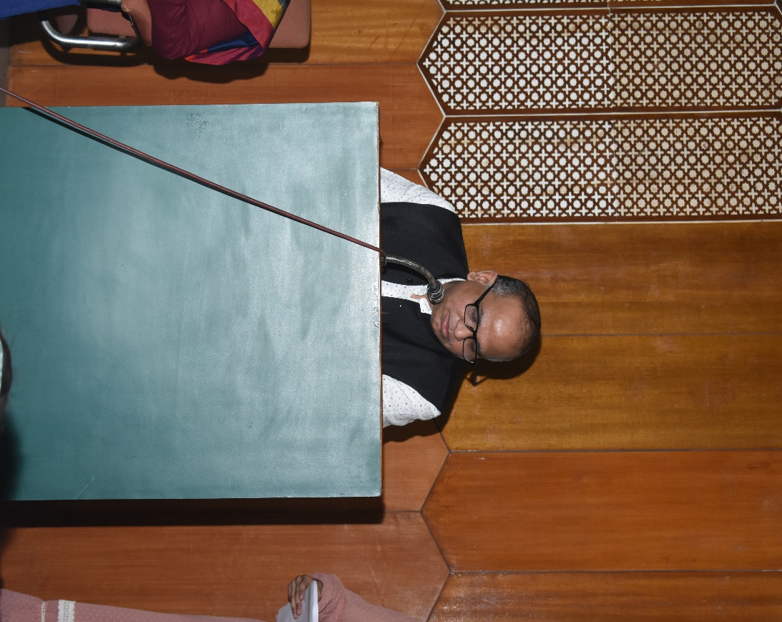

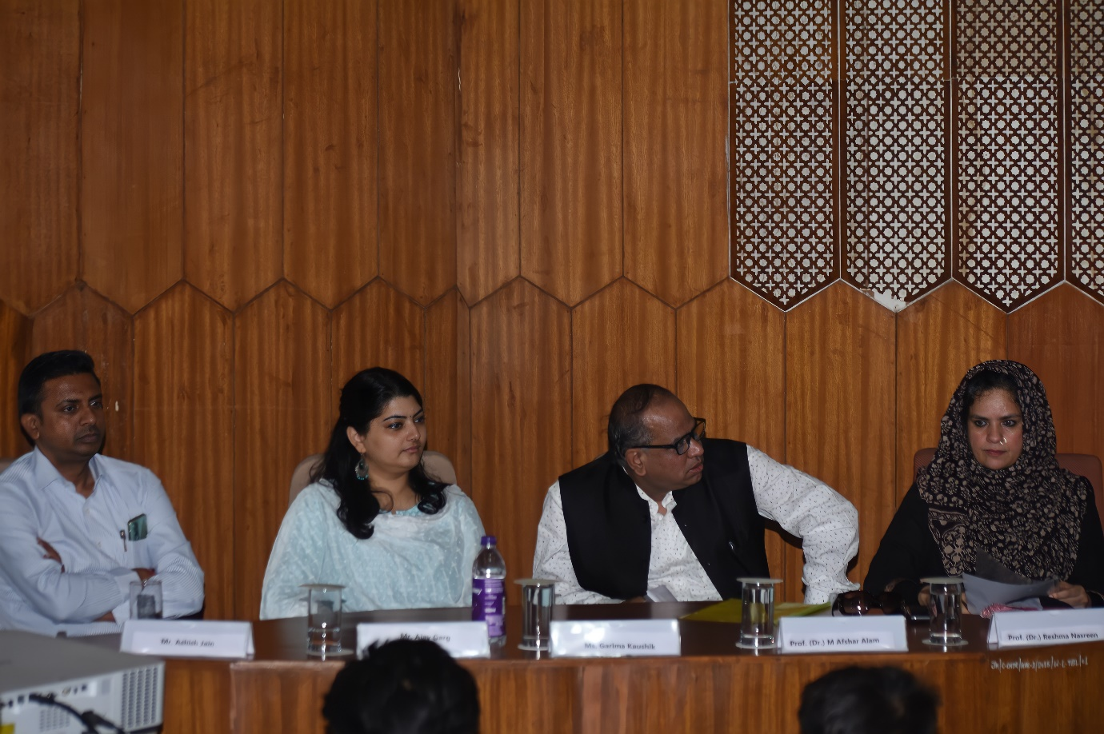
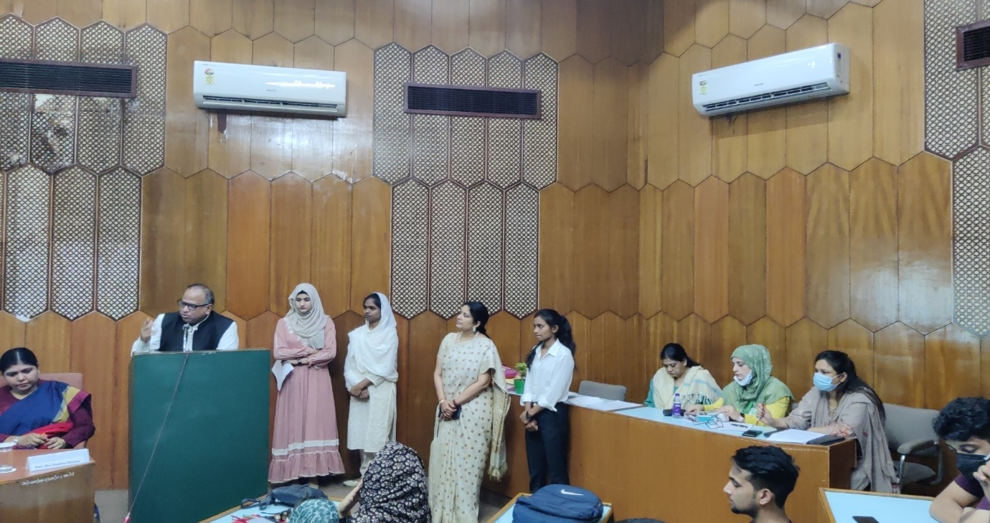

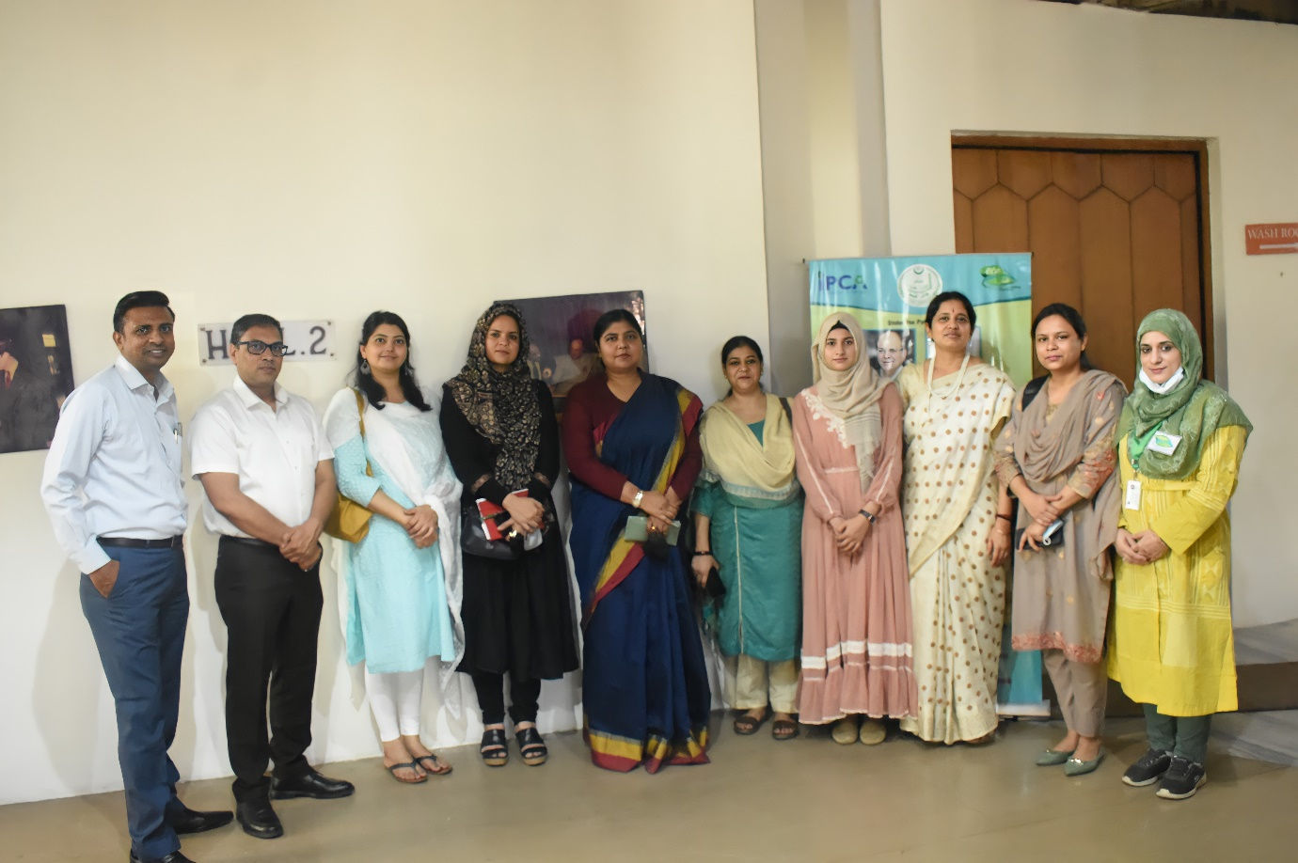
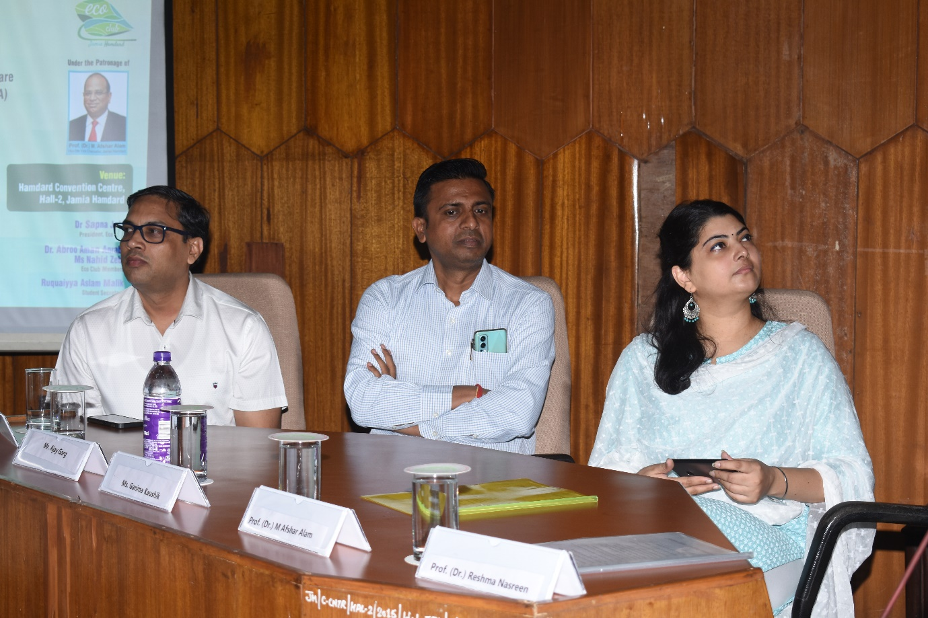

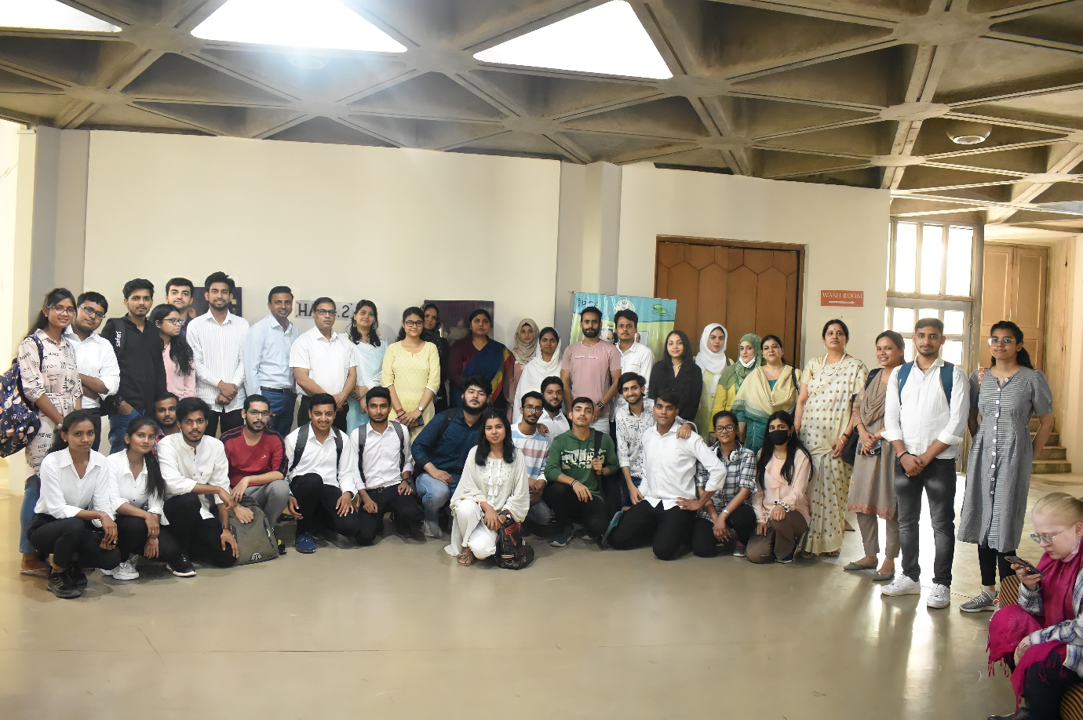

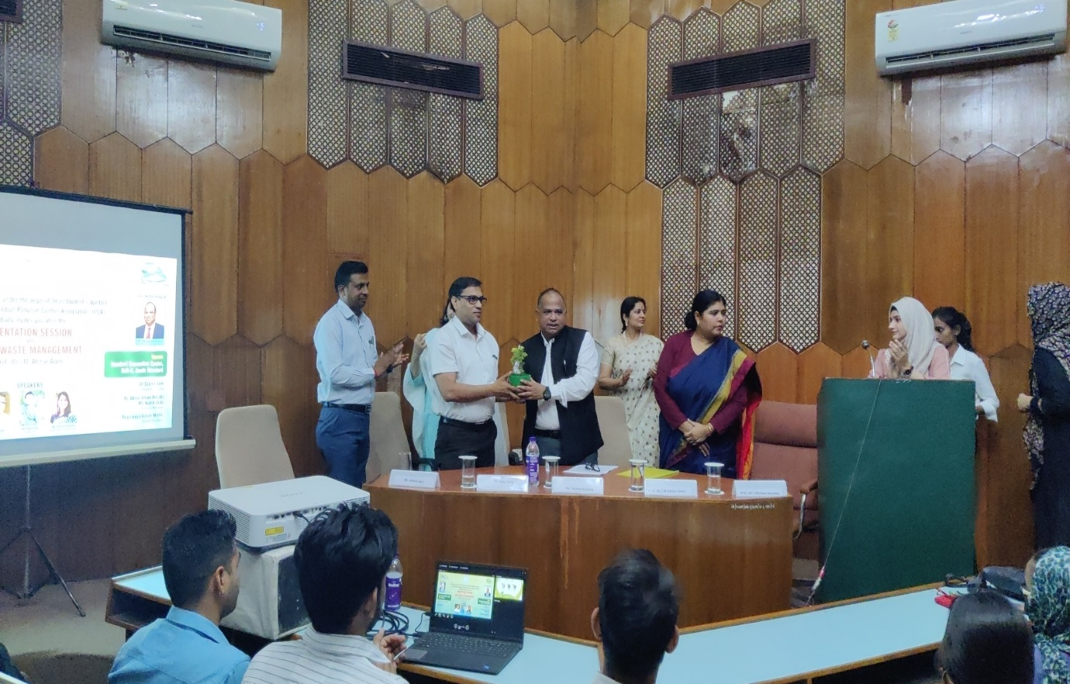
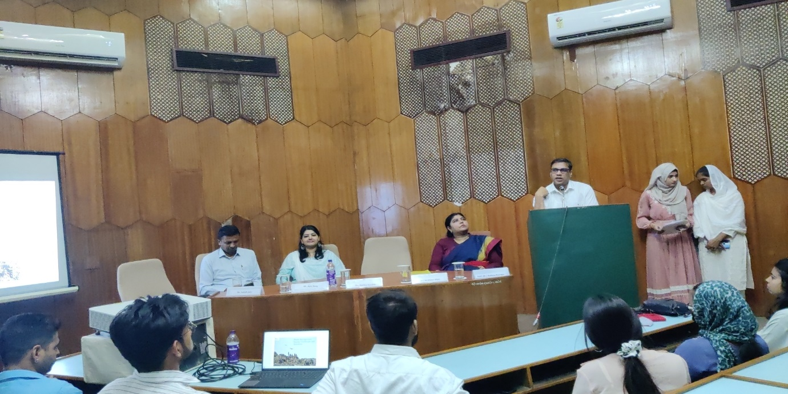
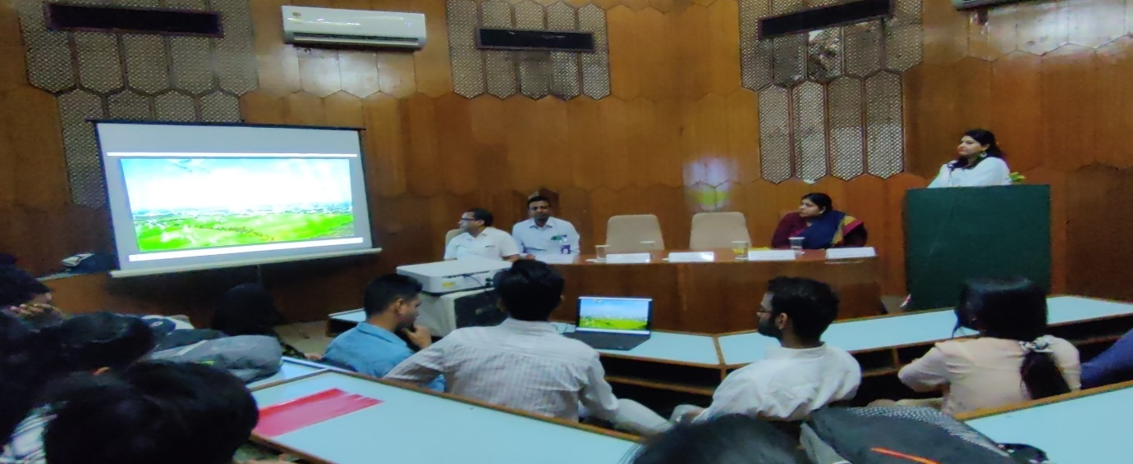
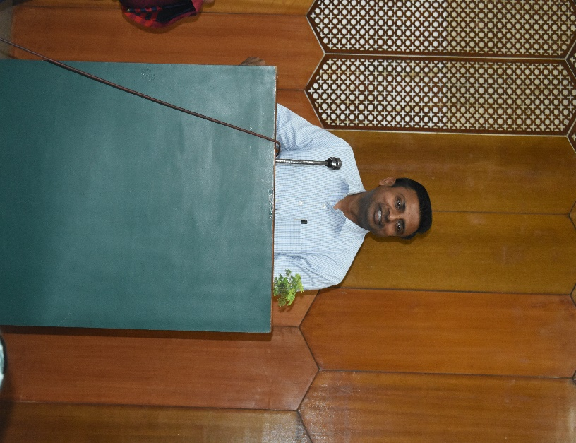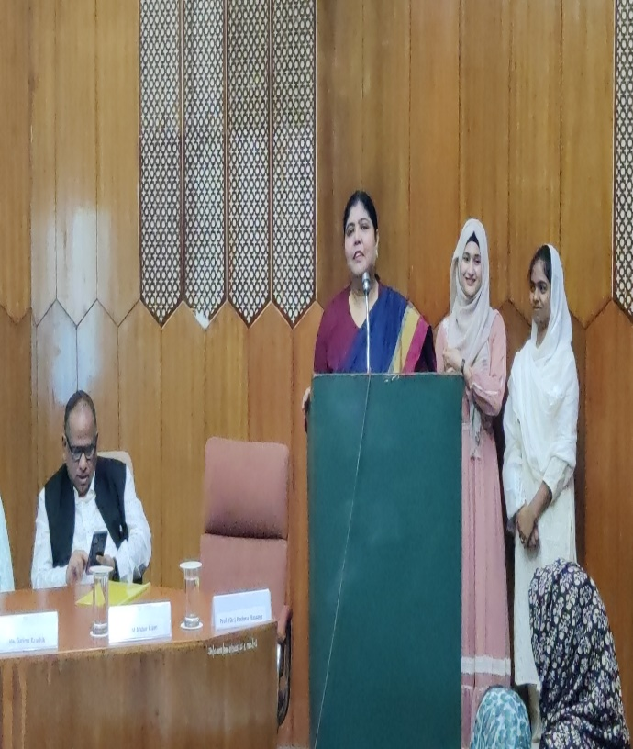
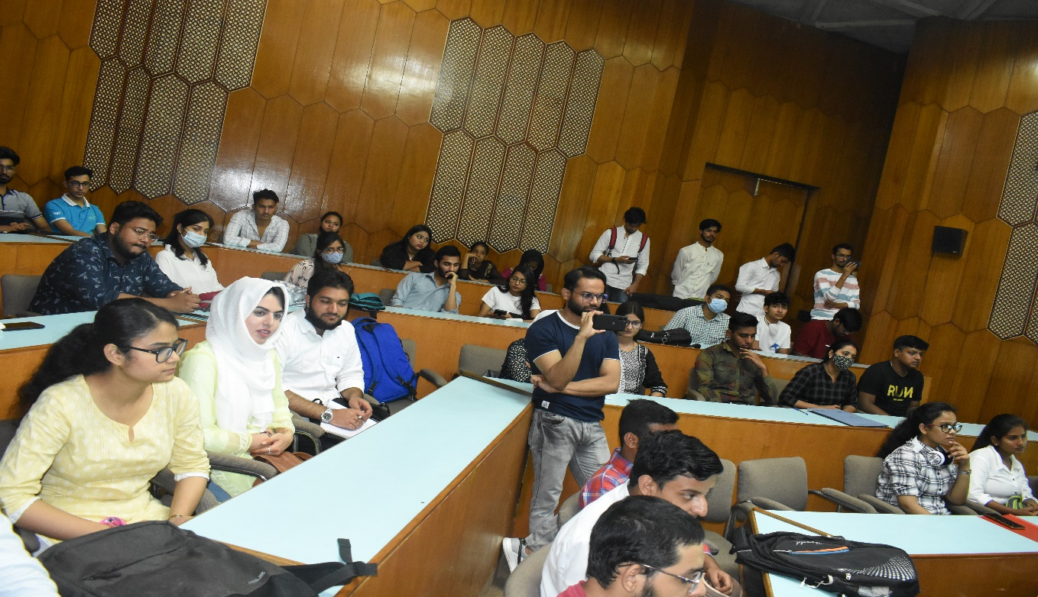
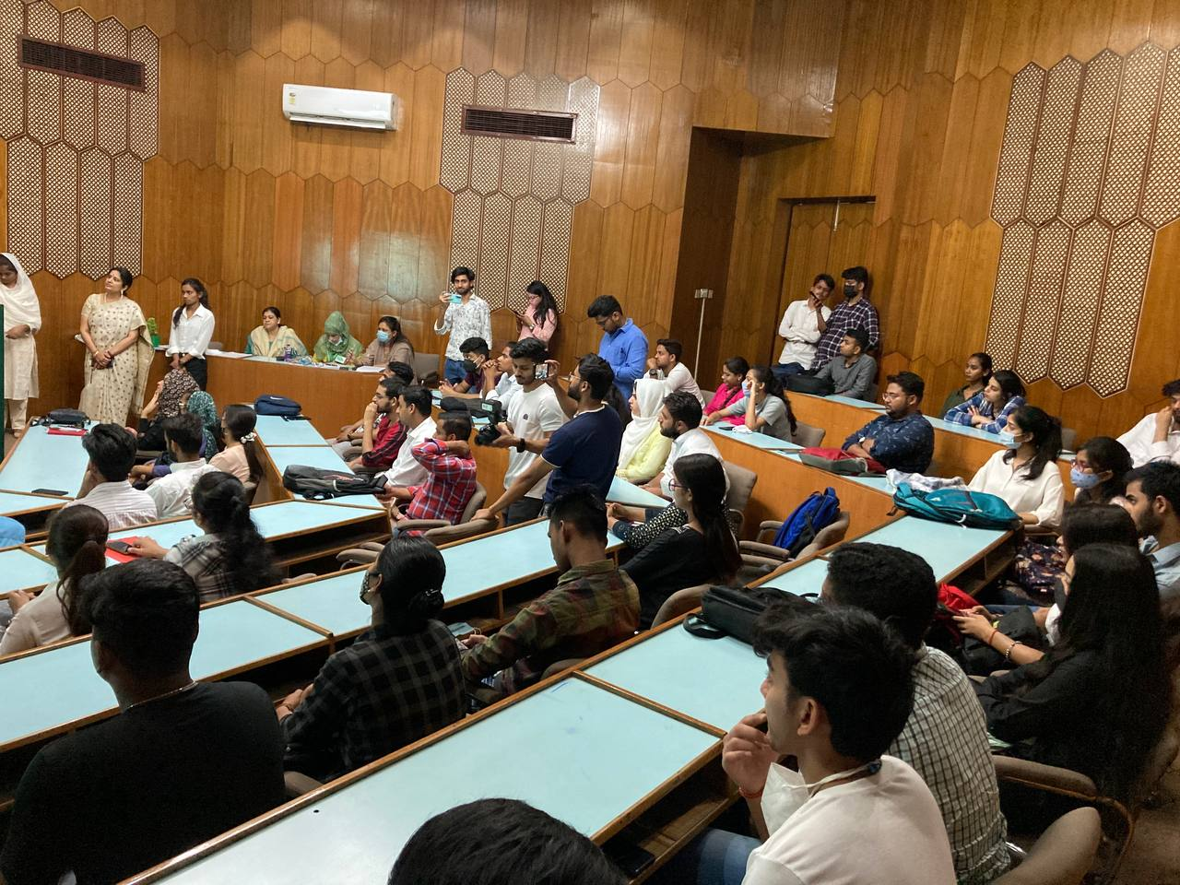

- WORLD ENVIRONMENT DAY, LAUNCH OF MY 10 KG PLASTIC CAMPAIGN, 2nd June,2022

On a World Environment Day,2022 theme #OnlyOneEarth # Shamrock, the eco-club of Jamia Hamdard under the aegis of Dean Student’s Welfare in collaboration with the Indian Pollution Control Association (IPCA) initiated a campaign to create awareness and drive innovation by encouraging all students, faculty, and staff towards reducing plastic waste pollution for contributing towards making a Jamia Hamdard a “PLASTIC FREE CAMPUS”. On 2nd June,2022 “My 10kg plastic campaign” by IPCA designed to create awareness on plastic waste collection and its segregation at the source and to stop littering and polluting the environment was started in the Jamia Hamdard Campus. The Eco club team and around 30 students from all the department in number collected the plastics waste and gathered near Herbal Garden, near administrative block to hand it over to the IPCA plastic waste collection vehicle which will be sent to respective recycling or co-processing unit. The students displayed slogans to sensitize the importance of plastic waste management and took pledge to take this campaign to each and every student and faculty member. “My 10kg plastic campaign” was initiated by IPCA in JULY 2019, under its CSR initiative with the support of EDMC. This was designed to create awareness on plastic waste collection and its segregation at the source and to stop littering and polluting the environment. With the students taking pledge to create and maintain strict and sustainable environment and to reduce, reuse and recycle plastic while promoting and contributing in reducing plastic waste., the campaign was a success in achieving the objectives. The participating students and the member of the organization were given an appreciation certificate for contributing for the benefit cause.

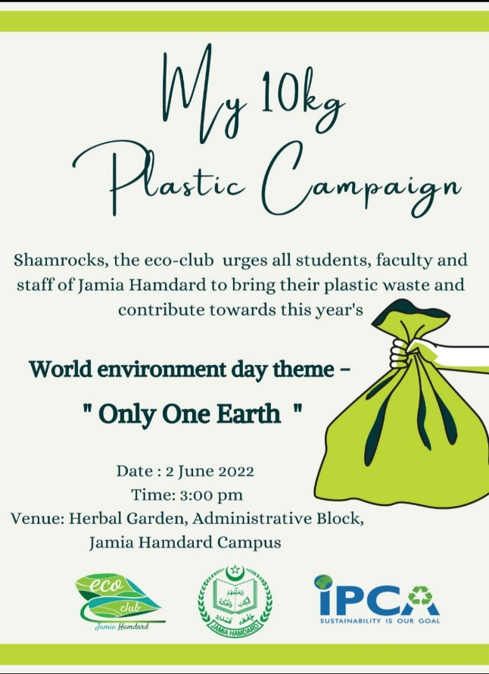
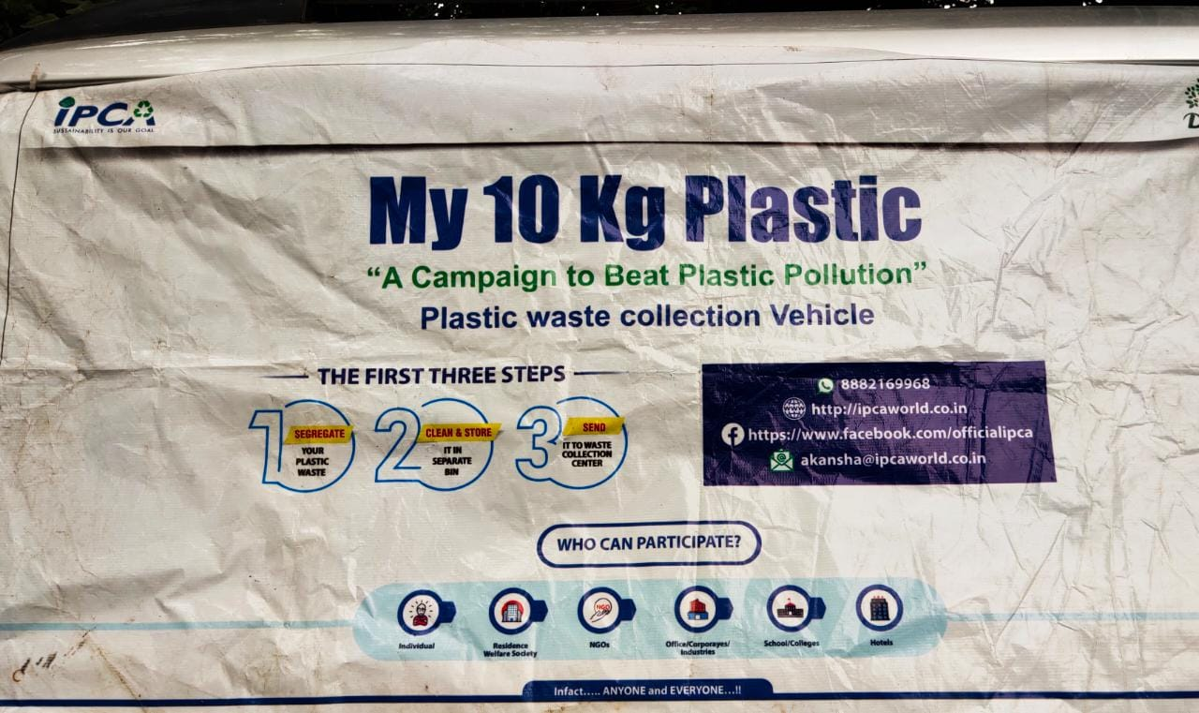
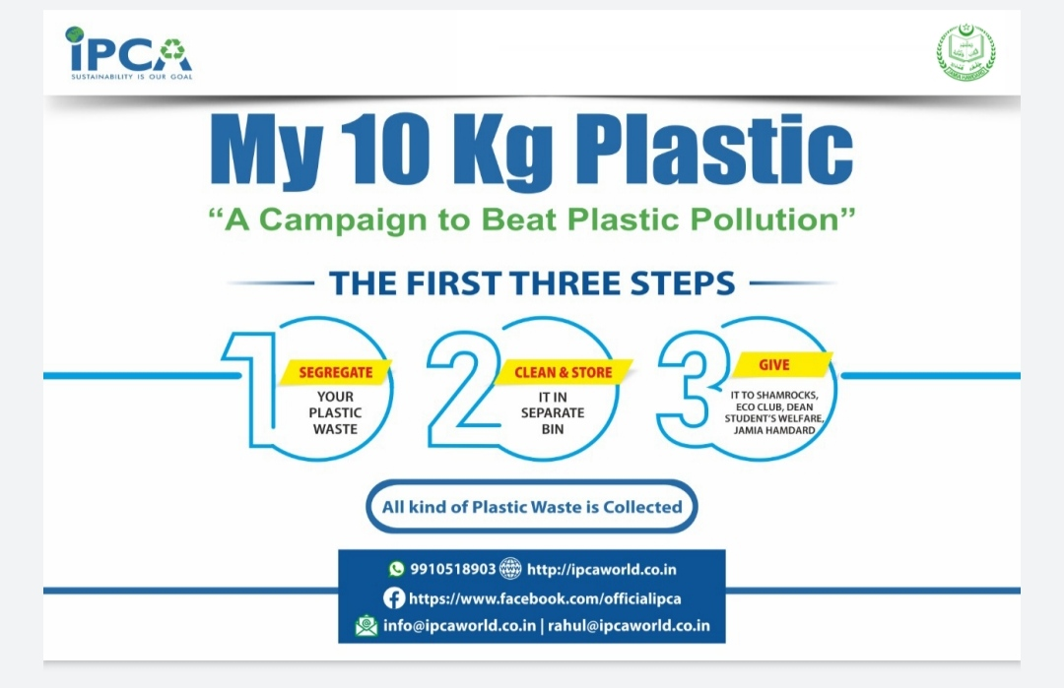
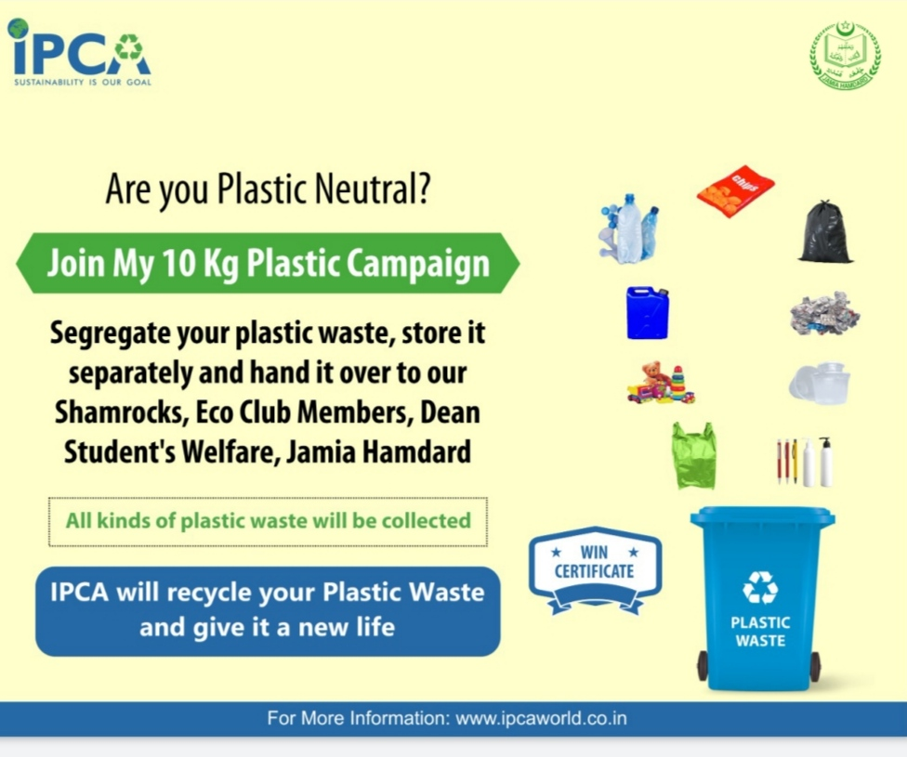

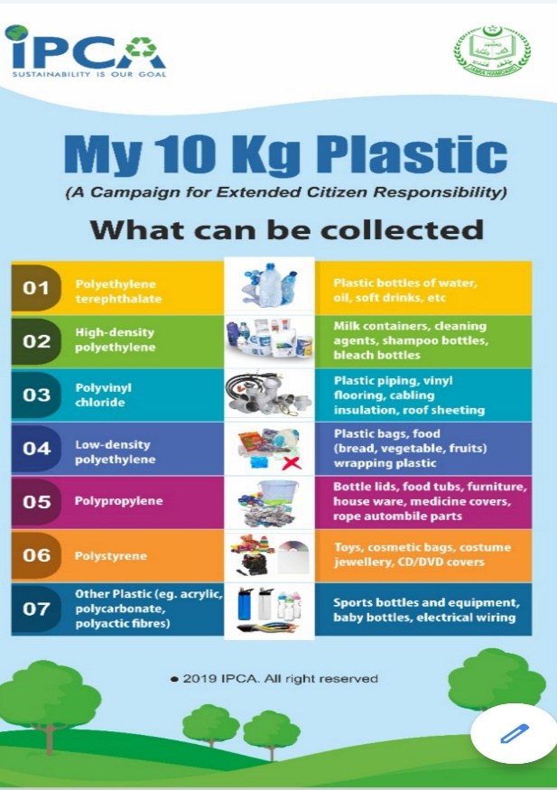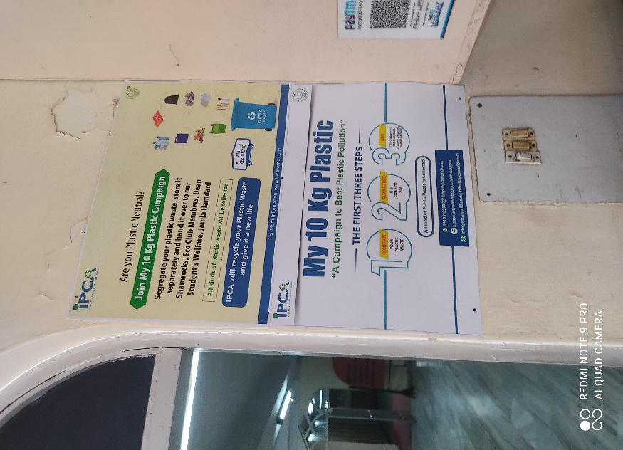

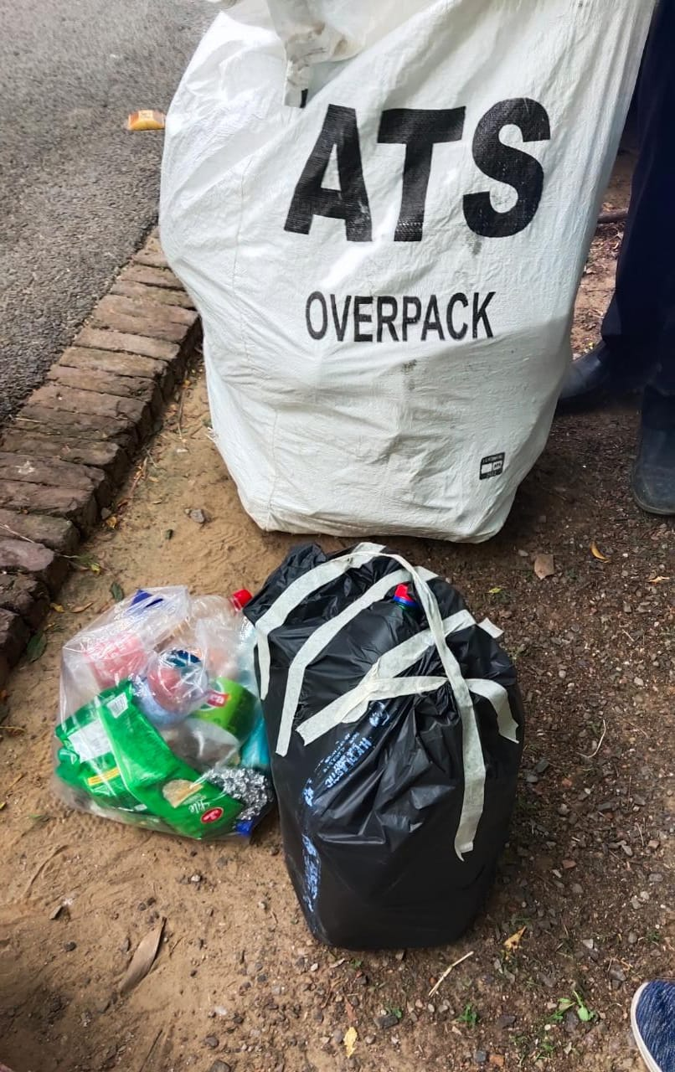
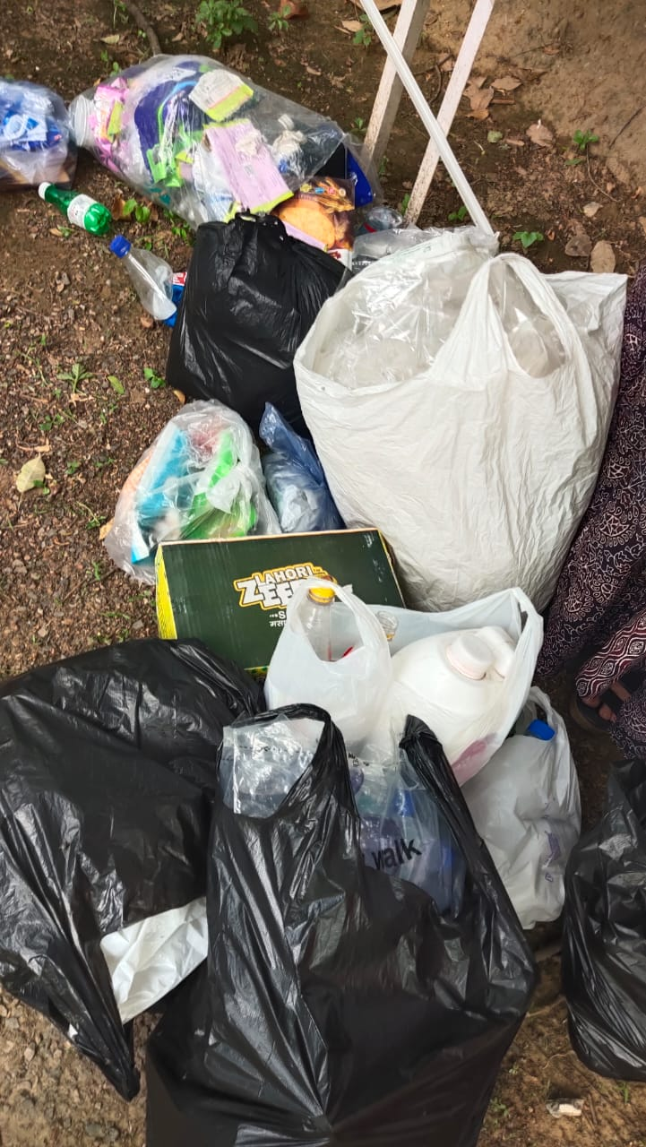

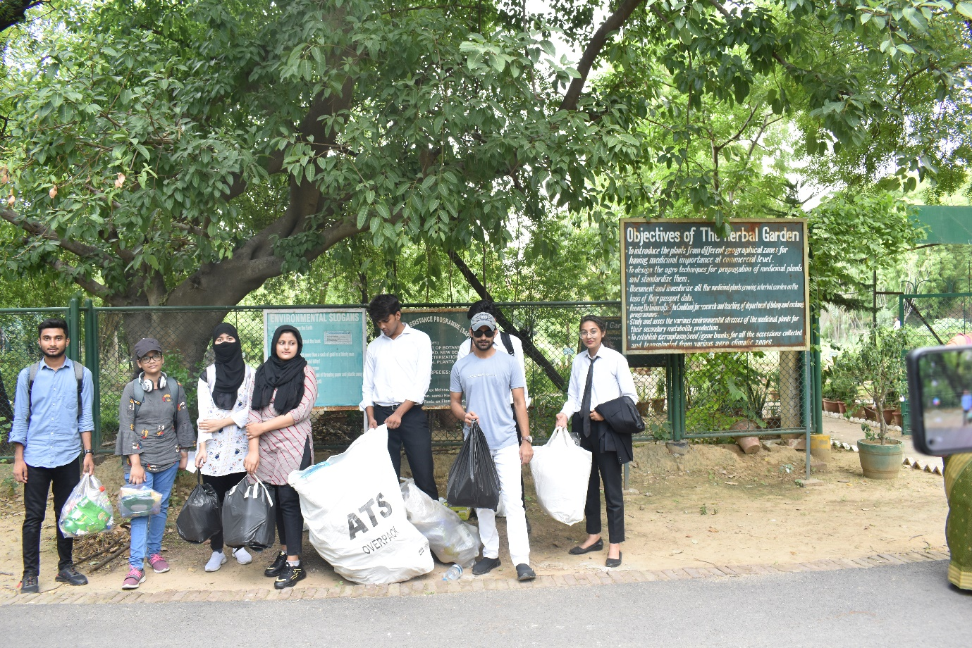
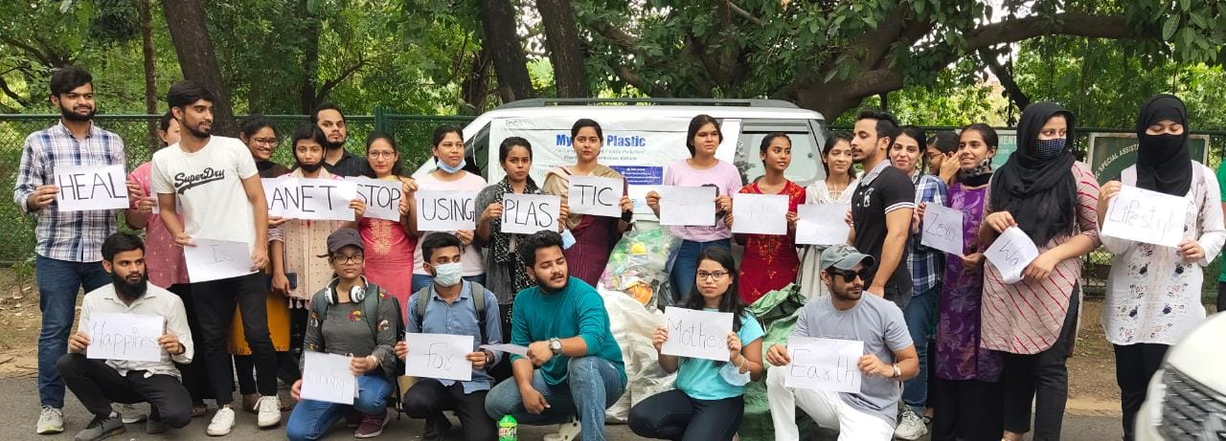
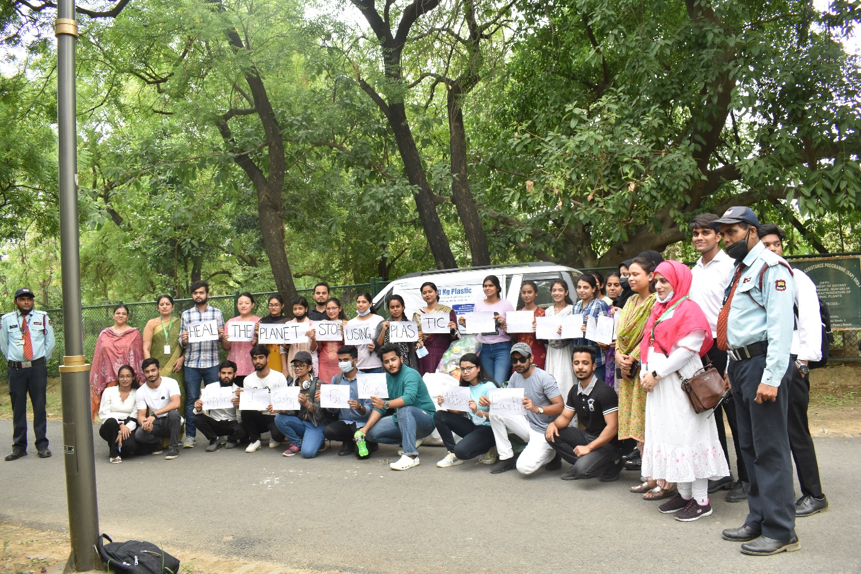

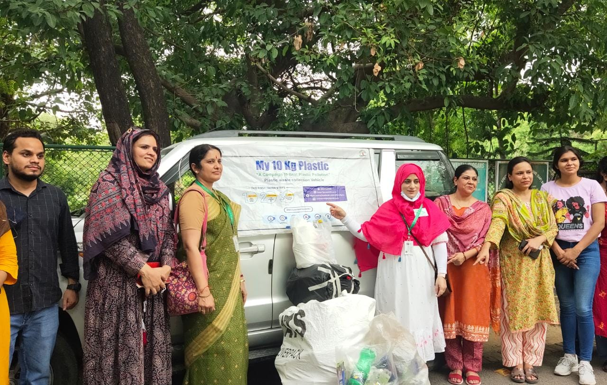

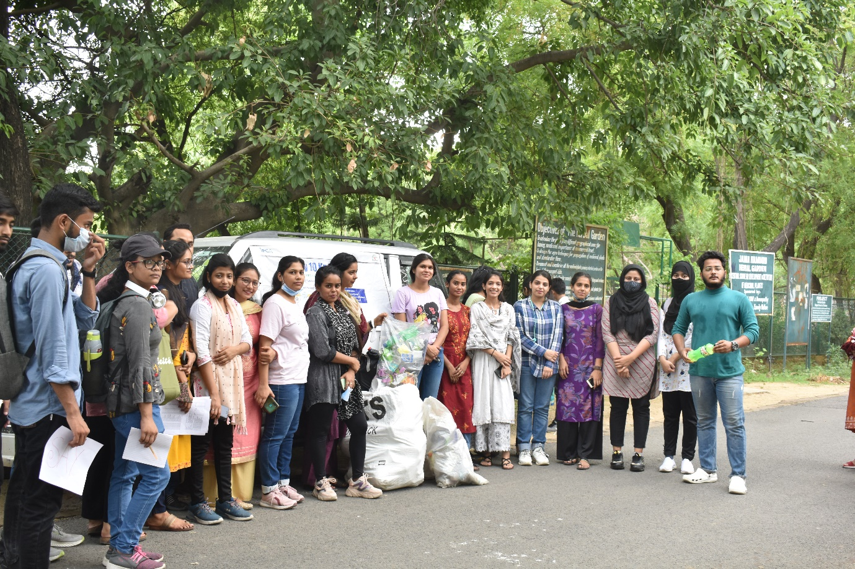
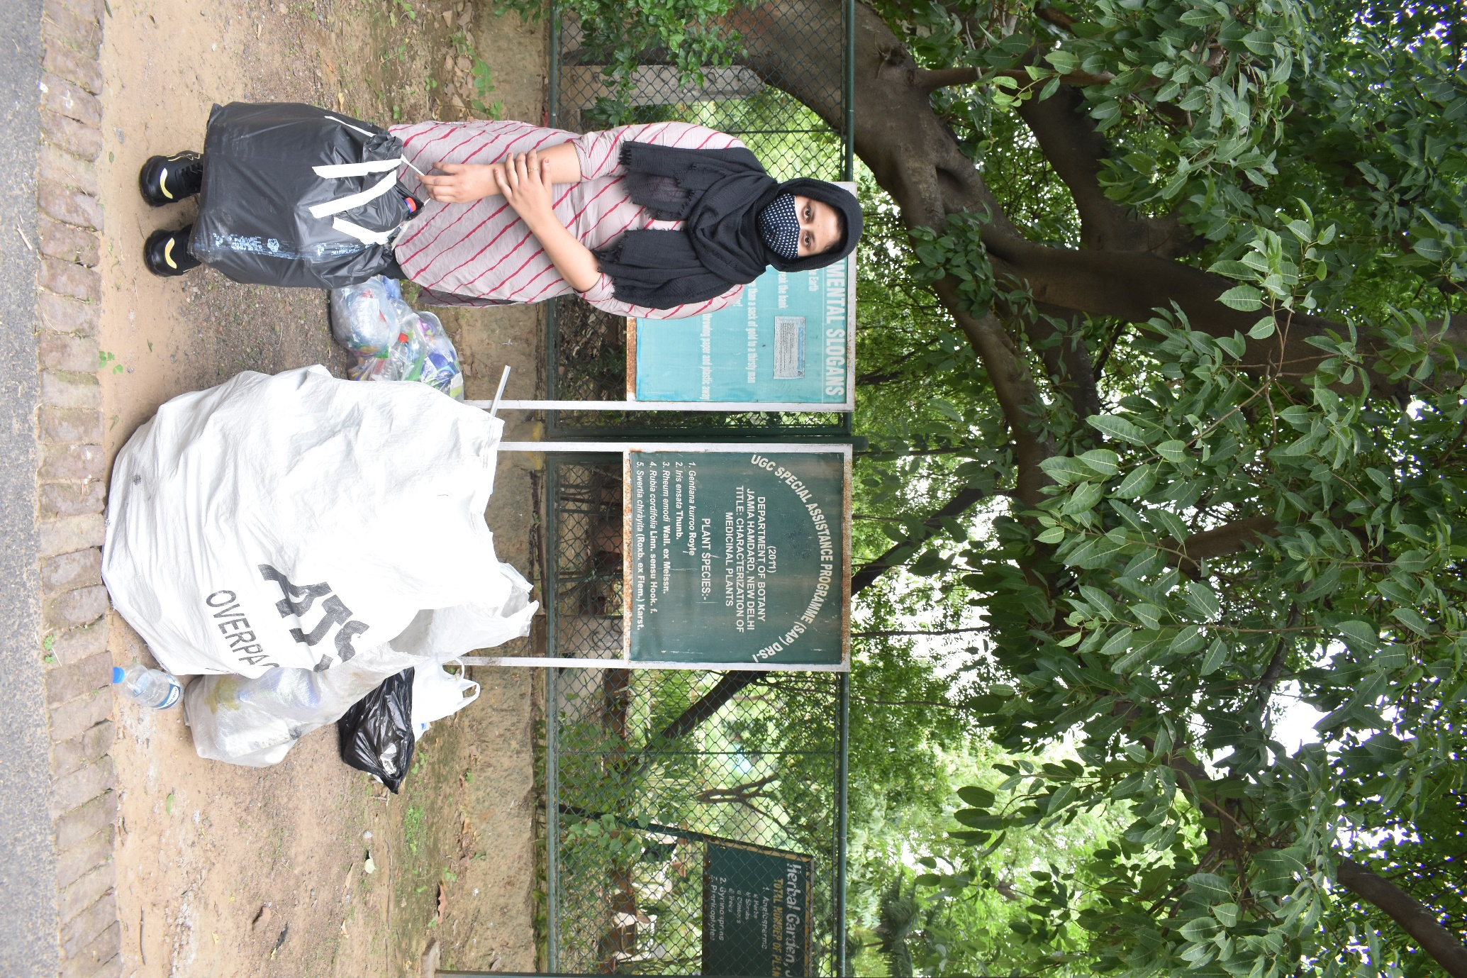

6)WORLD ENVIRONMENT DAY, AWARENESS WEBINAR ON “PLASTIC WASTE MANAGEMENT”, 4nd June,2022

On a World Environment Day,2022 theme #OnlyOneEarth # Shamrock, the eco-club of Jamia Hamdard under the aegis of Dean Student’s Welfare in collaboration with the Indian Pollution Control Association (IPCA) initiated a campaign to create awareness and drive innovation by encouraging all students, faculty, and staff towards reducing plastic waste pollution for contributing towards making a Jamia Hamdard a “PLASTIC FREE CAMPUS”. A webinar was held on 4th June,2022 by Ms. Garima Kaushik, Expert Program and Partnership, IPCA on “Plastic Waste Management”. The webinar was moderated by Ms. Ruqaiyya Aslam Malik, Student Secretary, Eco Club and Ms. Kritika Jain, Student member, Eco Club. The session began with the holy Quran recitation by Md. Mustufa Adil. Dr. Reshma Nasreen, Dean Student’s Welfare in her welcome address inspired the students to understand the importance of plastic waste management and act as a crusader to bring change in campus and society. Ms. Mikki Khan, Vice President, Eco club in her opening remarks explained the historical background about the observation of world environment day all over the world.
Ms. Garima Kaushik in her insightful interactive presentation sensitized the participants that plastic waste generation is estimated to increase to 31.4 million by 2031 and its harmful effects on aquatic animals, human beings and society. She discussed the approaches, plastic waste management rules, initiatives, alternatives to single use plastic (SUP), consequences of plastic waste, ban of SUP items and its alternatives and 'My 10 Kg Plastic' Campaign implementation guidelines in Jamia Hamdard campus. Dr. Abroo Aman Andrabi, Member, Eco club took question-answer session where students asked their queries and discussed their viewpoints and put forth their suggestions for methods which can be adopted to bring behaviour change regarding the management of the plastic in society. Dr. Sapna Jain, President, Eco Club in her concluding remarks urge the students to observe every day of the year as Environment Day by practicing the segregation of plastic waste in their life and motiving other to do it and become the agents of change for the sustainable development of society. Ms. Mikki Khan Member, Eco Club delivered the vote of thanks and the event was wrapped up by the national anthem. The students showed inquisitiveness and enthusiastically participated throughout the session. With the students taking pledge to create and maintain strict and sustainable environment and to reduce, reuse and recycle plastic while promoting and contributing in reducing plastic waste to address the root cause of the plastic pollution, the events conduction for the celebration of environment day was of a journey of thousand miles beginning with a single step to help make this EARTH better place to live in.
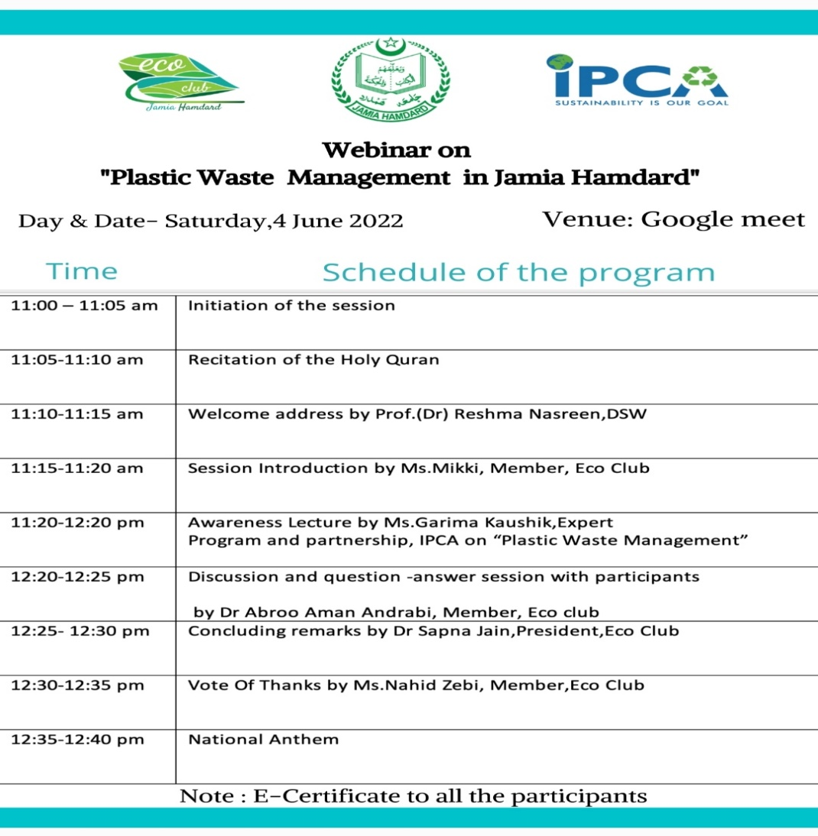

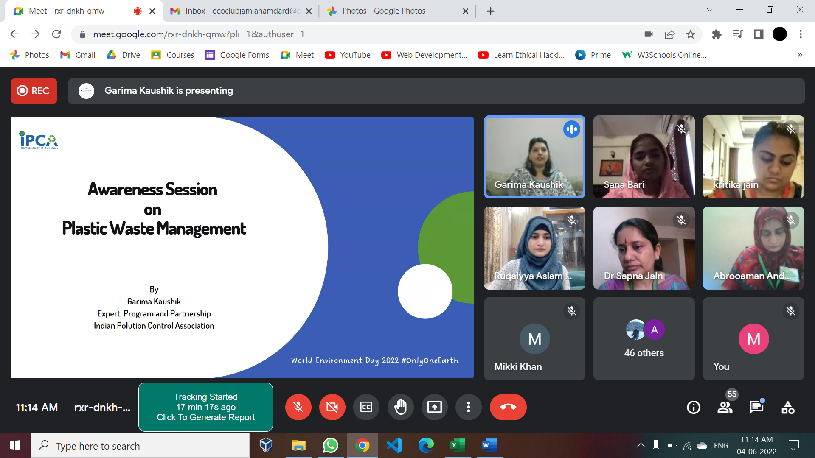
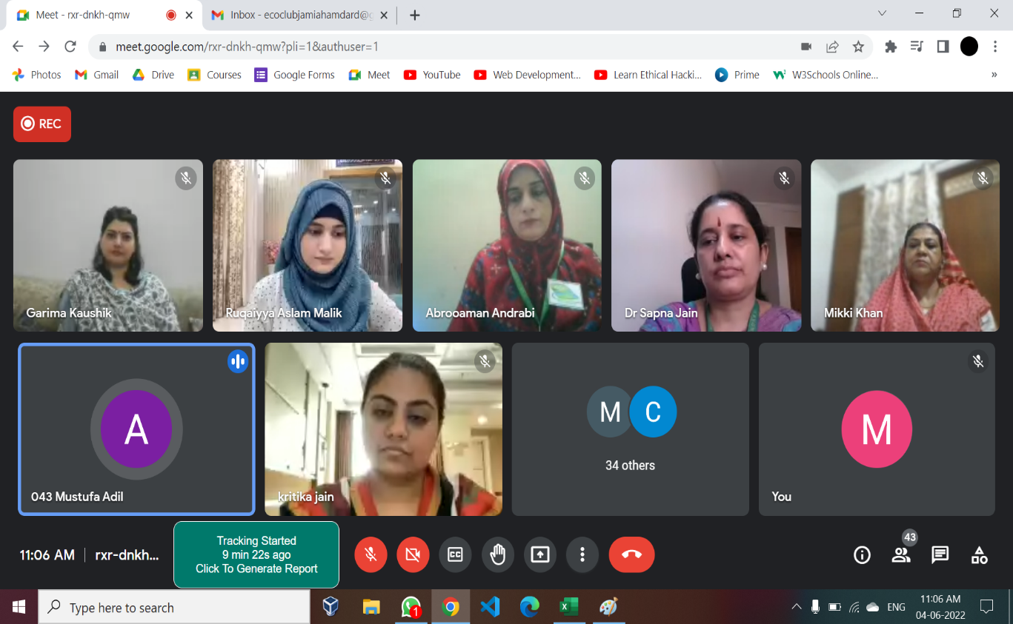

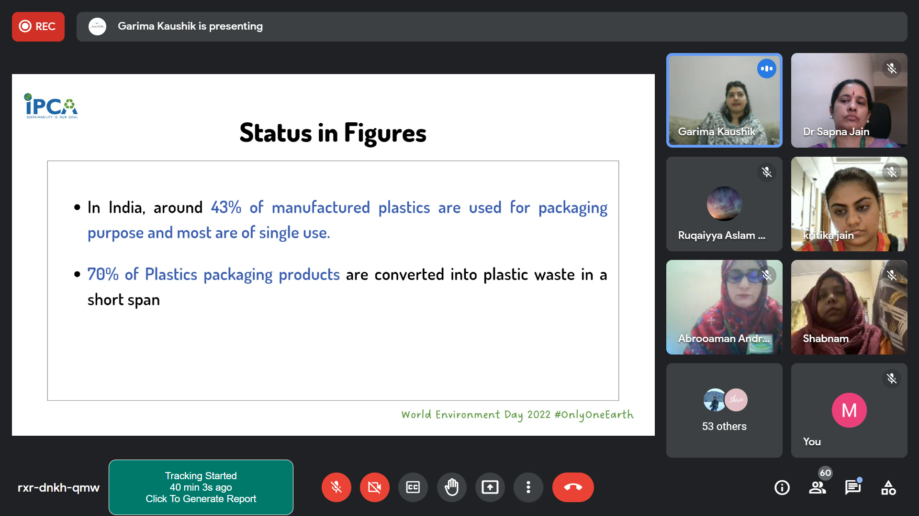

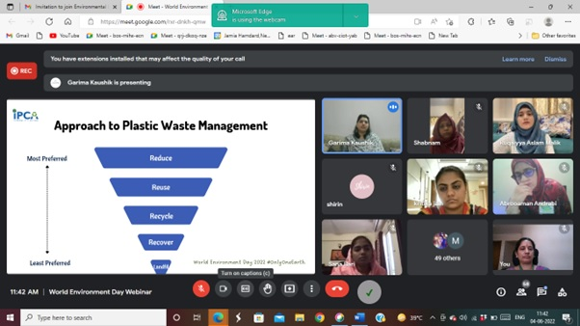
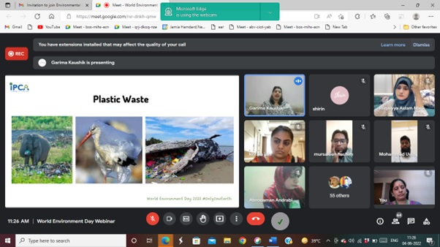
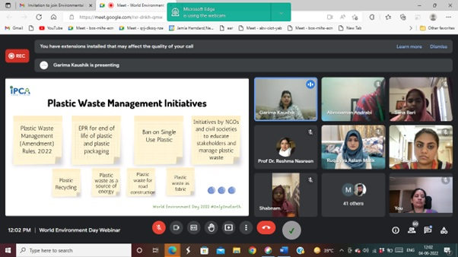

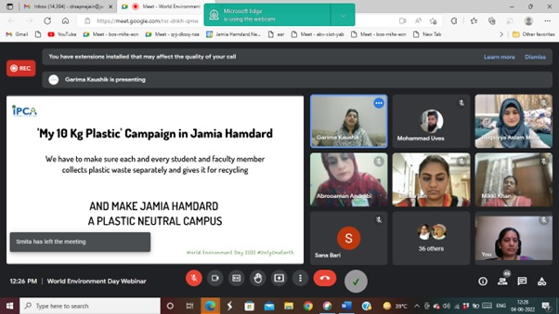
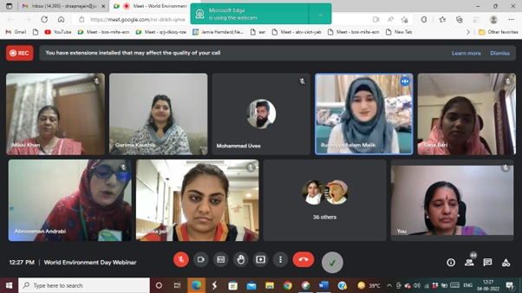
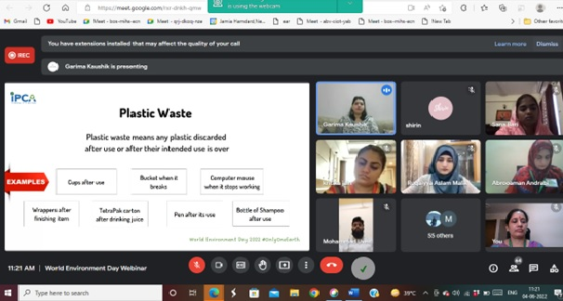
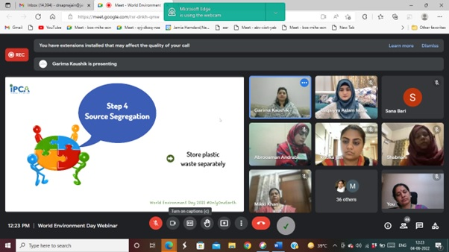

7)WORLD ENVIRONMENT DAY, ENVIRONMENTAL LITERACY PROGRAMME - ZERO WASTE LIFE STYLE, 2nd and 3rd June, 2022

On the occasion of World Environment Day 2022 campaign, #OnlyOneEarth, Shamrocks Eco Club, Dean Students Welfare team participated in the two webinars on “Environmental Literacy Programme - Zero Waste Life Style” organised by The Association of Indian Universities (AIU) in collaboration with Delhi State Legal Services Authority (DSLSA) on 2nd and 3rd June 2022. Dr. Pankaj Mittal, Secretary General, AIU is her address laid stress on students’ involvement in spreading awareness about environment conservation to contribute towards 17 Sustainable Development Goals. She said in universities the undergraduate and postgraduate students who plant trees, participate in environment conservation activities should be awarded with Green Degree. Sh. Bharat Parashar, Member Secretary, DSLSA discussed about importance of environmental legal literacy and urged everyone to use free legal aid helpline no 1516 entitled under section 12 Act and spread awareness about it to every citizen of Delhi .Sh. Sushant Changotra. Additional Secretary, DSLSA inspired everyone to adopt 4R’s Refuse, Reduce, Recycle and Reuse principle in their life by using sustainable practices for minimizing the harmful effect of solid waste in the society. Dr Alok K Mishra discussed the contribution of 900 universities working with AIU towards SDG goal 13 for minimizing carbon footprints by adopting eco-friendly measures. Dr. Sudhakar Gaikwad, Delhi Directorate of Education, Science Branch discussed that guidelines and action plan for mass plantation to schools and colleges prepared by DDE is in implementation phase. Mr Rohit Mishra, Additional Commissioner Income Tax Amritsar who is also known as Green Man of Punjab in his talk urged everyone to back to roots and use traditional knowledge practices in their daily life. Mr. Shivam Gupta, Project coordinator, Sahaas NGO in his presentation discussed about steps to zero waste living through home composting, making of bio enzymes, segregating waste, carrying my go-to kit, saying no to fast electronics, fast fashion and use reusable items. Around 40 shamrocks team members attended the webinar. The webinars were attended by Vice-Chancellors, professors, faculty, staff students of colleges and schools in Delhi, NCR region.

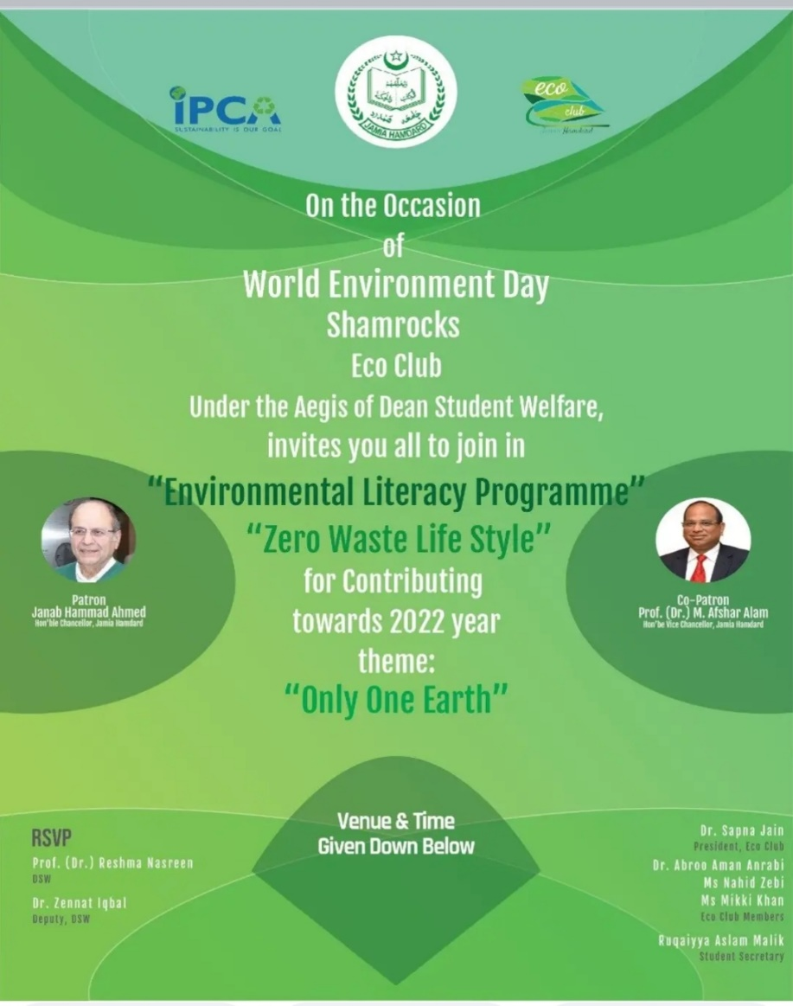

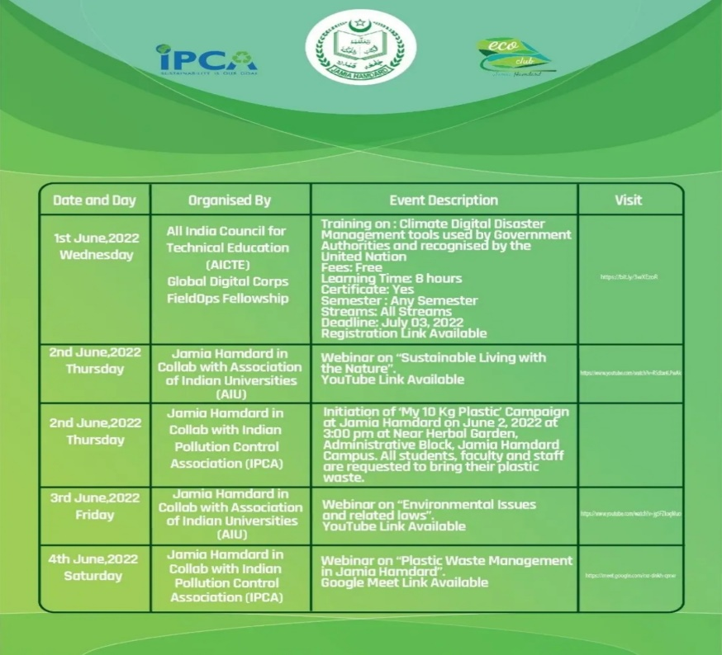

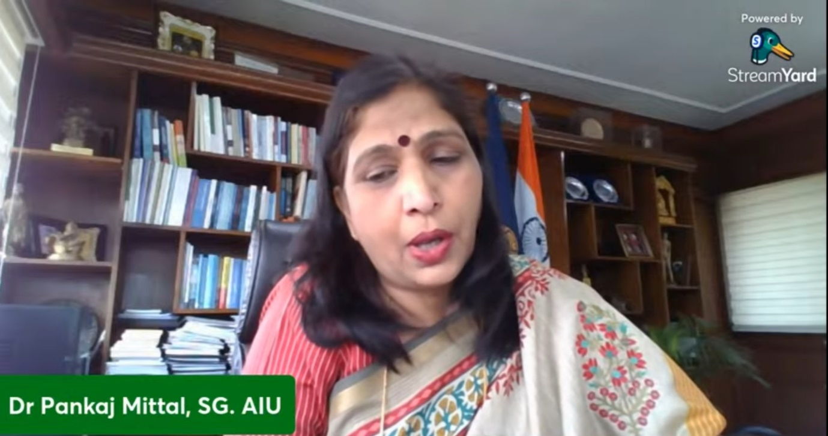

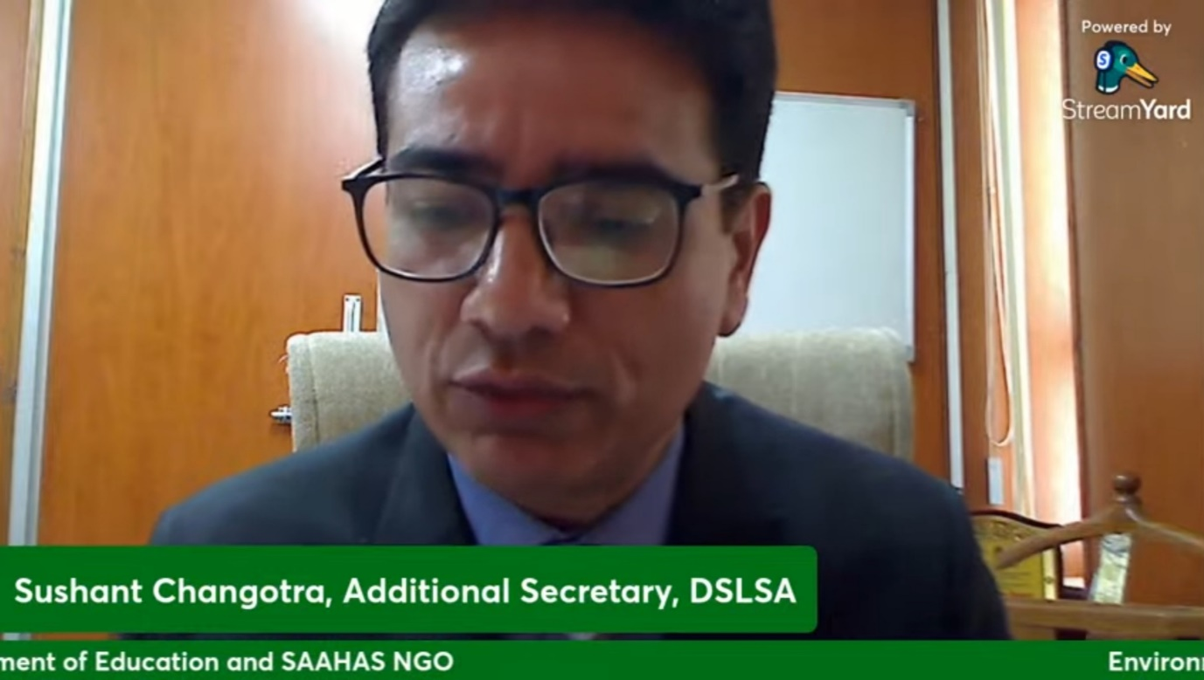

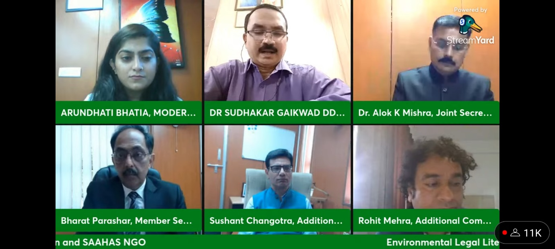

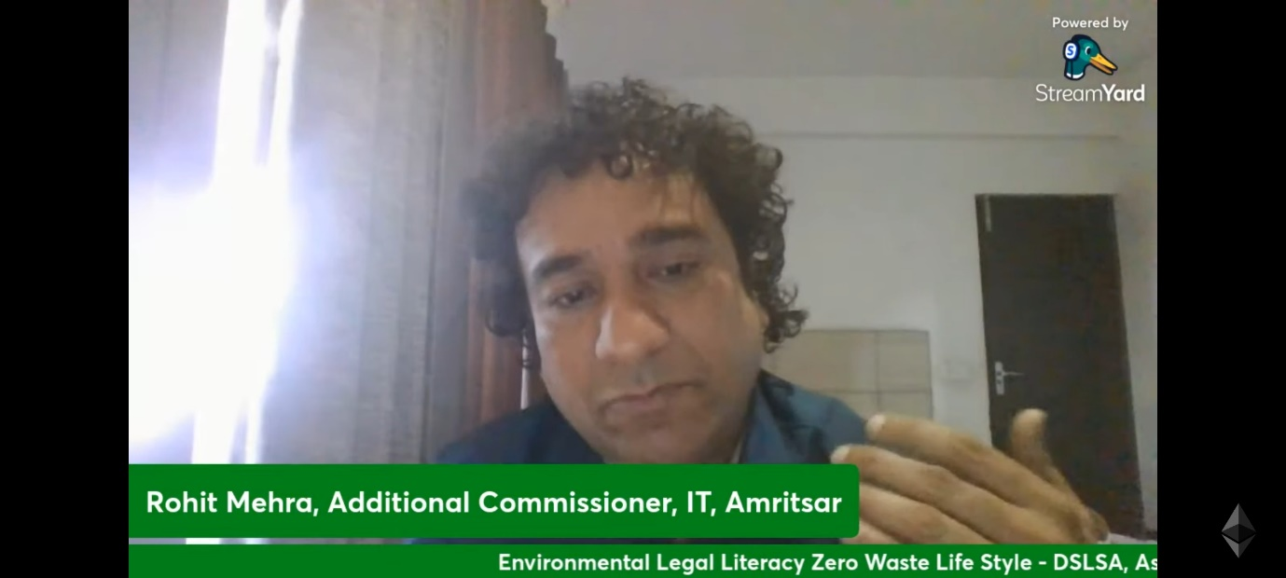

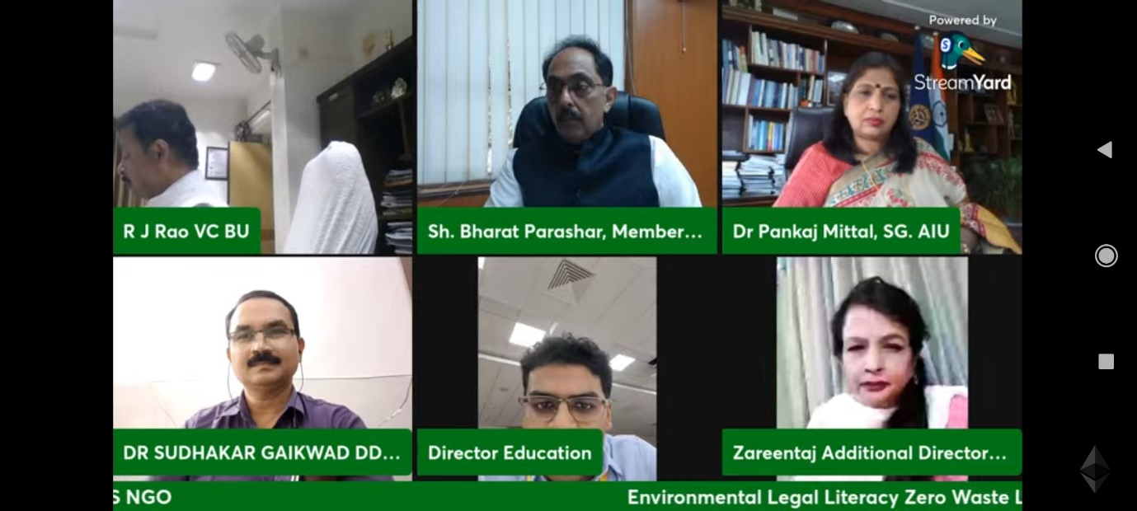

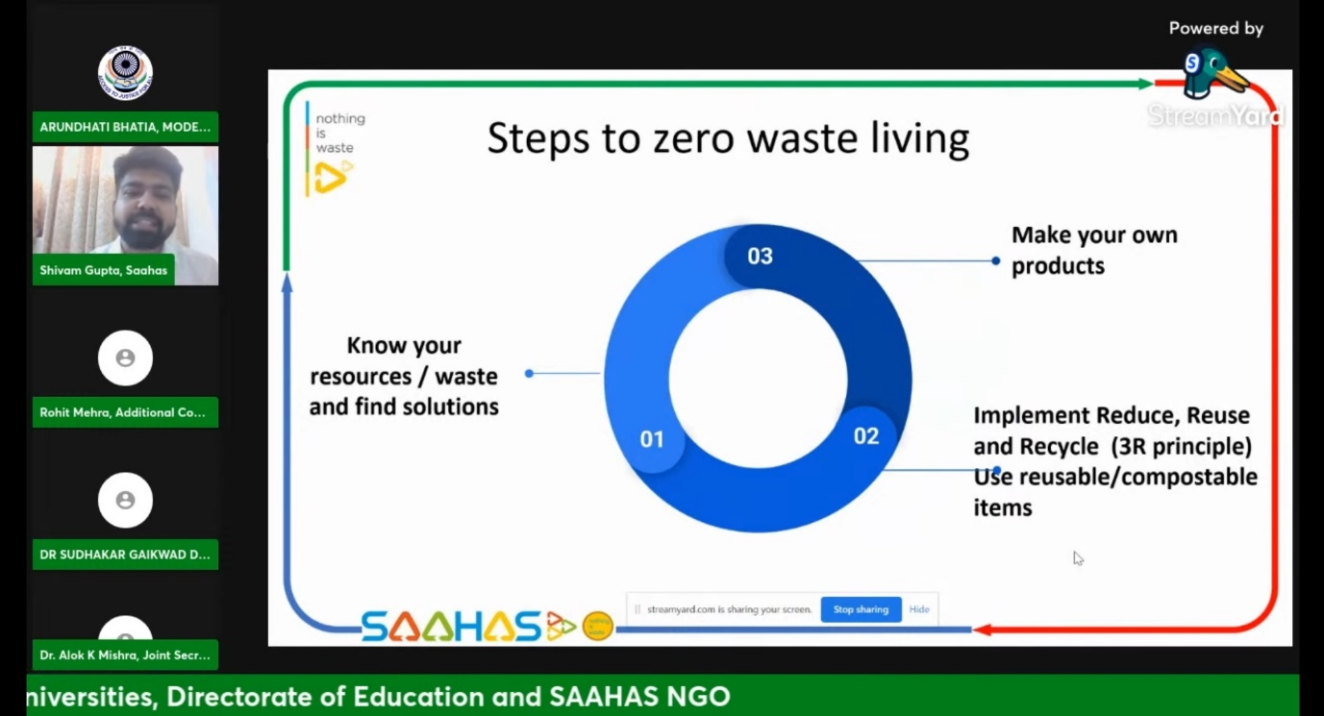

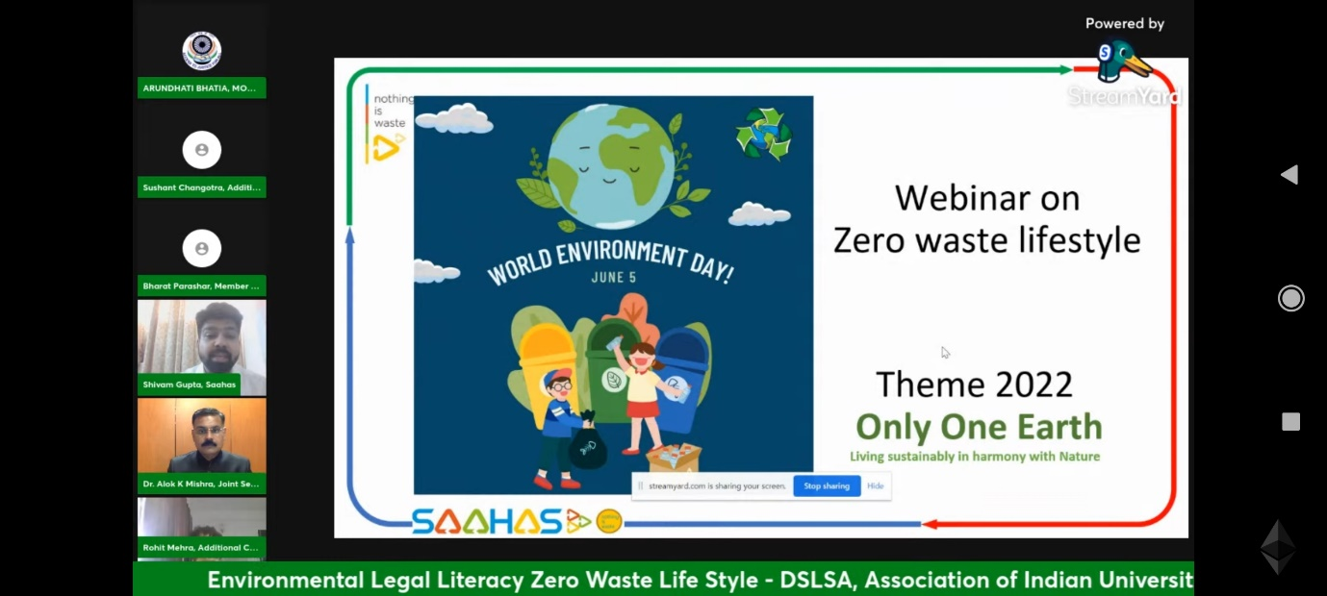

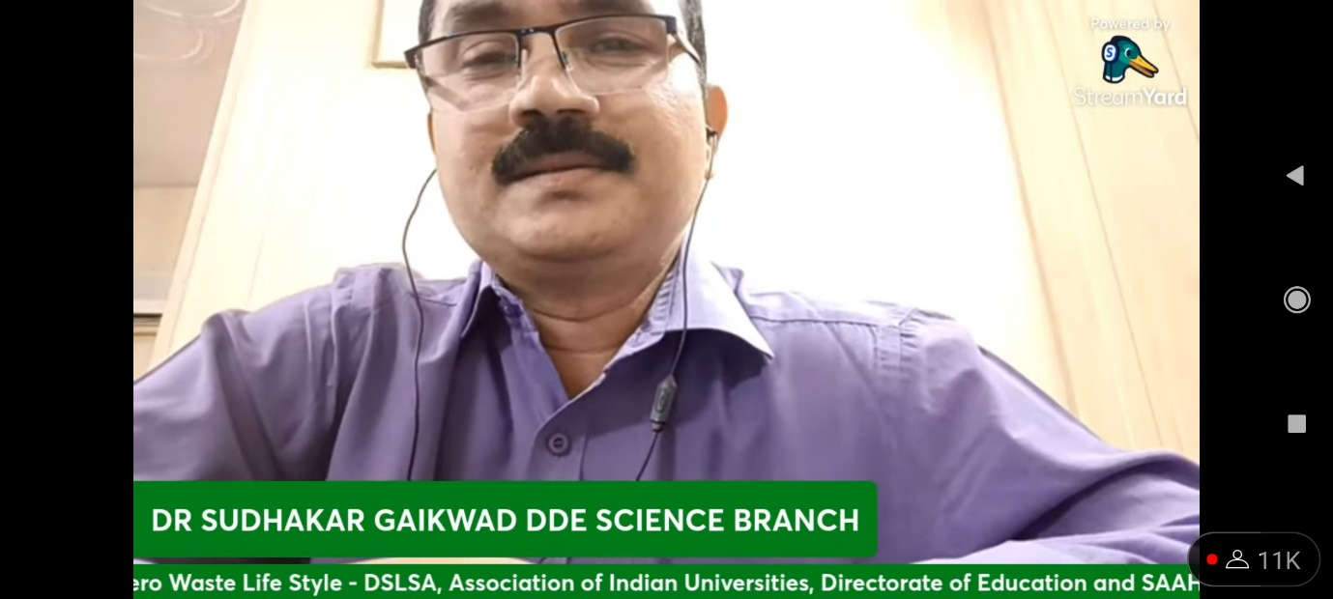

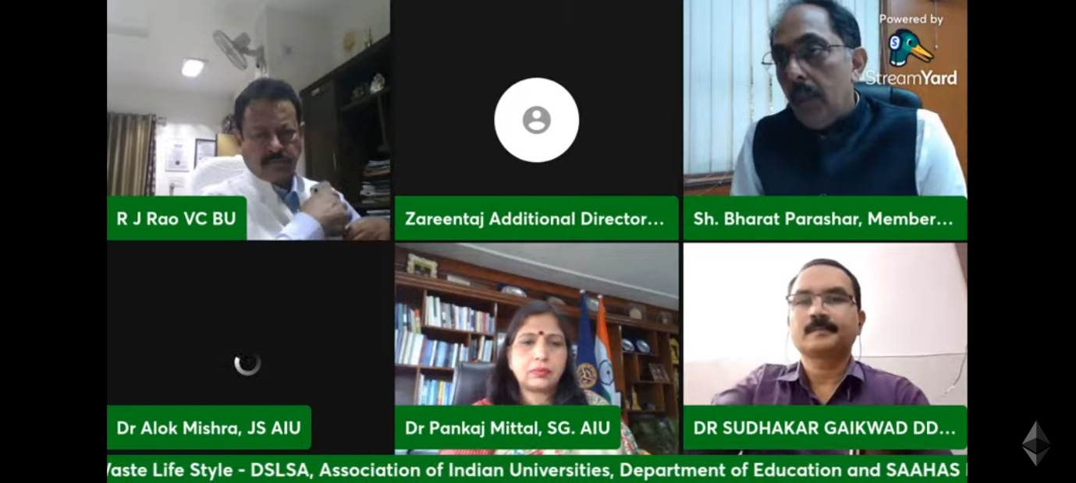

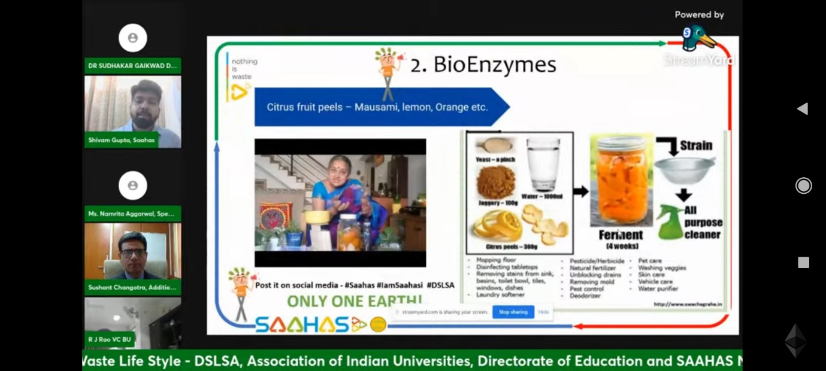

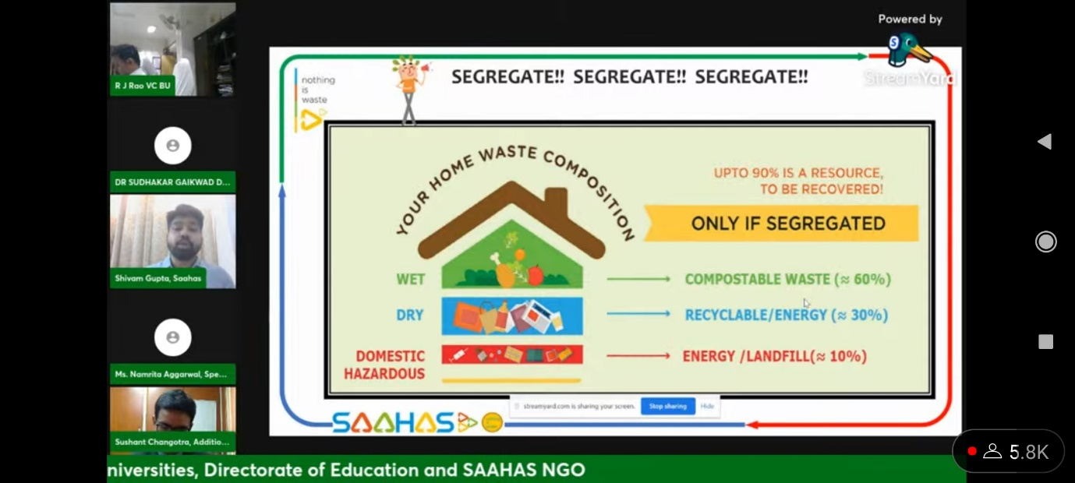

8) Training Session on Solid Waste Management for Housekeeping Staff, June 25,2022
Jamia Hamdard in collaboration with Indian Pollution Control Association (IPCA) under SORT Project implementation held a Training session programme on Solid Waste Management for Housekeeping Staff of the university. They were told about the fundamentals of Segregation of organic waste and treatment.
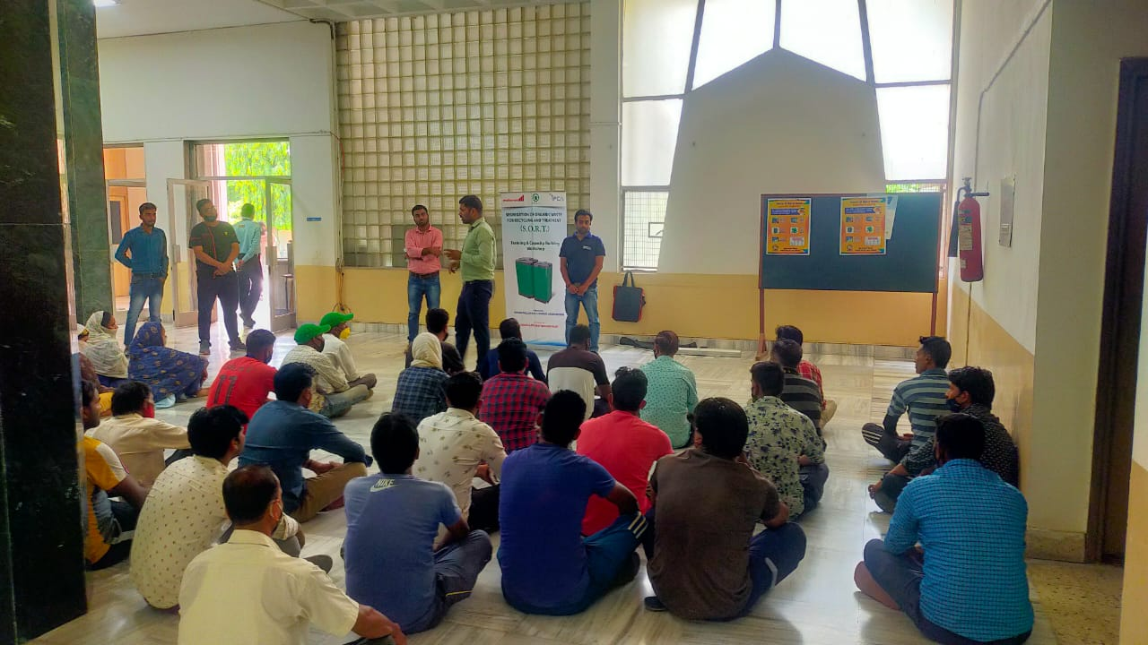
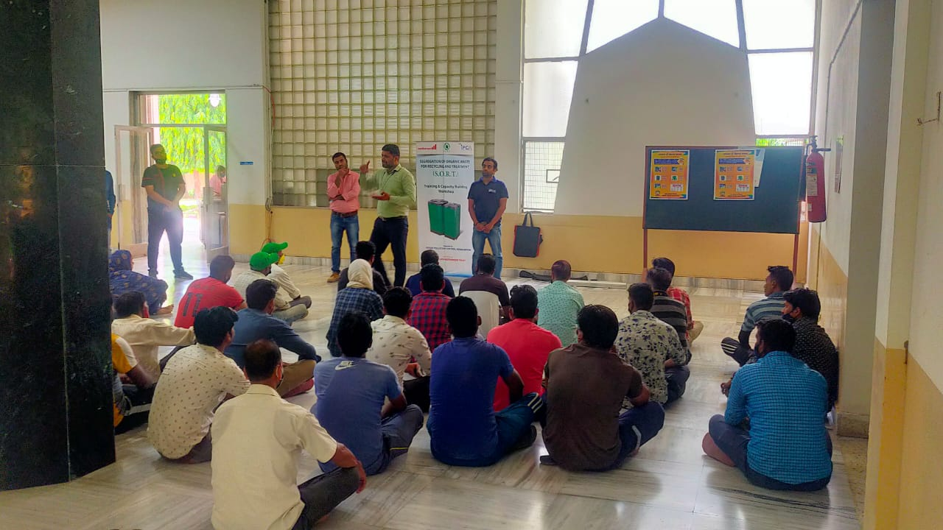

10) Installation of Aerobin Composters in Jamia Hamdard

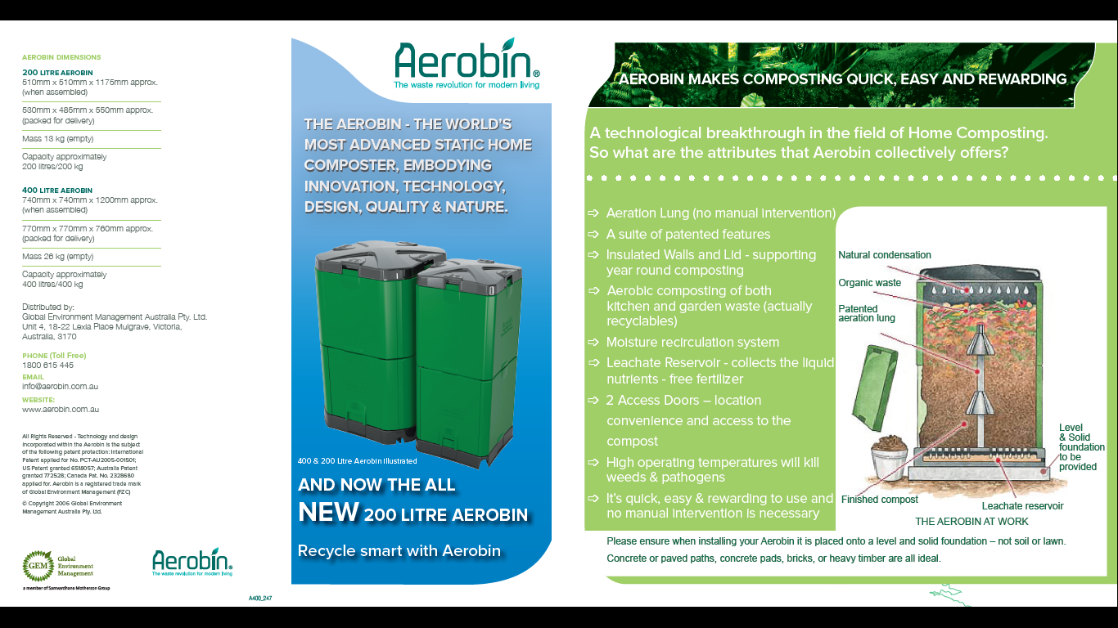
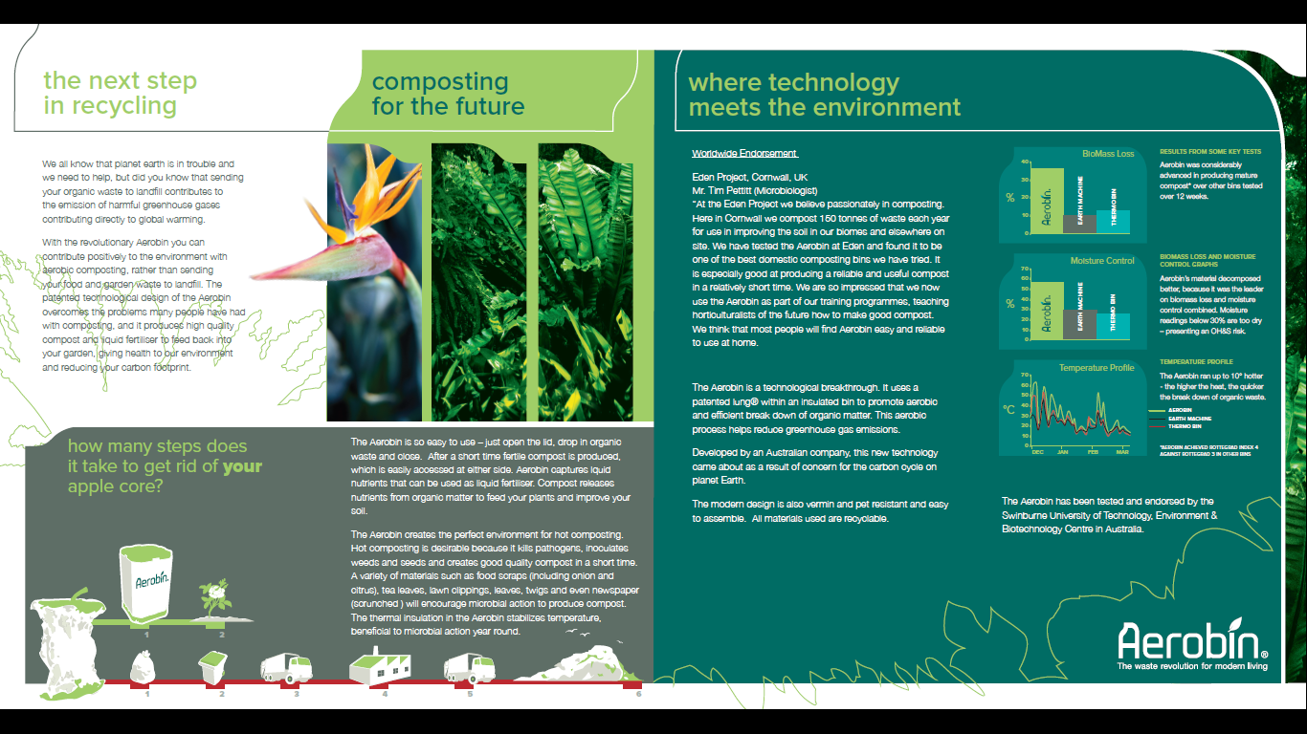
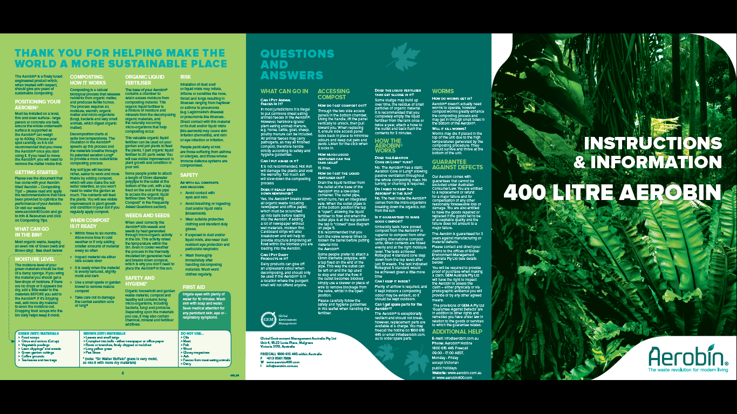
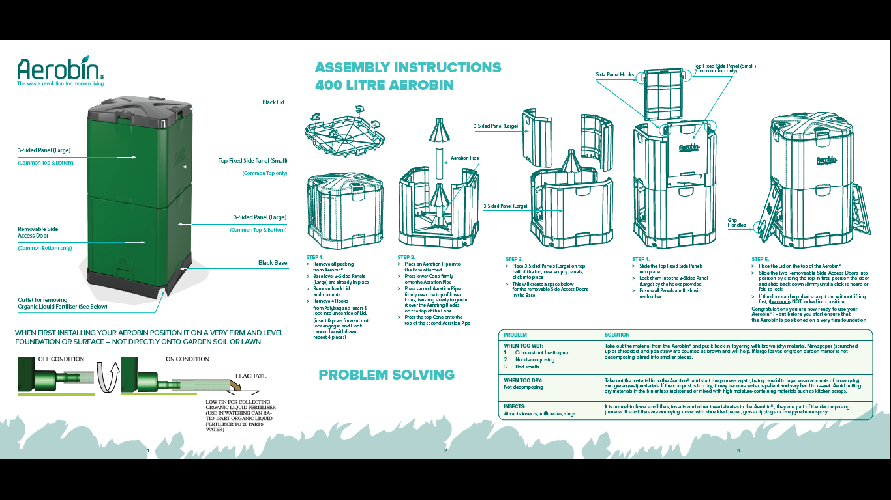
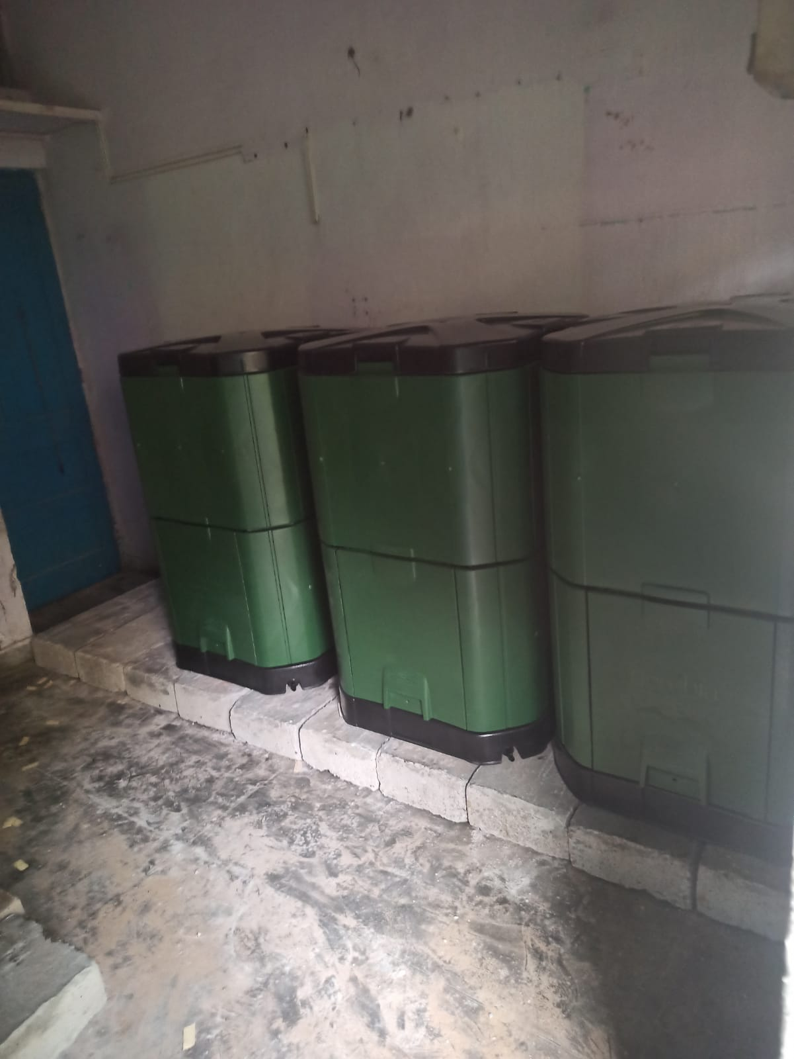
Aerobin in Jamia Hamdard

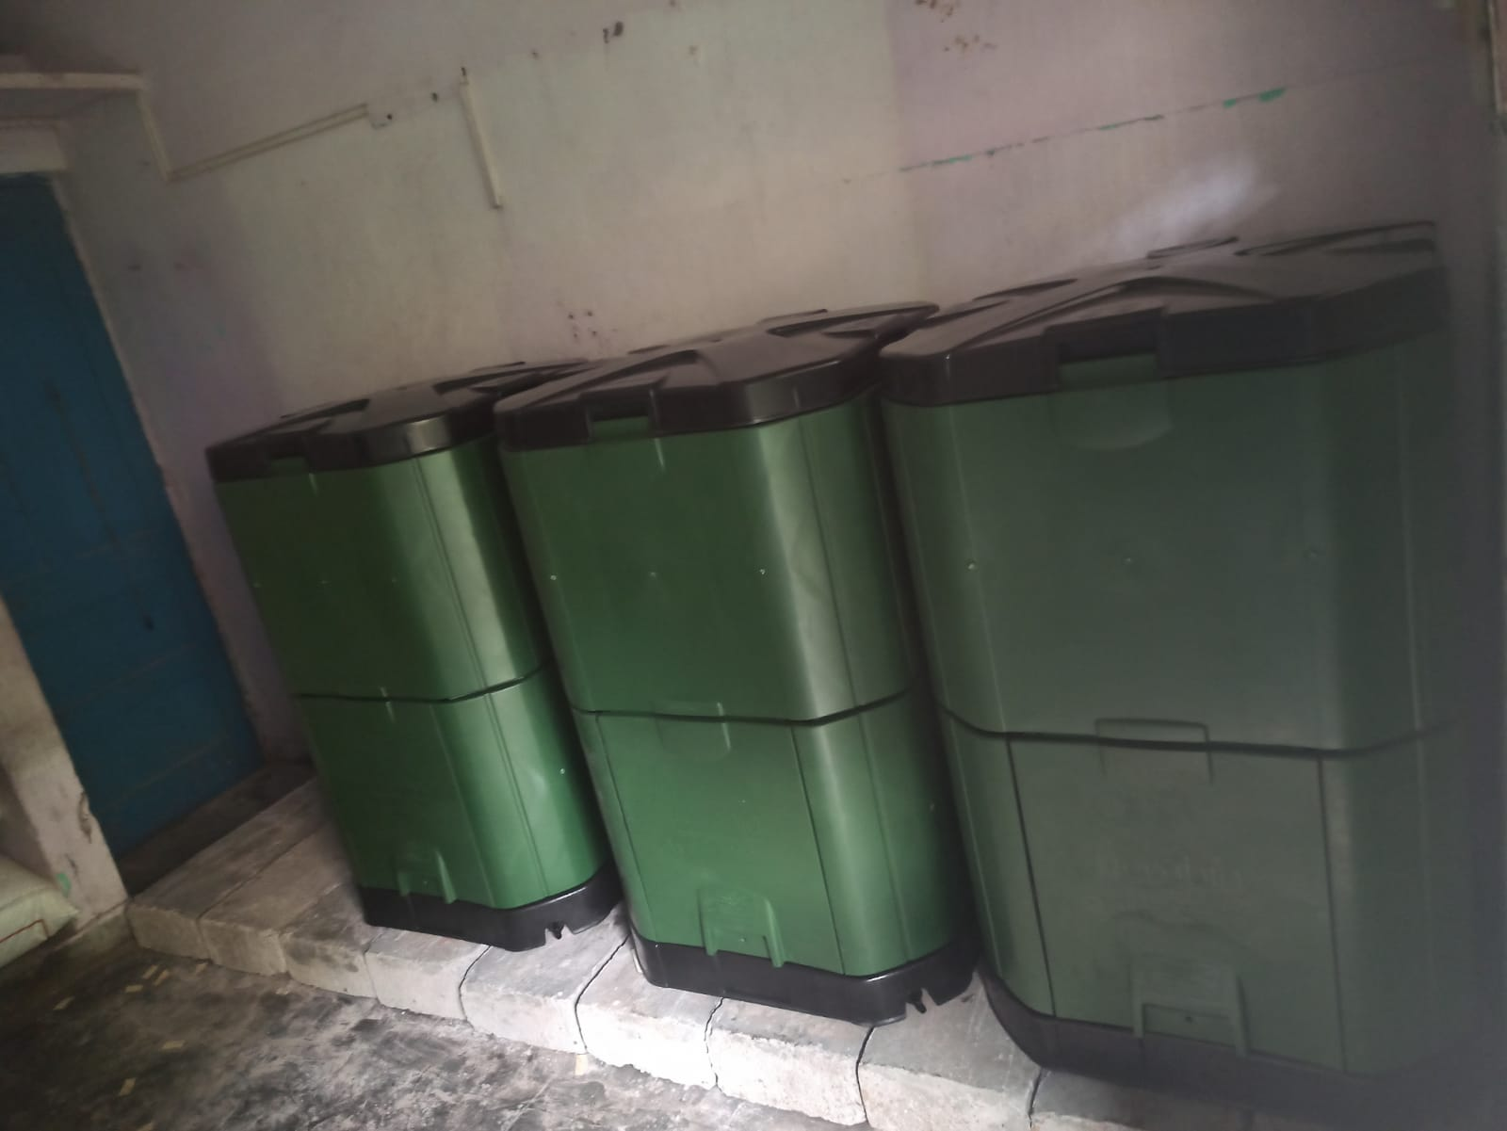
Aerobin in Jamia Hamdard

