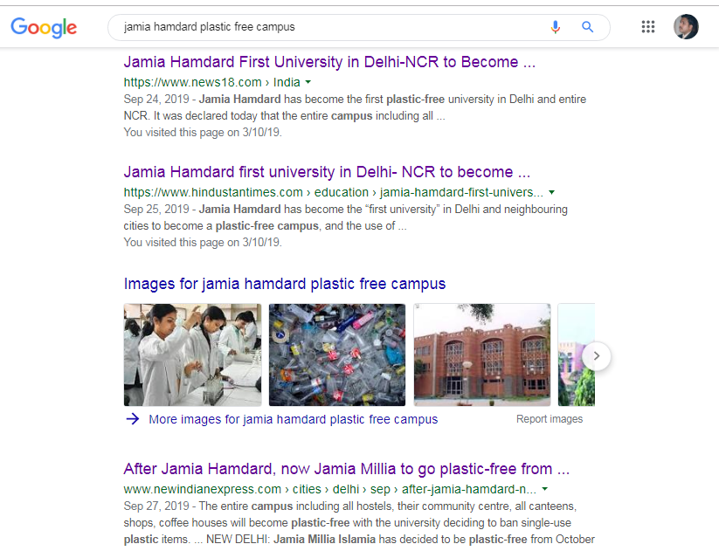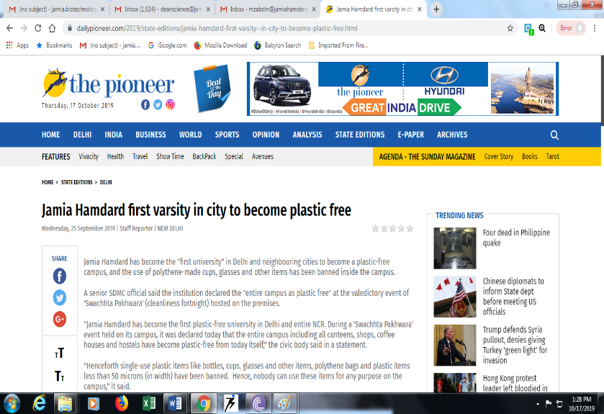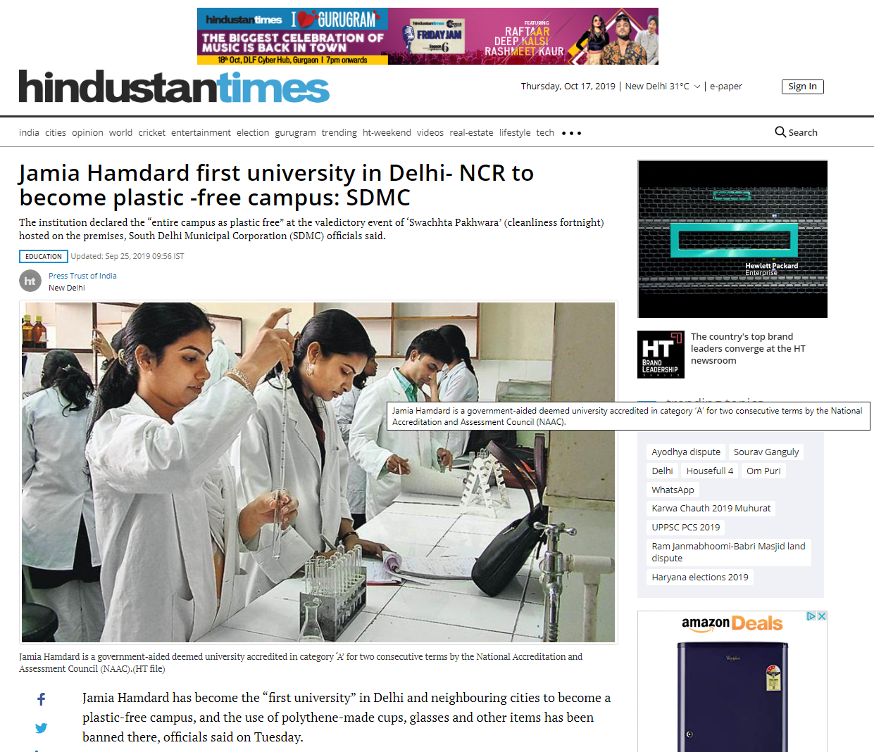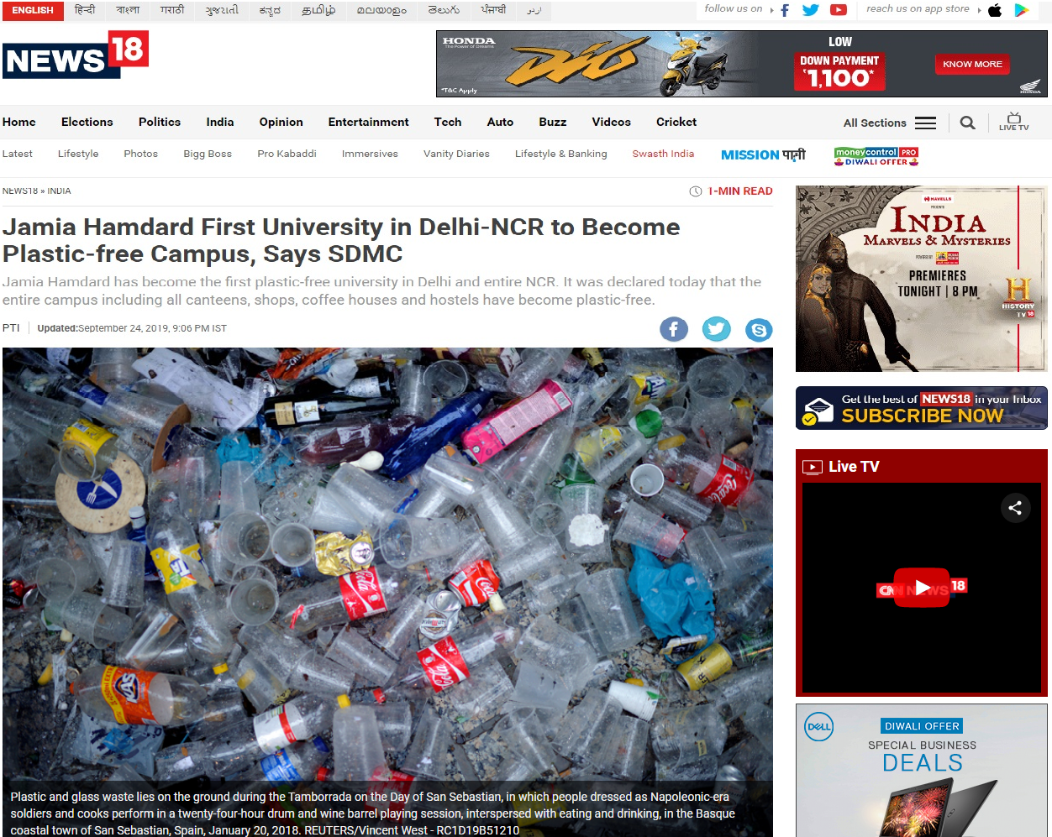

October, 2019, on 150th birth anniversary of Bapu to make the country free of single-use plastic. He also urged startups to come up with ideas to recycle plastics in the country. In accordance with the Prime Minister’s vision to shun single-use plastic, Jamia Hamdard has become the first University in Delhi-NCR that has declared its entire campus plastic-free and banned the use of polythene made cups, glasses and other items.