7.1.4 ***Water conservation facilities available in the Institution***

**7.1.4.1 Rain Water Harvesting System (2016-2021)**

In order to prevent the shear wastage of rain water, Jamia Hamdard has developed the rain water harvesting system. Centre for Science and Environment has made the campus as a model Campus of harvested water. This facility is frequently visited by National and International delegations. University had received “Rain Water Harvester Award” in 2006 from the Government of Union Territory of Delhi. The details of rain water harvesting is given below:

1. **Rain water available for harvesting**

Total rooftop and surface area: 3,15,380 square meters (sq 1i)m).

Average annual rainfall in Delhi: 611 millimeters (mm).

Total volume of rainwater harvested: 67444 cubic meters (m³) or 6,74,44,000 liters.

This represents 35 per cent of the total rainwater harvesting potential.

1. **Rain water harvesting system**

Rainwater from various catchment areas such as rooftop, surface runoff from open areas and runoff from the Jahanpanah Reserve Forest is harvested.

1. **Rooftop rain water harvesting**

**a) Rooftop rainwater harvesting at the library building**

Rainwater from the library's rooftop is taken to a desilting chamber measuring 2m x 2m x 3m through a closed drain. A baffle wall divides the desilting chamber into two compartments, settlement and filtering chambers. The rainwater first enters the desilting chamber, where the silt gets collected and then overflows into the filtering chamber. The filtering chamber has pebbles, which further filters the rainwater before diverting it into the recharge well. The recharge well measures 1.5m x 1.5m x 3m in size with a 30m deep recharge bore well measuring 100mm in diameter.

**b) Rooftop rainwater harvesting at the girls' hostel**

Rainwater from the hostel terrace is diverted to a circular recharge well, 2m in diameter and 3m deep through a closed channel. A desilting chamber is created by constructing a baffle wall inside the recharge well. The rainwater from the terrace flows into the desilting chamber, where the silt gets deposited. The silt-free water overflows into the recharge well. Encompassing a bore well, is 100mm in diameter and 30m deep, where it is stored.

1. **Surface Runoff Water Harvesting**

**a) Surface runoff water harvesting near library building**

Surface runoff water from the paved and unpaved areas surrounding the library is collected in two trenches located in the eastern part of the campus (near Gates 5 and 6). The runoff collected near Gate 5 is diverted into a recharge well. Similarly, the runoff from the northern side of the building is drained into an abandoned open dugwell near Gate 6.

**b) Surface runoff water harvesting from Jahanpanah ReserveForest**The surface runoff water from the Jahanpanah reserve forest is collected in a pond from where it flows through a storm water drain adjacent to the Scholars' House. This runoff water is channelized into a desilting chamber and then into a recharge well with 2m x 2m x 3m dimensions and 1m high diversion wall.

1. **Surface Runoff and Rooftop Rainwater Harvesting At Hamdard Archives & Research Centre**

The rooftop rainwater and the surface runoff water is collected in an open drain which runs adjacent to the building. This drain, measuring 450mm in width and 300mm in depth carries the rainwater into the desilting chamber. The silt-free water is diverted to a recharge well which has a bore well to recharge the groundwater.

1. **Details of Rain Water Harvesting Wells in the Campus**

**The detailed descriptions of rain water harvesting wells in the campus are given in the following table:**

|  |  |  |  |  |
| --- | --- | --- | --- | --- |
| **S.No.** | **Location** | **Number of wells**  **(Nos.)** | **Roof Top Area (sqm)** | **Remarks** |
| **1.** | Faculty of Science building | 02 | 3130.00 | Maintained |
| **2.** | IBN-e Batuta Hostel | 01 | 1022.00 | Maintained |
| **3.** | JLN Hostel | 01 | 918.00 | Maintained |
| **4.** | Scholar’s house | 01 | 1319.00 | Maintained |
| **5.** | HIMSR Building | 03 | 2400.00 | Maintained |
| **6.** | Hamdard Convention Centre | 01 | 2035.32 | Maintained |
| **7.** | HARC Building | 01 | 1854.00 | Maintained |
| **8.** | Faculty of Pharmacy | 01 | 2937.00 | Maintained |
| **9.** | Unani Hospital | 01 | 971.00 | Maintained |
| **10.** | Central Library Building | 01 | 2750.82 | Maintained |
| **11.** | Well near Gate No. 6 (storm & road water) | 01 |  | Maintained |
| **12** | CARPS Building | 01 | 2016.00 | Maintained |
| **13.** | HAHC Hospital | 02 | 4522.00 | Maintained |
|  | **Total wells** | **17 Nos.** |  | Maintained |

**v)New Water Harvesting Programmes**

Two harvesting wells near new Hospital Block and new Girls Hostel with required infrastructure are in process and will be started soon.

**vi)Water supply source**

The daily water requirement of approximately six lakh liters of Jamia Hamdard is extracted from six bore wells.

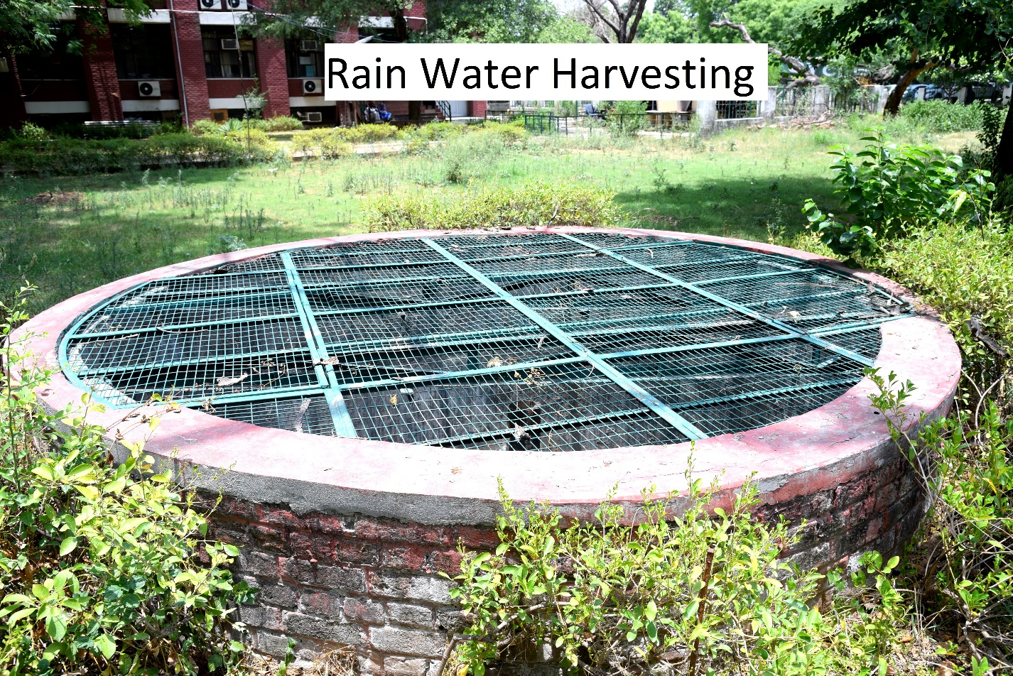

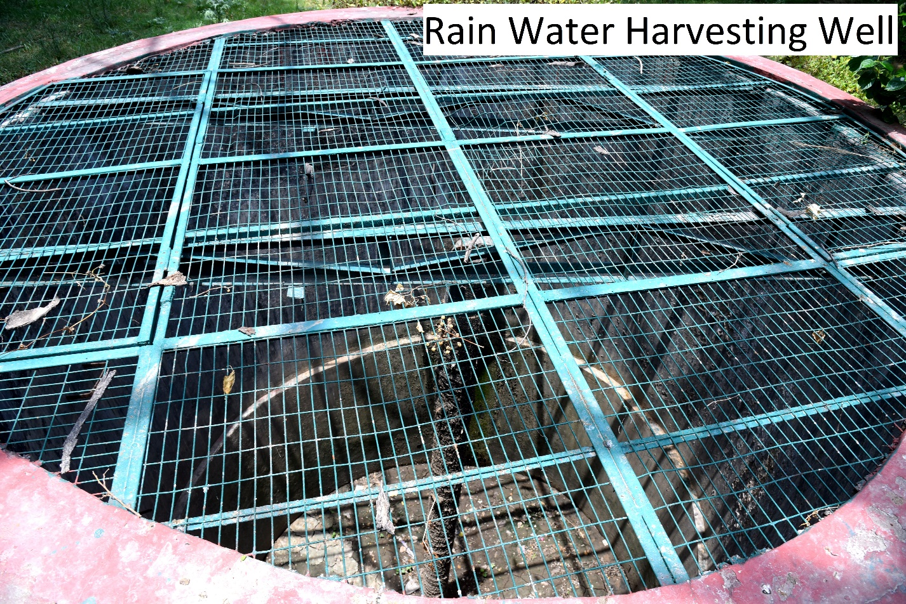

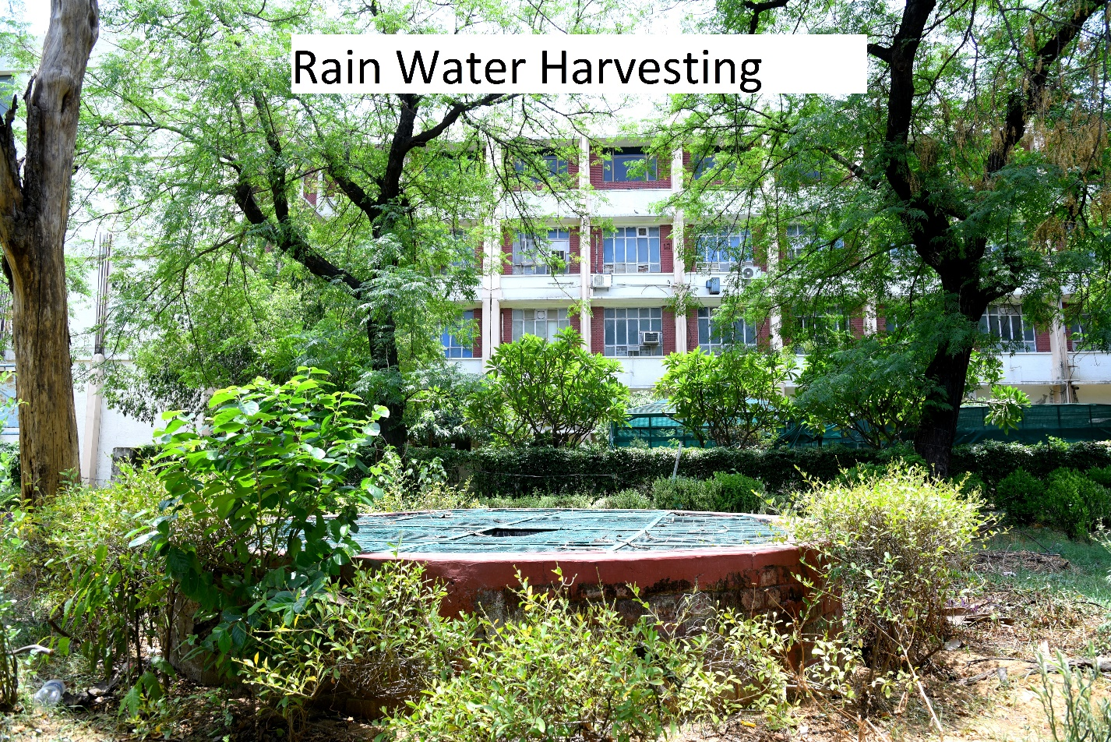

* + - 1. **Effluent Treatment Plant (ETP) (2016-2021)**

To minimize the use of fresh water in irrigating lawns, gardens, parks etc. and also to fulfill the mandatory requirement of working hospitals, ETP/STP plants have been installed at two locations in campus i.e near old block of HAHCH and near the new Hospital building. The capacity of the plants is 250 KLD and 400 KLD respectively. Treated water from both the plants are being used for irrigation purpose at different locations in the campus with zero discharge to the Municipal drain. The pipeline and pumping accessories have been installed to facilitate the process of irrigation. The lawns and herbal gardens that are irrigated with treated water are as under:

1. Central Library Building Lawn
2. Hamdard Archives Building Lawn
3. Convention Centre Lawn
4. Vice Chancellor’s Lodge Lawn
5. Chancellor’s Lodge Lawn
6. A, C & D residential Blocks Lawns
7. HAHCH Lawns
8. Herbal Garden

Besides, some smaller units are also installed for using treated water for irrigation at different locations, like HIMSR Building, Scholar’s House, International Hostel, Ibne-Batuta Hostel, Registrar Bungalow Lawn & Faculty of Pharmacy Lawn. Some water lines are to be laid for other lawns. The details of the E.T.P in tabular form and pictures are as under.

|  |  |  |  |  |  |  |
| --- | --- | --- | --- | --- | --- | --- |
| **Jamia Hamdard** | | | | | | |
| **S.No.** | **Description** | **Location** | **Capacity** | **Date of installation** | **Installed By** | **Remarks** |
| 1. | Effluent Treatment Plant/STP | Near old block of HAHCH | 250 KLD | 2012 | M/s Brisanzia | Functional |
| 2. | Effluent Treatment Plant/STP | New Hospital Building | 400 KLD | 2015 | M/s Meera Green | Functional |

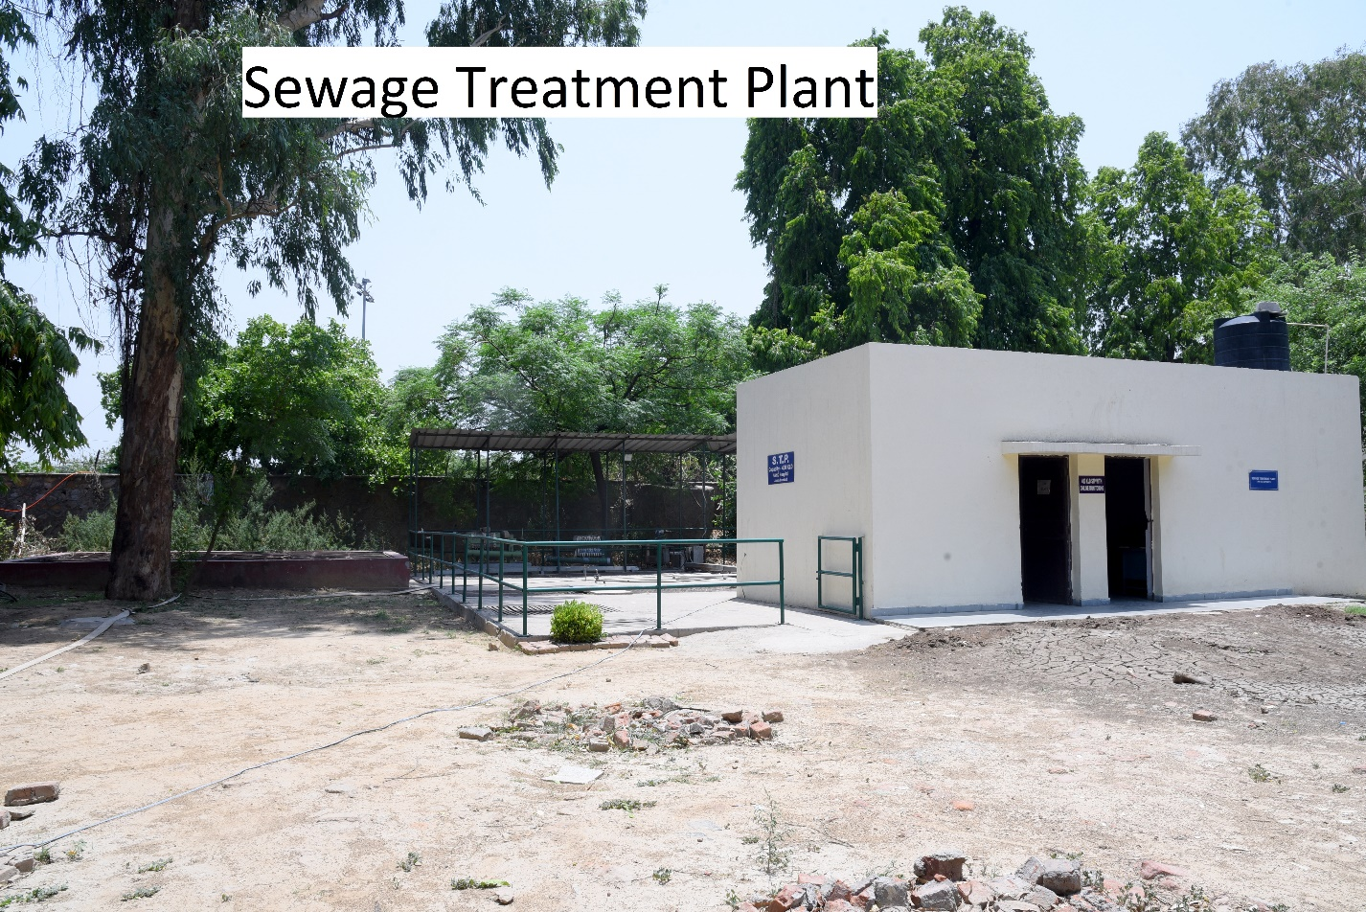

**EFFLUENT TREATMENT PLANT, Jamia Hamdard**

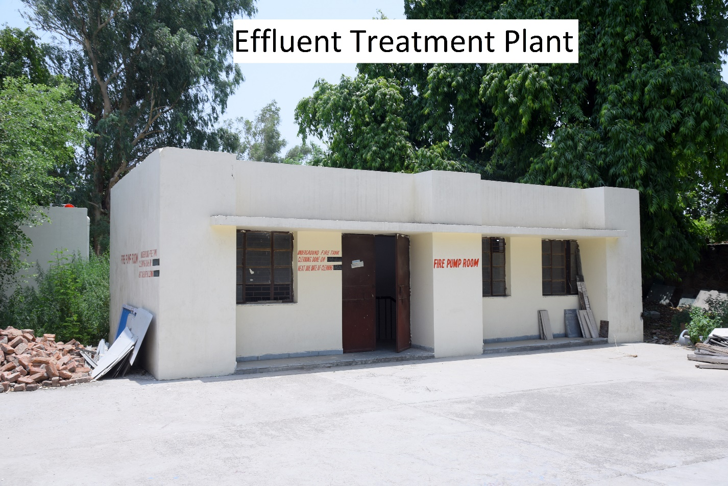

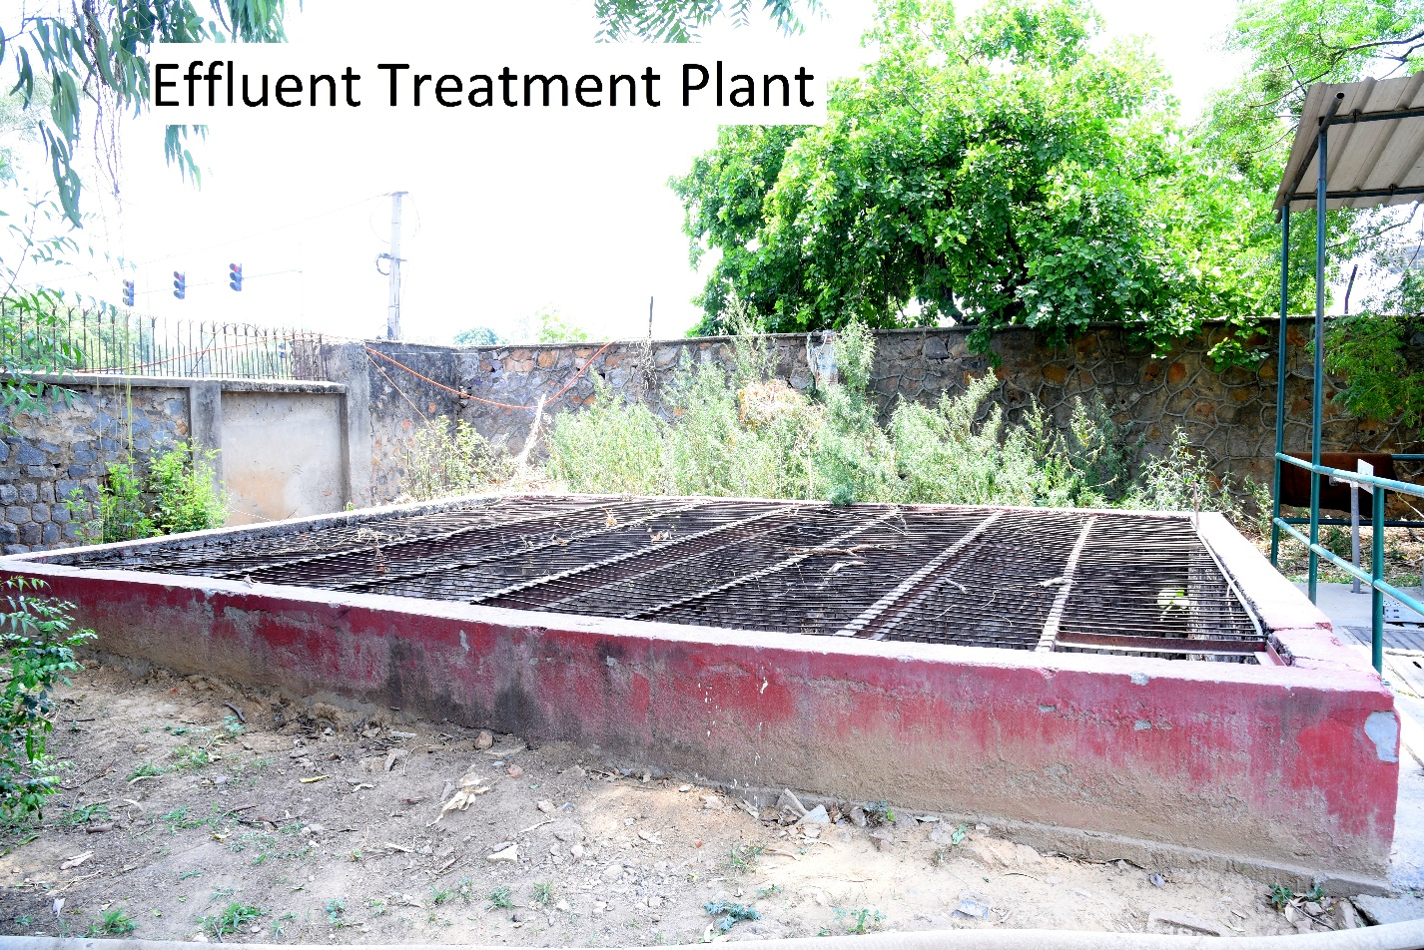

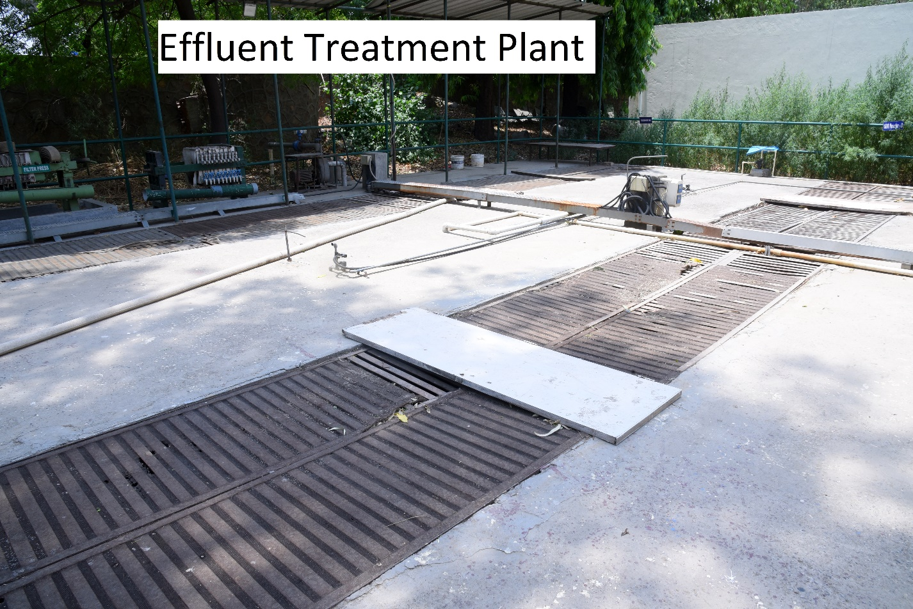

**Tank - 1**

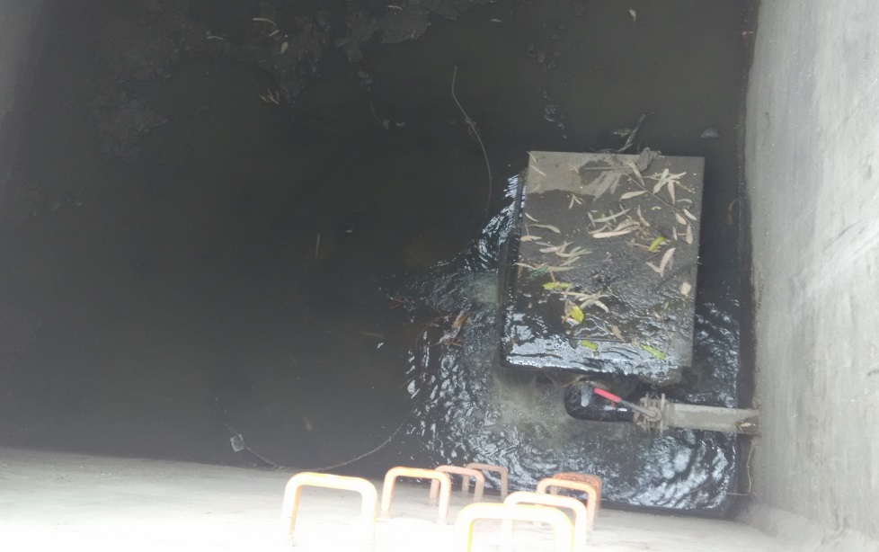

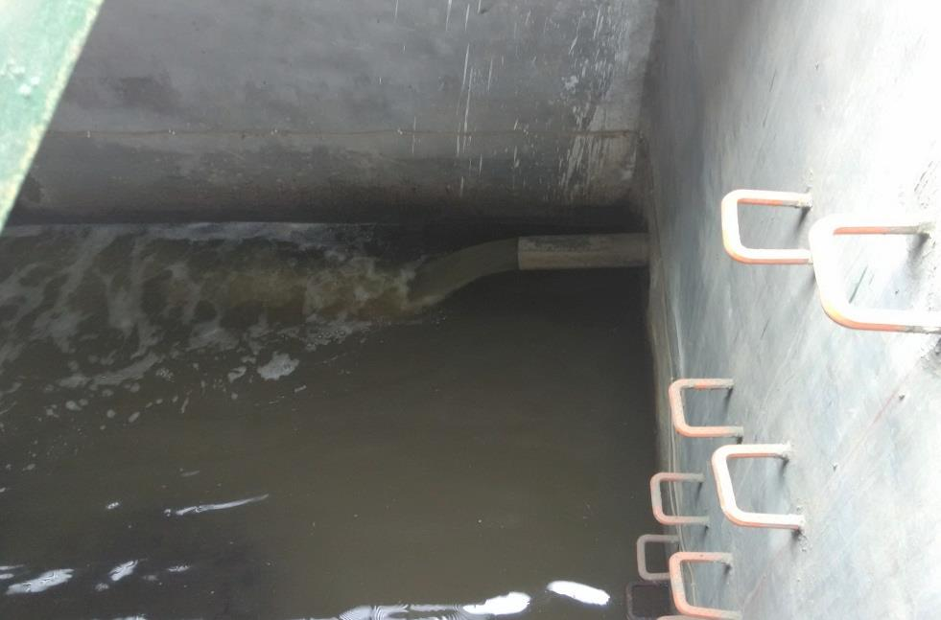

**Tank-2**

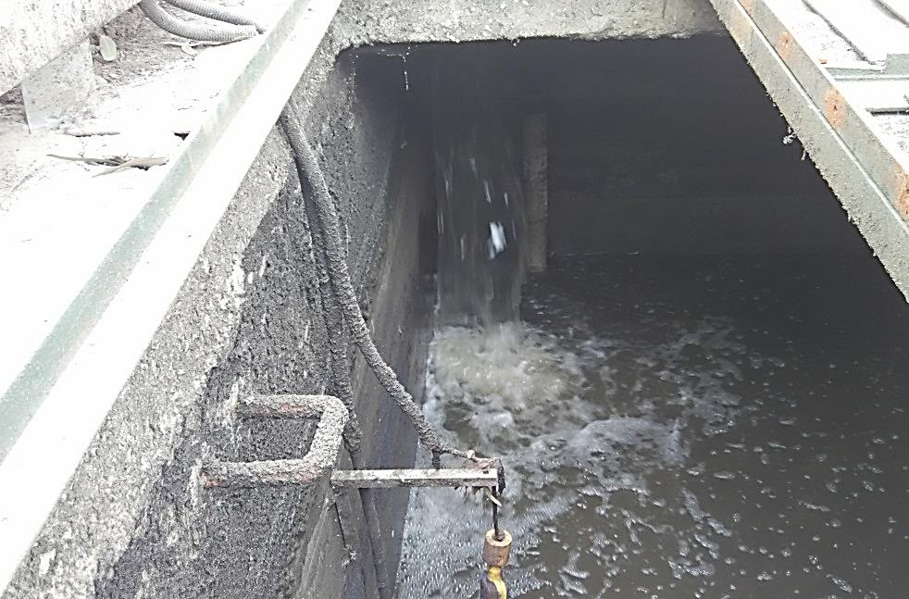

**Tank-3**