**7.1.2 *The Institution has facilities for alternate sources of energy and energy conservation measures.***

**7.1.2 Solar Energy**

To save the conventional energy, solar water heating systems and low energy consuming street lamps have been installed in the University Campus. The detailed description of these systems along with their locations of installations are given in the following table:

|  |  |  |  |  |  |
| --- | --- | --- | --- | --- | --- |
| **S.N.** | **Description** | **Location** | **Capacity** | **Date of installation** | **Installed by** |
| 1 | Solar Water Heating System | New Hospital | 6000LPD | Nov.2015 | Green Tech. India |
| 3 | Solar Water Heating System | Girls Hostel | 6000LPD | 10.11.13 | Cornic Technology Pvt. Ltd. (TATA) |
| 4 | Solar Water Heating System | International Hostel | 7500LPD | Nov. 2003 | Jain Irrigation Pvt. Ltd. |
| 5 | Low Energy Consuming Street Lamps | Road side | - | Various | Various |

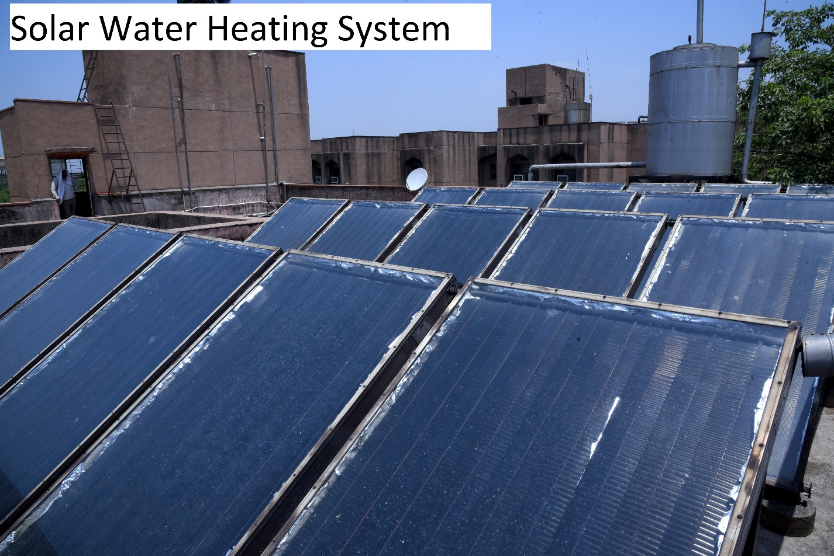

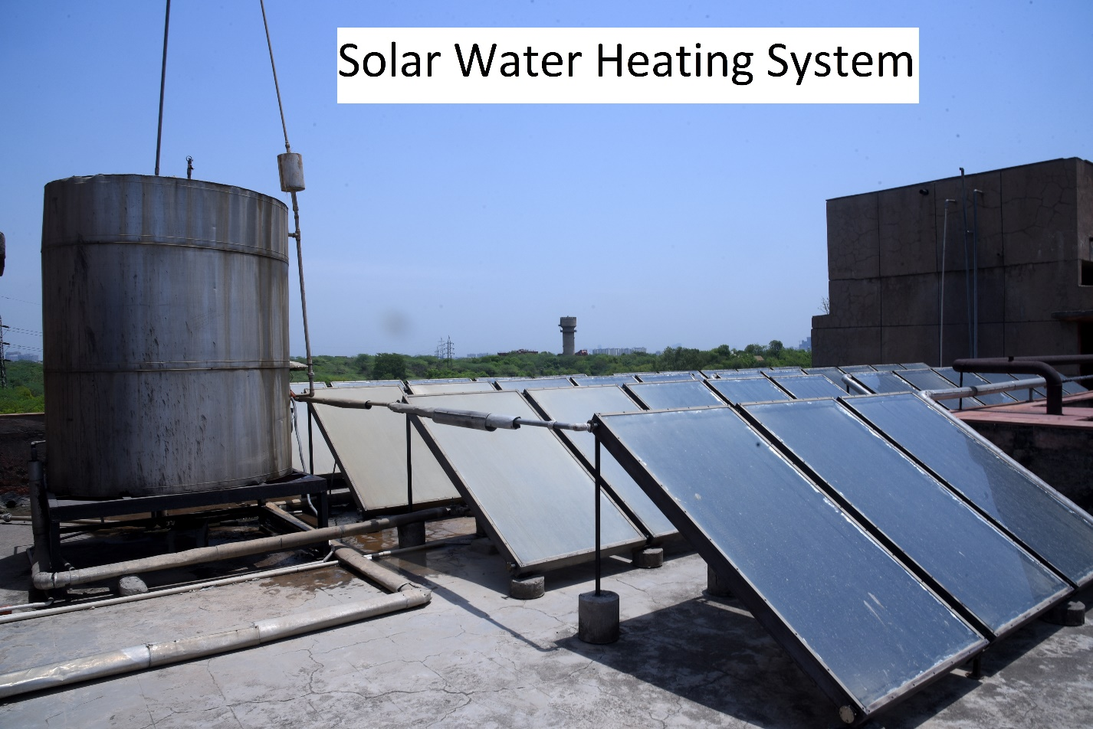

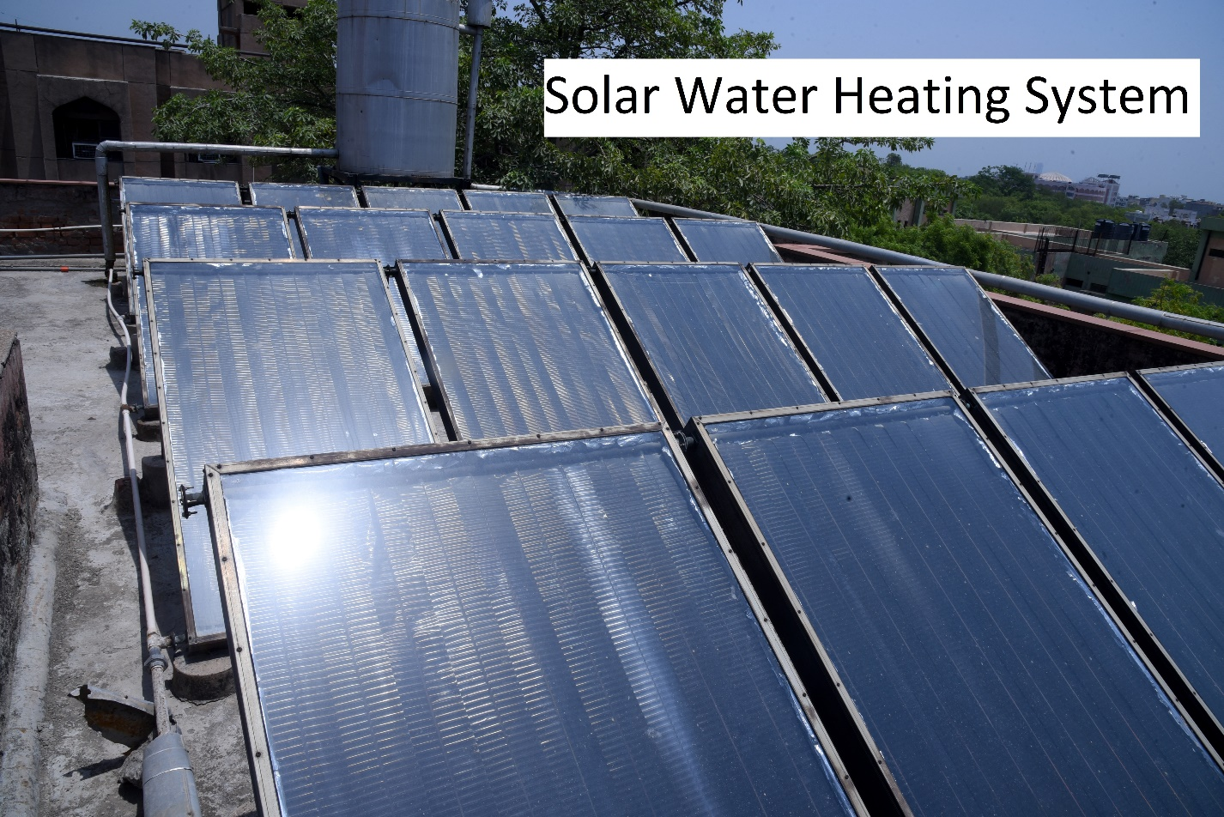

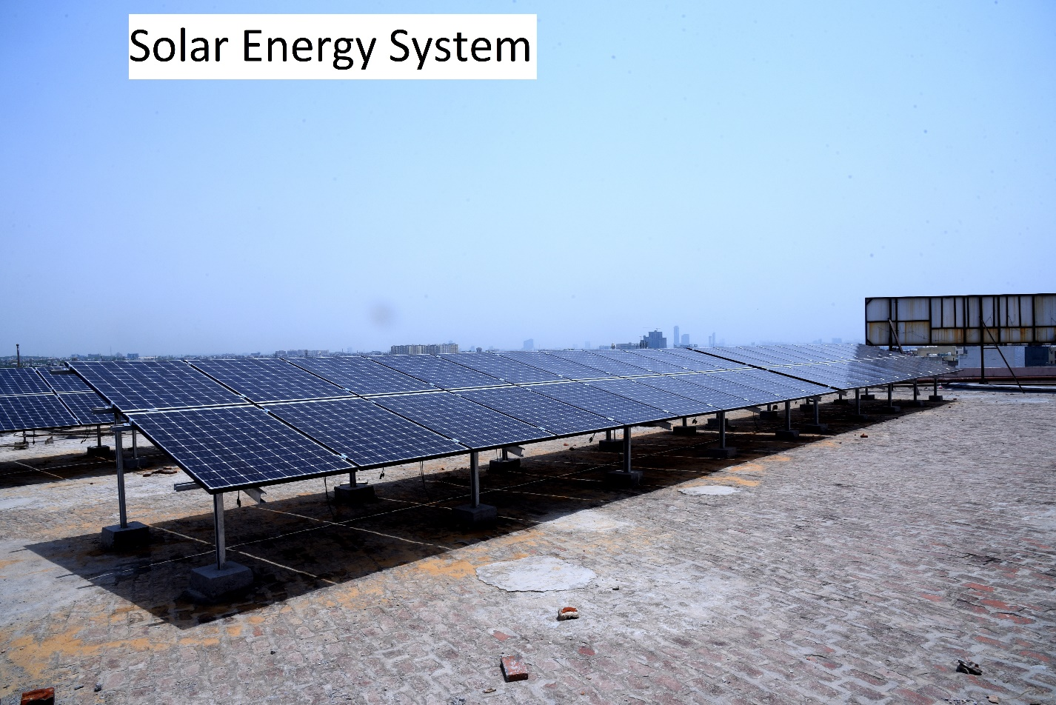

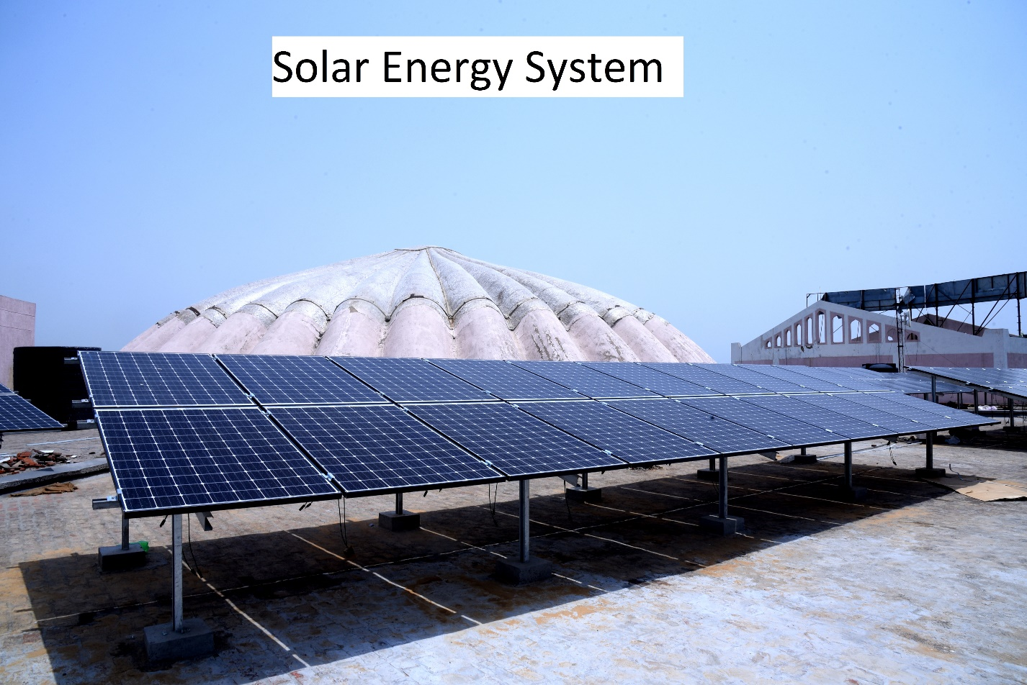

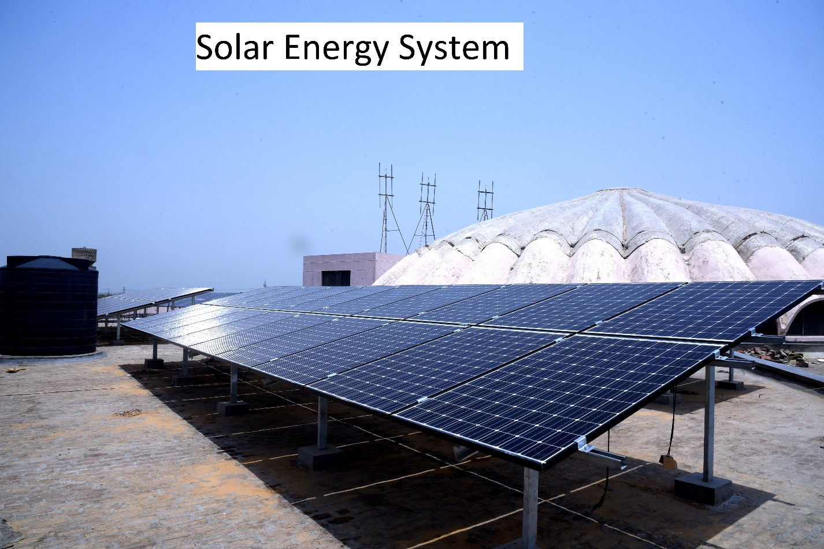

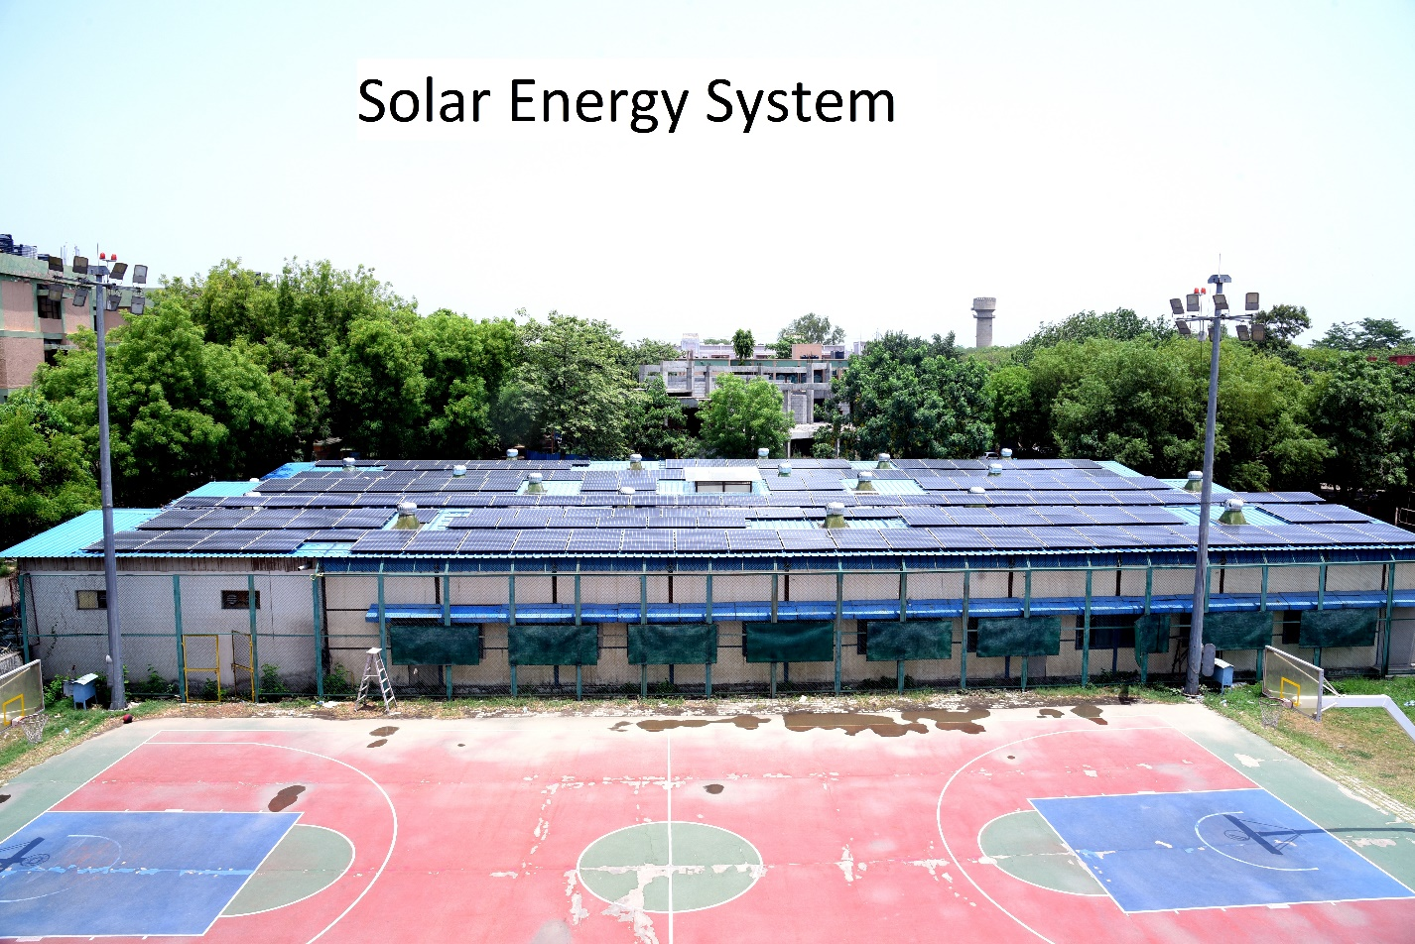

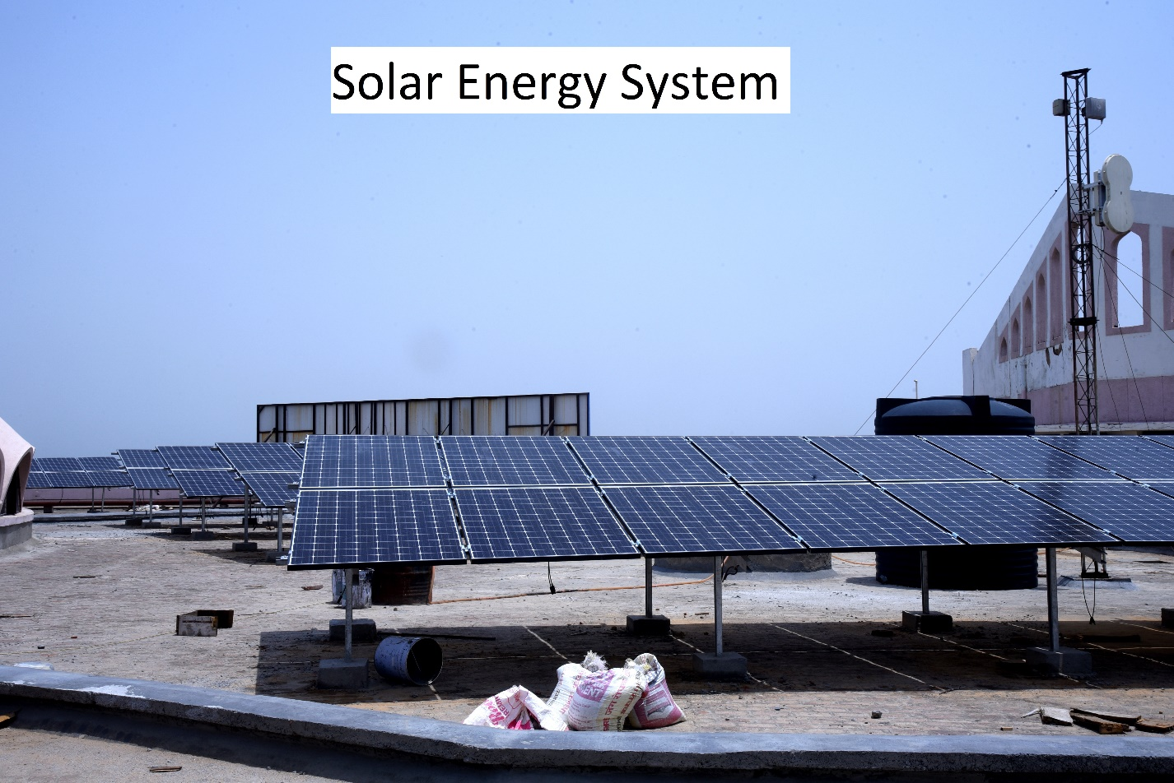

To economize the use of energy, following main systems are adopted:

1. Adequate design of transmission and distribution system to limit the losses of electricity.
2. Use of energy efficient devices like light sources such as true-lite.
3. fluorescent lamps, compact fluorescent lamps and LED Lamps
4. Use of capacitors at load centers to improve voltage and power factor to reduce the distributional losses and also to avoid penalty.
5. Use of sensors/timers for common area/ passage lighting.
6. Use of high efficiency motors.
7. Installation of hydropneumatics system for domestic water supply pumping to the hospital to save energy.