JAMIA HAMDARD

Criterion I – Curricular Aspects

(150)

Key Indicator – 1.1 Curriculum Design and Development (60)

MetricNo. |  |  | Weightage
1.1.1  Q_{l}M | Curricula developed and implemented have relevance to the local, national, regional and global developmental needs which is reflected in Program outcomes (POs), Program Specific Outcomes (PSOs) and Course Outcomes (COs) of the Programs offered by the University  Write description in maximum of 500 words  Jamia Hamdard has designed the holistic curriculum that focuses on upholding the rich traditional values and at the same time incorporating the recent advances & technology. We have School of Unani Medicine and Educational Research offering programmes in Unani medicine which is recognised as a center of excellence by CCRUM and apart from that we have B. Tech in A.I., M.Sc. in virology which are implemented due to emerging needs recent covid pandemic and has industry and society driven approach guided by PEO’s in alignment with its Vision and Mission, meeting requirements of its stakeholders.  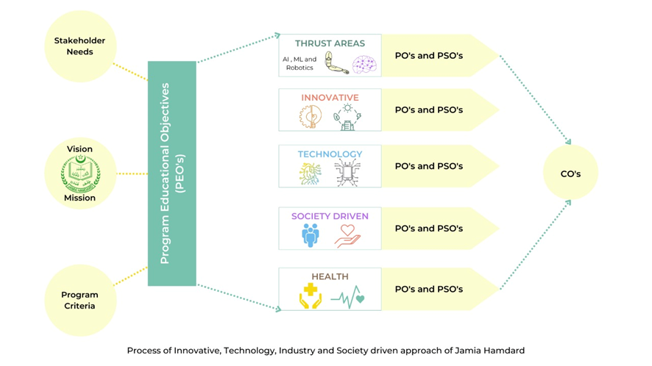  Jamia Hamdard has implemented The National Education Policy-2020” notified by the Government of India in phased manner with comprehensive strategic plan. Apart from core concepts, curriculum is focussed on thrust areas like AI, ML and Robotics, health care, professional ethics, human values, industry complaint, environment and sustainability and oriented towards society and community.  The Program Outcomes, Program Learning Outcomes and Course Learning Outcomes based framework fulfil the graduate qualities by preparing them with long lasting aptitudes to confront real-time challenges and societal needs by joining basic considerations, administration qualities, and be part of corporate and social obligations. Efficient teaching learning to augment and strengthen the learning process is practiced by the University. Structured POs,COs and CLOs that are formulated and practiced for the programs as a quality indicator for Outcome Based Education to meet the global needs. Attainment of COs is done to improvise the curricula and teaching learning standards.  For local, national, regional and global developmental needs, we have BOS of each department from judicially selected experts that help in achieving the excellence and reflect it in POs, COs of the programme offered having visionary and stalwarts as mentioned in academic council. It gets further sharpened and leads to perfection. Regular Academic council and Board of Studies meetings critically analyze the relevance of the programme for meeting the changes in the community, hospitals and industry with inputs received from stakeholders in industry, nationally reputed institutions, research organizations as well as alumni, faculty and students. For implementation of the outcome–based education within the framework of CBCS pattern, Center for Teaching Support and Innovations has been constituted through regular mentorship in Jamia Hamdard. Centre is continuously working to get the vision accomplished.  In keeping with the Learning Outcome-based Curricular System, all programs advertised by the university have expressly spelt-out learning targets and results that are connected to instructional methods and the assessment/evaluation design.Learning, which is student-centric (courses, assignments, extended work, internship, field trip etc.), is typified through organized educational programs which experience intermittent surveys and undergo periodic reviews to form the educational module more modern and important. Online courses such as MOOC and Spoken Tutorial offer enhanced learning encounters to the learners. Community and Societal oriented curriculum engages students in social surveys to learn livelihood issues and recommend solutions.These aspects are very well reflected in POs pertaining to social responsibilities and outreach activities.  Apart from core concept curriculum has thrust areas like machine learning, robotics, virology. Technology and industry driven curriculum of Jamia Hamdard enhances problem analyzing and solving skills of the students in the thrust areas helping them to address the societal problems at local, regional and global level and develop innovative products and technologies. Students are exposed to industry and clinical areas for skill development. Medical, Nursing, Paramedical, rehabilitation studentsare posted in multiple hospitals and communities for sufficient clinical exposure.  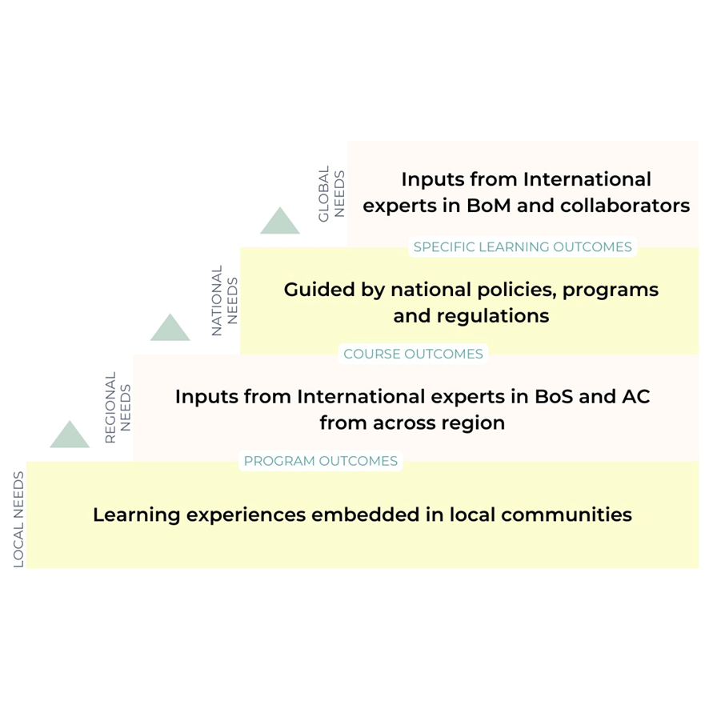  File Description Document  Upload Additional information Link for Curriculum: https://drive.google.com/drive/folders/1PK1oBGKjd01MeIHIyZ_2jr8P_mtqU3xR?usp=sharing  Link for Additional Information https://drive.google.com/file/d/16mXTcskq22MX3wc2ppjB7i8lDcge_Cwf/view?usp=sharing |  | 20
1.1.2  Q_{n}M | Percentage of Program where syllabus revision was carried out during the last five years  Response: 73.6 %  - : How many Programs were revised out of total number of Programs offered during the last five years:  Response: 81  - : Number of all Program offered by the institution during the last five years (last five years)  Response: 110  Formula:  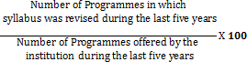  File Description (Upload) (Annexure 1)  - Minutes of relevant Academic Council/BOS meeting:  https://drive.google.com/drive/folders/1JjI0-OiJSZkgXm6etUJZ5msf9FhaJDi1?usp=sharing  - Any additional information:  compiled list of programmes for revision and submission.xlsx - Google Sheets  - Details of Program syllabus revision in last 5years (Data Template):  https://docs.google.com/spreadsheets/d/1nPcSkENAVu2s2oLjAYGhA4AOGTRO-FWa/edit?usp=sharing&ouid=107800398178863903808&rtpof=true&sd=true |  | 20
1.1.3  Q_{n}M | Average percentage of courses having focus on employability/entrepreneurship/skill development offered by the University  Response: 77.1%  - : Number of courses having focus on employability/ entrepreneurship/ skill development year wise during the last five years:  Response:  2017-18 2018-19 2019-20 2020-21 2021-22  Courses focus on employability 1773 2134 2232 2322 2407  Total number of courses in all programmes 2347 2758 2884 2999 3106  Percentage 75.54% 77.37% 77.39% 77.42% 77.47%  https://docs.google.com/spreadsheets/d/1iuSWchTQibeym4dXsH_f6lvA3D9KLUPV/edit?usp=sharing&ouid=107800398178863903808&rtpof=true&sd=true  - Name of the Course with Code  - Activities with direct bearing on Employability/Entrepreneurship/Skill development  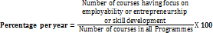  Formula:  Average percentage =  File Description (Upload) Annexure 2  - Any additional information:  - Program/Curriculum/ Syllabus of the course:  https://drive.google.com/drive/folders/1PK1oBGKjd01MeIHIyZ_2jr8P_mtqU3xR?usp=sharing  - Minutes of the Boards of Studies/ Academic Council meetings with approvals for these courses  https://drive.google.com/drive/folders/1-IdopAvnRMd31lKg5YTkN_nJqk68HAQP?usp=sharing  - MoU's with relevant organizations for these courses, if any  - Average percentage of courses having focus on employability/entrepreneurship (Data Template)  https://docs.google.com/spreadsheets/d/1iuSWchTQibeym4dXsH_f6lvA3D9KLUPV/edit?usp=sharing&ouid=107800398178863903808&rtpof=true&sd=true | 10

Key Indicator–1.2 Academic Flexibility (40)

Metric No. |  | Weightage
1.2.1  Q_{n}M | Percentage of new courses introduced of the total number of courses across all programs offered during the last five years  Response: 36.99 %  - : How many new courses were introduced within the last five years  1149  - : Number of courses offered by the institution across all Programs during the last five years  3106  Data Requirement for last five years: (As per Data Template)  - Name of the new course introduced  https://docs.google.com/spreadsheets/d/1iqXUiVgtuVhhduWU6SKFY8zVan2qsJzIxoEfZYGNPWI/edit#gid=1107683884  Formula:  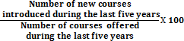  1149/3106*100 = 36.99%  File Description (Upload) (Annexure 1)  - Minutes of relevant Academic Council/BOS meeting  https://drive.google.com/drive/folders/1mYwOg41IG2eJptZLB7jBpmEJ8Hz39Yqa?usp=sharing  https://drive.google.com/drive/folders/1-IdopAvnRMd31lKg5YTkN_nJqk68HAQP?usp=sharing  - Any additional information  - Institutional data in prescribed format (Data Template)  link: https://docs.google.com/spreadsheets/d/1iqXUiVgtuVhhduWU6SKFY8zVan2qsJzIxoEfZYGNPWI/edit#gid=1107683884 | 30
1.2.2  Q_{n}M | Percentage of Programs in which Choice Based Credit System (CBCS)/elective course system has been implemented (Data for the latest completed academic year)  - 1.2.2.1: Number of Programs in which CBCS/Elective course system implemented. = 79  - Data requirements :(As per data Template):  - Name of all programmes adopting CBCS  - Name of All programmes adoptings elective course system  Total Number of Programmes offered = 110  Percentage of Programmes in which Choice Based Credit System (CBCS)/elective course system has been implemented (2017-2022):  79/110*100= 71.81%  File Upload:  Any Additional Information:  https://drive.google.com/drive/u/1/folders/1LOETDxBQvHpykmW8AofmBz34MfmNm6x9  Minutes of relevant Academic Council/BOS meetings  https://drive.google.com/drive/folders/1mYwOg41IG2eJptZLB7jBpmEJ8Hz39Yqa?usp=sharing  https://drive.google.com/drive/folders/1-IdopAvnRMd31lKg5YTkN_nJqk68HAQP?usp=sharing  Institutional Data in Prescribed Format(Data Template)  link:  https://docs.google.com/spreadsheets/d/1nPcSkENAVu2s2oLjAYGhA4AOGTRO-FWa/edit#gid=916549063 | 10

Key Indicator–1.3 Curriculum Enrichment (30)

Metric No. |  | Weightage
1.3.1  Q_{l}M | Institution integrates crosscutting issues relevant to Professional Ethics, Gender, Human Values, Environment and Sustainability into the Curriculum  1.3.1 Institution integrates crosscutting issues relevant to Professional Ethics, Gender, Human Values, Environment and Sustainability into the Curriculum  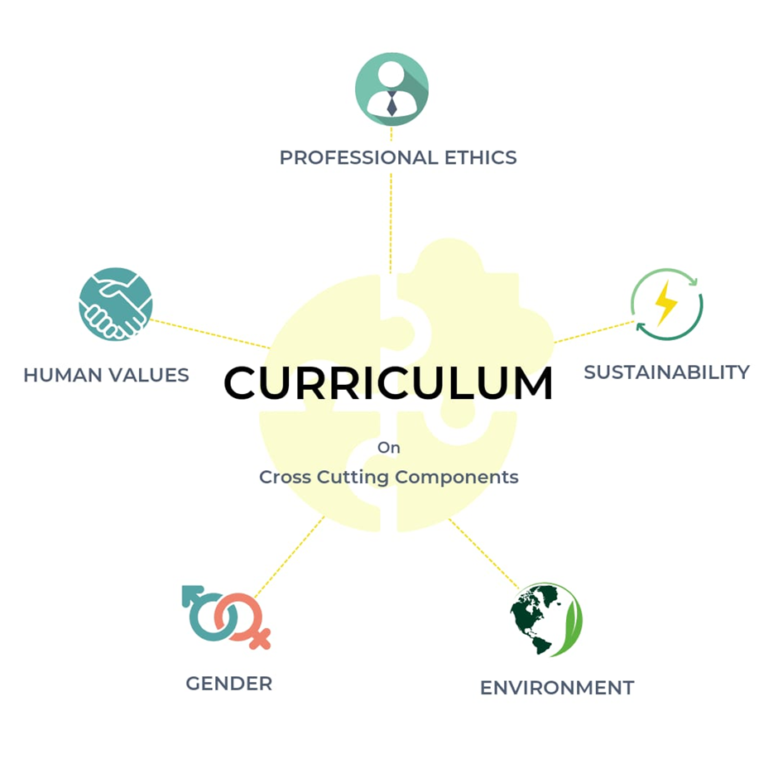  Courses offered by Jamia Hamdard give special emphasis on inclusiveness and all round development of the students therefore pays special attention to Professional Ethics, Gender, Human Values, Environment and Sustainability in accordance with the rules given by regulatory bodies. Integration of such courses gives a conducive environment for advancement of students' identity within his journey, to inculcate justice, harmony, peace, societal connect, sense of responsibility and commitment.  Professional Ethics and Human Values  ● Courses pertaining to professional ethics and human values are offered across various disciplines both for UG and PG students like: Humanities, Universal Human Values, Constitution of India and other audit courses that focus on human values in decision-making, social responsibilities, societal welfare, and best business practices.  ● Medical ethics, community health nursing course indulges in activities of training programs with Delhi police, encouraging students in activities such as visiting old age homes, shelter homes, spastic children centre, organizing blood donation camps, health check-up camps and carrying out cleanliness drives, helping patients admitted in Majeedia quarantine centre and COVID care centre during the pandemic when society actually needed it.  ● During covid pandemic situation learnings through courses like Hospital and Community medicine and Hospital and community pharmacy inculcated a sense of responsibility among the students and online consultation were provided to quarantined patients, webinars were conducted to spread awareness, and to find solutions for diagnosis, treatment, and cure as part of deliberations held.  ● IPR and Cyber Laws, Cyber laws and Ethics, Humanities-II, Social Media, Social media ethics, Value Education etc. courses offered to UG and PG students provide grooming for value oriented-life.  ● Human Rights and Duties in India and Gender Youth and Society course curriculum activities infuse a sense of “Unity in Diversity” among the students and staff, active participation in events like: Jashn-e-Adab aim to promote peace and harmony in society through art and literature.  ● Community Medicine including Humanities course inculcates student’s participation in Unnat Bharat Abhiyan from year 2019, by adopting 5 villages with successful implementation of Covid project in 2020 and also received further projects this year too.  Gender  ● With 50% of girls students studying in Jamia Hamdard, gender related matters are conceptually interlaced into educational modules investigating rise of gender characters, improvement, mindfulness, orientation, entrepreneurial openings, group activities, women in literature and other wellbeing issues, etc.,  ● Every year, interactive sessions, girl up programs on women empowerment and honoring women entrepreneurs are organized on International Women’s Day.  ● Internal Complaint Committee (ICC), Equal opportunity cell and Women’s Grievances Redressal Cell, are in place to address grievances, issues of sexual harassment, if any, promote gender equality, women empowerment, safe-guarding and promoting the well-being of all women employees and female students of the institution.  Environment and Sustainability  ● Environment Science, Environment Studies and Disaster Management, Animal Welfare in Toxicology, Animal Biotechnology courses make students environment conscious, create awareness about the ecosystem, biodiversity, environment pollution, global warming, green computing, waste management, disaster management and related issues.  ● Biosafety and Bioethics, Biotechnology & Human Health, Biotechnology: Environmental & Ethical Aspects courses initiate and sensitize students for rallies, awareness campaigns, debates, and exhibitions on the theme environment and sustainability and the community at large. Jamia Hamdard Environment club and Environmental Quality Cell are committed to minimize the negative environmental impact not only in Jamia Hamdard campus, but also its surroundings to help develop a cleaner and greener environment and more sustainable world.  File Description (Upload)  File Description Document  Upload the list and description of the courses which address the Gender, Environment and Sustainability, Human Values and Professional Ethics into the Curriculum https://docs.google.com/document/d/1KZ0IZYPlF-x9OL4qVv_0eZTtV3Padnh9/edit?usp=sharing&ouid=107800398178863903808&rtpof=true&sd=true  Link for Additional Information Additional Information 1.3.1 - Google Docs  - Any additional information  - Upload the list and description of the courses which address the Gender, Environment and Sustainability, Human Values and Professional Ethics into the Curriculum  - Link for list of courses that integrate cross cutting issues mentioned above. | 5
1.3.2  Q_{n}M | Number of value-added courses for imparting transferable and life skills offered during last five years  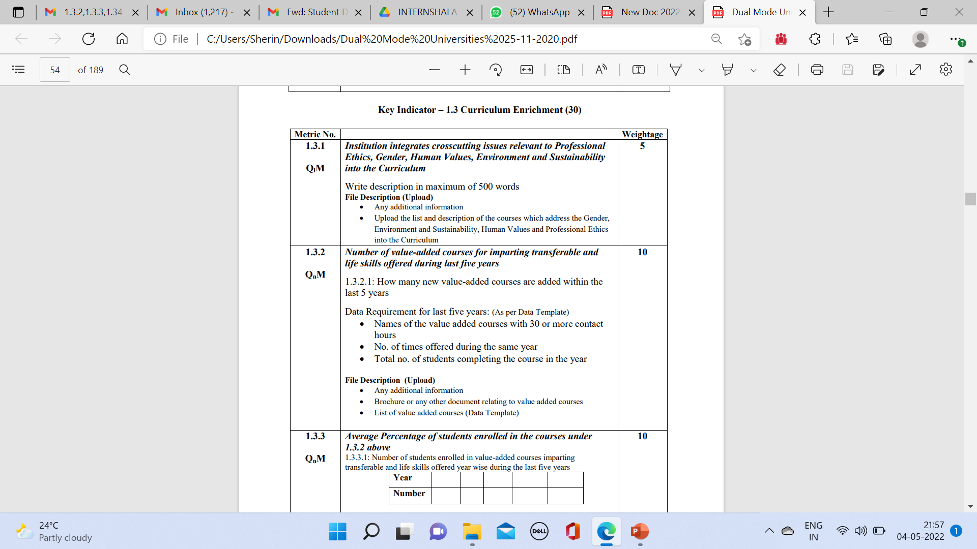  - : How many new value-added courses are added within the last 5 years: 392  Names of value added courses: 1.3.2 - Google Sheets  Additional Information  https://drive.google.com/file/d/1H4LSqCZBny_gn2CoYCmoidN7UVafn2yd/view?usp=sharing  https://docs.google.com/document/d/1MeLdbYokM2RUx3tsqfRxaRvQ0mm2wBhW/edit?usp=sharing&ouid=107800398178863903808&rtpof=true&sd=true | 10
1.3.3  Q_{n}M | Average Percentage of students enrolled in the courses under  1.3.2  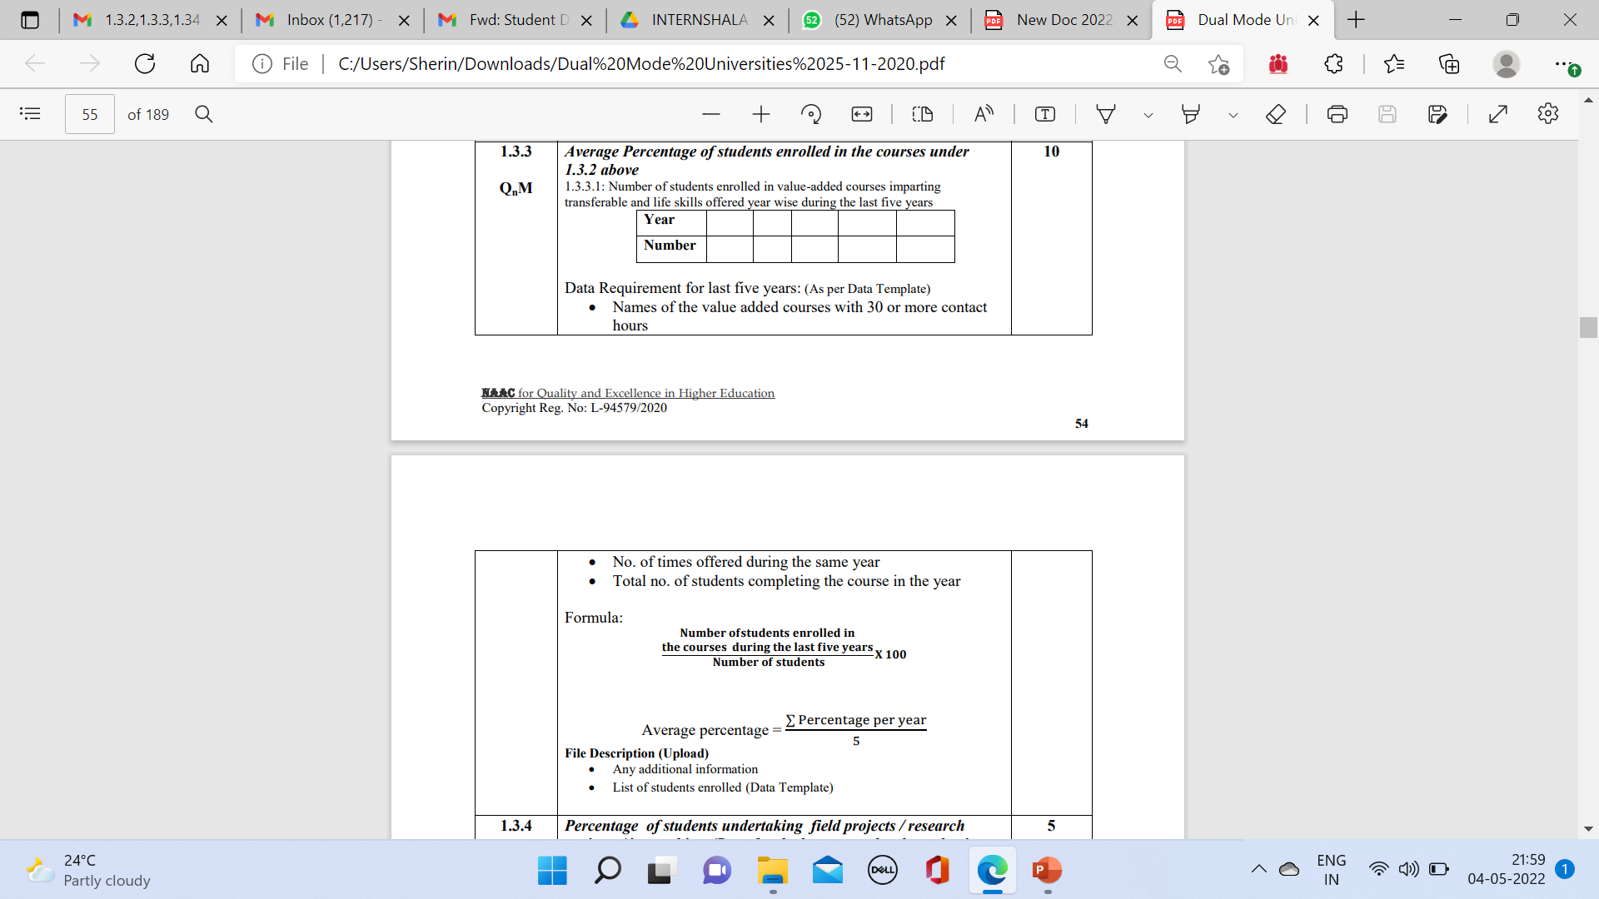  Response:  Year 2021-22 2020-21 2020-19 2019-18 2018-17  Number 7130/9254 77.04% 7399/8345 88.60 6000/7092 84.60 5000/6670 74.96 4467/5916 75.50  Names of value added courses: 1.3.2 - Google Sheets  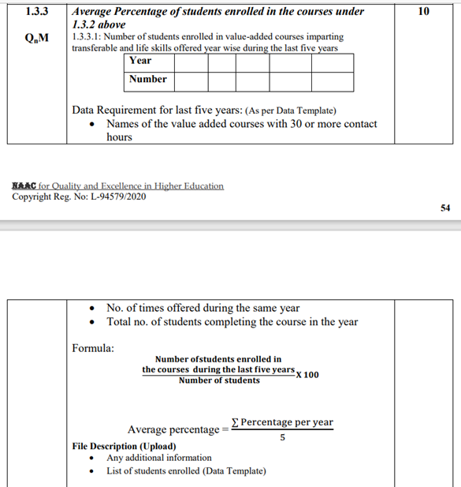Percentage= 29,996/37,277  80.46  Average percentage= 77.04, 88.60, 84.60, 74.96, 75.50  80.152  Additional Information  https://drive.google.com/file/d/1H4LSqCZBny_gn2CoYCmoidN7UVafn2yd/view?usp=sharing  https://docs.google.com/document/d/1MeLdbYokM2RUx3tsqfRxaRvQ0mm2wBhW/edit?usp=sharing&ouid=107800398178863903808&rtpof=true&sd=true | 10
1.3.4  Q_{n}M | Percentage of students undertaking field projects / research projects / internships (Data for the latest completed academic year)  - : Number of students undertaking field project or research projects or internships  Percentage:- 6987/9254=75.50%  https://docs.google.com/spreadsheets/d/1WnEQ3OdFwQIdI2pHZacK393ND4frwWGVGlxm7SPcNqo/edit?usp=sharing  Data Requirements:(As per Data Template)  Formula:  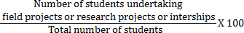  Link for Internships and field projects and research project details:  https://drive.google.com/file/d/1JqWm_kssz6Nqs4G-j8MViXqQHs8r3q_L/view?usp=sharing  - Any additional information  - List of Programmes and number of students undertaking field projects research projects/ /internships (Data Template) | 5

Key Indicator–1.4 Feedback System (20)

 | Metric no. | AS PER UNIVERSITY FEEDBACK SYSTEM | Weightage
 | 1.4.1  Q_{n}M | Structured feedback for design and review of syllabus – semester wise/ year wise is received from  1) Students, 2) Teachers, 3) Employers, 4) Alumni  Options:  - All 4 of the above  - Any 3 of the above  - Any 2 of the above Opt one  - Any 1 of the above  - None of the above  Data Requirements: (As per Data Template)  Response: A | 10
Report of analysis of feedback received from different stakeholders’ year wise

Response: A

File Description:

Blank Forms

SSS link : https://forms.gle/Mf9mhP3vqbV1gKzA7
Alumni Link: https://forms.gle/1gMEx8CFrucv54qr9
Parents link: https://forms.gle/Ue8RKTS99vja1xei6
Employer link: https://forms.gle/LXJRe62wqKCV3aL98
Teacher link: Online Teachers Feedback link

Feedback sample forms:

Students:
Students Satisfaction Responsse Sample.pdf
Parents:
Parent Survey Response Sample.pdf
Employers
Employer Feedback Response sample.pdf
Alumini
Copy of Alumni Feedback Response Sample.pdf
Teachers
Jamia Hamdard Curriculum Feedback Form-Teachers19-20.pdf
Jamia Hamdard Curriculum Feedback Form-Teachers, 2016-17.pdf
https://drive.google.com/file/d/19ZOYOYgmf-V203dhwR81ofOupNnRM1H-/view?usp=sharing
- URL for stakeholder feedback report
- Sample of structured feedback form designed by institute.
- Action taken report of the University on feedback report as stated in the minutes of the Governing Council, Syndicate, Board of Management (Upload)
- Any additional information (Upload)

1.4.2 |  | Feedback processes of the institution may be classified as follows: | 10
Q_{n}M |  | - Feedback collected, analysed and action taken and feedback available on website  - Feedback collected, analysed and action taken  - Feedback collected and analysed  - Feedback collected  - Feedback not collected _{Opt one}
Response: A

Report of analysis of feedback received from different stakeholders year wise

2017-2018: Criteria _ 1.4 .2-Analysis of Structured feedback for design and revision of syllabus _ 2017-18 (4).pdf

2018-2019:
Criteria _ 1.4 .2-Analysis of Structured feedback for design and revision of syllabus _ 2018-19 .pdf
2019-2020:
Criteria _ 1.4 .2-Analysis of Structured feedback for design and revision of syllabus _ 2019-20 .pdf
2020-2021:
Criteria _ 1.4 .2-Analysis of Structured feedback for design and revision of syllabus _ 2020-21.pdf
Alumni feedback:
Criteria _ 1.4 .2- Alumni feedback analysis for design and revision of syllabus.pdf
Parent Feedback
Crtieria 1.4.2 Parent feedback analysis on Design and revision of syllabus.pdf

Employer Feedback
Crtieria 1.4.2 Parent feedback analysis on Design and revision of syllabus.pdf
Action taken report of the University on feedback :

Criteria I.4.2Action taken report on Feedback for curricular design (1).docx (1).pdf

Criteria I.4.2Action taken report on Feedback for curricular design (1).docx

Bos Minutes:

https://drive.google.com/drive/folders/1JjI0-OiJSZkgXm6etUJZ5msf9FhaJDi1?usp=sharing

Documents:

Upload Stakeholder feedback report, Action taken report of the university on it as stated in the minutes of the Governing Council, Syndicate, Board of Management
File Description

- Upload any additional information
 |  | - URL for feedback report

