

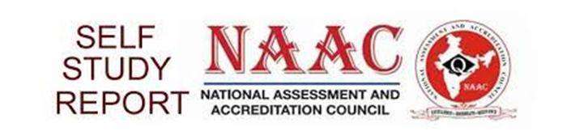

**COURSES RELEVANT TO CROSS CUTTING ISSUES**

**Metric: 1.3.1**

**Course syllabus relevant to cross cutting issues:**

1.1.1 LINK FOR CURRICULUM